**NetSim®**

Accelerate Network R & D

Advanced 5G Experiments

A Network Simulation & Emulation Software

By



The information contained in this document represents the current view of TETCOS LLP on the issues discussed as of the date of publication. Because TETCOS LLP must respond to changing market conditions, it should not be interpreted to be a commitment on the part of TETCOS LLP, and TETCOS LLP cannot guarantee the accuracy of any information presented after the date of publication.

This manual is for informational purposes only.

The publisher has taken care in the preparation of this document but makes no expressed or implied warranty of any kind and assumes no responsibility for errors or omissions. No liability is assumed for incidental or consequential damages in connection with or arising out of the use of the information contained herein.

**Warning! DO NOT COPY**

Copyright in the whole and every part of this manual belongs to TETCOS LLP and may not be used, sold, transferred, copied, or reproduced in whole or in part in any manner or in any media to any person, without the prior written consent of TETCOS LLP. If you use this manual, you do so at your own risk and on the understanding that TETCOS LLP shall not be liable for any loss or damage of any kind.

TETCOS LLP may have patents, patent applications, trademarks, copyrights, or other intellectual property rights covering subject matter in this document. Except as expressly provided in any written license agreement from TETCOS LLP, the furnishing of this document does not give you any license to these patents, trademarks, copyrights, or other intellectual property. Unless otherwise noted, the example companies, organizations, products, domain names, e-mail addresses, logos, people, places, and events depicted herein are fictitious, and no association with any real company, organization, product, domain name, email address, logo, person, place, or event is intended or should be inferred.

Rev 14.0 (V), Nov 2023, TETCOS LLP. All rights reserved.

**All trademarks are the property of their respective owner.**

**Contact us at**

TETCOS LLP

# 214, 39th A Cross, 7th Main, 5th Block Jayanagar,

Bangalore - 560 041, Karnataka, INDIA.

Phone: +91 80 26630624

E-Mail: [sales@tetcos.com](mailto:sales@tetcos.com)

Visit: [www.tetcos.com](http://www.tetcos.com)

1. Understanding the 5G NR PHY 4

2. MIMO Beamforming in 5G: A start with MISO and SIMO 17

3. Understanding 5G NR (3GPP) pathloss models 33

4. Performance of OFDMA SU-MIMO in 5G 45

5. 5G Numerologies and their impact on end-to-end latencies 57

6. MIMO Communication: Channel Matrix Asymptotic Analysis 67

7. Impact of Interference in 5G Networks 81

8. On the Study of MAC Scheduling algorithms in 5G Communications 98

9. Study of 5G Handover procedure 111

# Understanding the 5G NR PHY

## Objective

This experiment has four goals. First, to gain an appreciation for the 5G NR physical layer, i.e., the time-frequency resource grid in the OFDM access scheme. Second, to understand how a packet is transmitted over this OFDM PHY in NetSim, and the assumptions involved. Third, to analytically estimate (per 3GPP standards) the application throughput for a simple use case. And finally, to simulate and analyze throughput as different PHY parameters are varied.

## I**ntroduction**

**OFDM:** 5G uses Orthogonal Frequency Domain Multiplexing (OFDM) as the multiple access scheme for both downlink and uplink transmissions with the flexibility of multiple subcarriers spacing that supports diverse application scenarios. The smallest physical resource, known as the resource element (RE), comprises one subcarrier and one OFDM symbol.

The time-domain transmission structure comprises of frames 10 ms (to support backward compatibility with LTE). Each frame is composed of 10 subframes of 1 ms each. The 1 ms subframe is then divided into one or more slots in 5G, whereas LTE had exactly two slots in a subframe. The slot size depends on the numerology, $μ,$ and is equal to $\frac{1}{2^{μ}}$ ms. The number of OFDM symbols per slot is 14 for a configuration using a normal cyclic prefix. For extended cyclic prefixes, the number of OFDM symbols per slot is 12. Data is transmitted over these symbols.

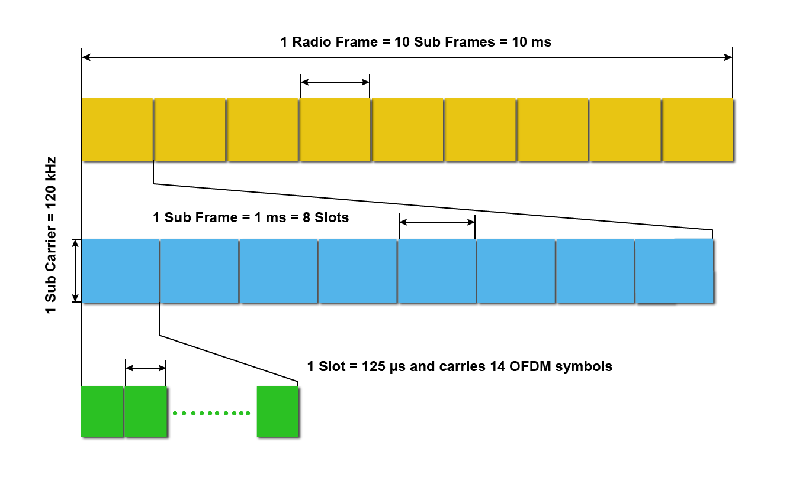

Figure 1‑1: NR Frame Structure when numerology μ is set to 3.

In the time division duplex version, each frame is partitioned into downlink subframes and uplink subframes. The downlink part of each frame is used to send data from the gNB to the UEs. The uplink part of the frame is used to send data from the UEs to the destinations, via the gNB. The uplink-downlink ratio is a GUI parameter in NetSim. If Internet access is a major application in a system, then the downlink part of the frame would be substantially larger than the uplink part, due to the asymmetry of Internet access traffic.

In the frequency domain, the group of 12 consecutive sub-carriers forms a resource block (RB). The sub carrier spacing (SCS) is also dependent on numerology, $μ$ and is equal to $2^{μ}×15$ KHz. 5G supports total carrier bandwidth up to 400 MHz with a maximum of 275 RBs.

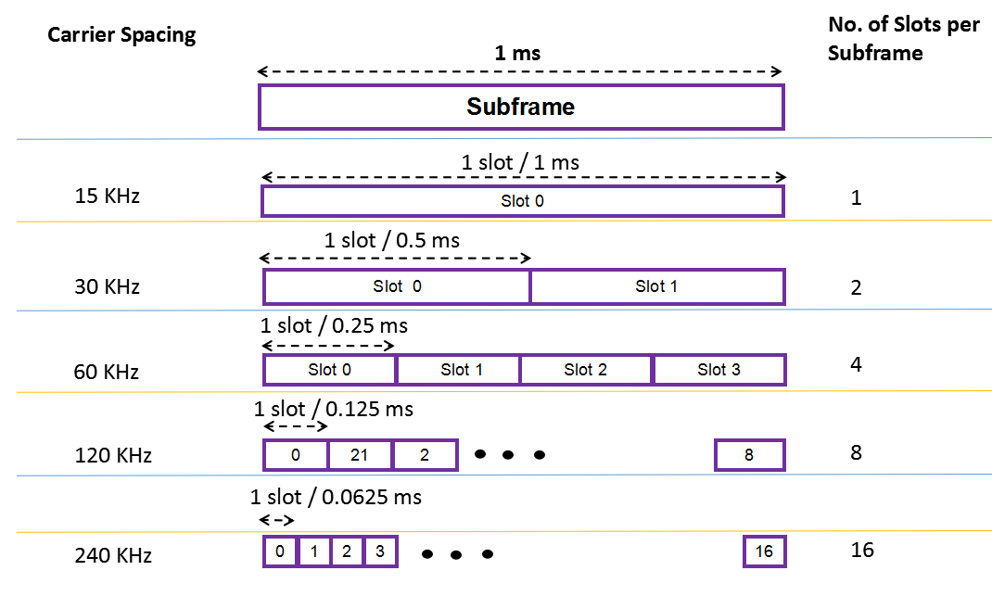

Figure 1‑2: The OFDM frame structure. Slot times get shorter as the sub-carrier spacing gets larger.

**Data Transmission in NetSim**

* In TDD operation the UL and DL transmissions are separated in the time-domain over different frames/subframes/slots/symbols and use the same carrier frequency. In FDD operation UL and DL transmissions are separated in the frequency domain, with different frequencies used for UL and for DL transmissions. NetSim does slot-based scheduling. For example, if the DL:UL ratio is 4:1 then 4 slots are allotted to DL and 1 slot to UL.
* Higher layer packets arrive at the RLC buffer for each UE and each gNB.
* The MAC Scheduler determines the Transport block size (TBS) based on the channel quality index (CQI). The CQI is determined by the Adaptive Modulation and Coding (AMC) function based on the SNR.
* Now, the SNR is determined from a) large-scale path loss and shadowing calculated per the 3GPP’s stochastic propagation models, and b) the small-scale fading which leads to beamforming gains when using MIMO. These models provide signal attenuation as an output. Several parameters are used in the model, including the distance between the transmitter and the receiver. These computations are executed each associated UE-gNB pair, in DL and UL, at the start of simulation and again at every mobility event. In calculating SNR, the noise power is obtained from N=k×T×B.
* Note that the SNR/CQI is not computed/fed-back using reference signals but is computed on the data channel. Then it is assumed to be instantaneously known to the transmitter and receiver. This assumption is known as perfect CSIT and CSIR. With perfect CSIT the transmitter can adapt its transmission rate (MCS) relative to the instantaneous channel state (SNR).
* Based on this SNR the AMC determines a wideband CQI which indicates the highest rate Modulation and coding scheme (MCS), that it can reliably decode, if the entire system bandwidth were allocated to that user. The rate adaptation is discrete (not continuous), and the modulation and coding scheme (MCS) is selected from a standard specified table. The modulation scheme defines the number of bits, that can be carried by a single RE. Modulation scheme supported by 5G include QPSK (2 bits), 16 QAM (4 bits), 64 QAM (6 bits), and 256 QAM (8 bits). The code rate defines the proportion of bits transmitted that are useful. It is computed as the ratio of useful bits by total bits that are transmitted. The modulation order Q_m, which denotes the number of bits per RE, and the code rate denoted by R are jointly encoded as modulation and coding scheme (MCS) index. These values of Q_m and R are then passed to the TBS determination function.
* At each gNB a frame of length 10ms is started. Each frame in turn starts 10 sub frames each of length 1ms. Each sub frame then starts a certain number of slots based on numerology.
* The PHY layer in NetSim then notifies the MAC about the slot start. The MAC sub layer in turn seeks a buffer status report from the RLC layer and invokes the MAC scheduler. It then notifies the RLC of the transmission. The RLC then transmits the transport block to the PHY layer. The downlink and uplink data channels (PDSCH, PUSCH) receive this transport block as its service data unit (SDU), which is then processed and transmitted over the radio interface.

## Procedure

1. Use the following download Link to download a compressed zip folder which contains the workspace [GitHub link](https://github.com/NetSim-TETCOS/5G_Advanced_Experiments_v14.0/archive/refs/heads/main.zip)
2. Extract the zip folder.
3. The extracted project folder consists of a NetSim workspace file (5G_advanced_experiments_with_NetSim.netsimexp).
4. Go to NetSim Home window, go to Your Work and click on import.

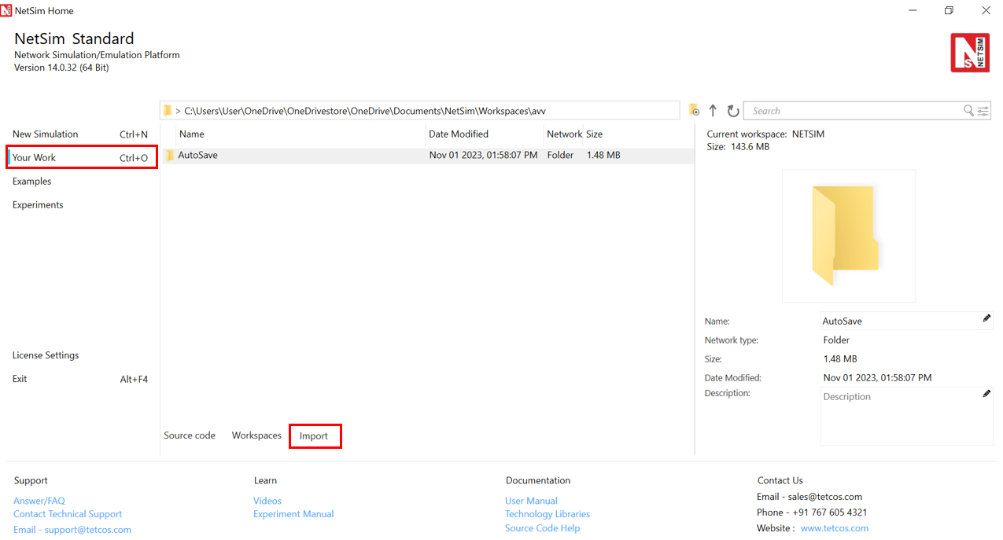

Figure 1‑3: NetSim Home Window

1. In the Import Workspace Window, browse and select the 5G_advanced_experiments_with_NetSim.netsimexp file from the extracted directory. Click on create a new workspace option and browse to select a path in your system where you want to set up the workspace folder.
2. Choose a suitable name for the workspace of your choice. Click Import.

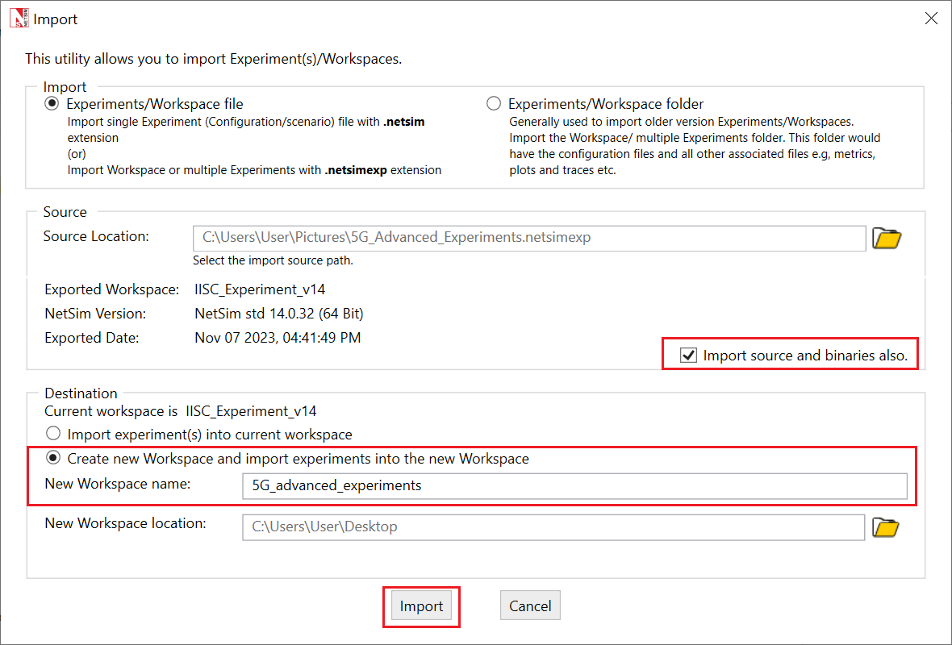

Figure 1‑4: NetSim Your Work Window to import a workspace.

1. The Imported Project workspace will automatically be set as the current workspace.
2. The list of experiments is now loaded onto the selected workspace.

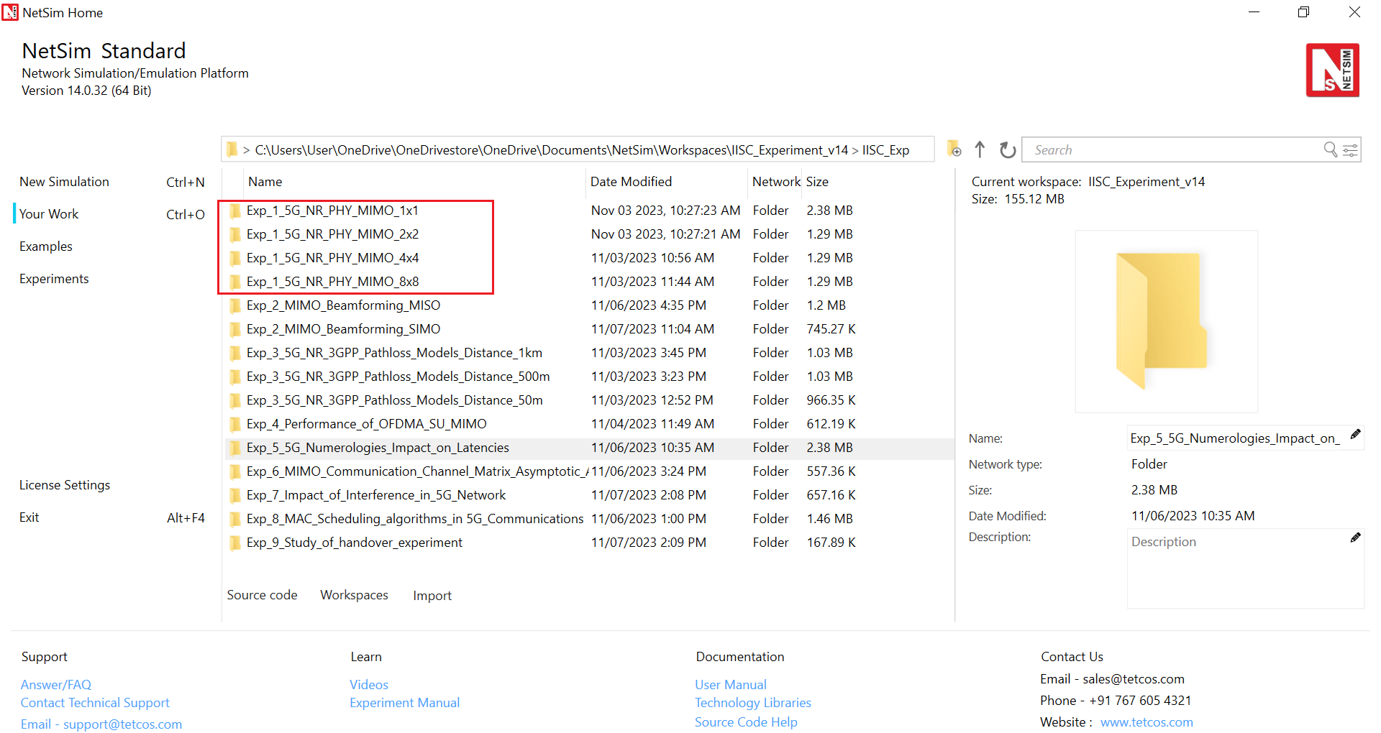

Figure 1‑5: NetSim Your Work Window with the experiment folders inside the workspace.

## Network Setup

NetSim UI would display the following network topology when you open the example configuration file as shown below screenshot.

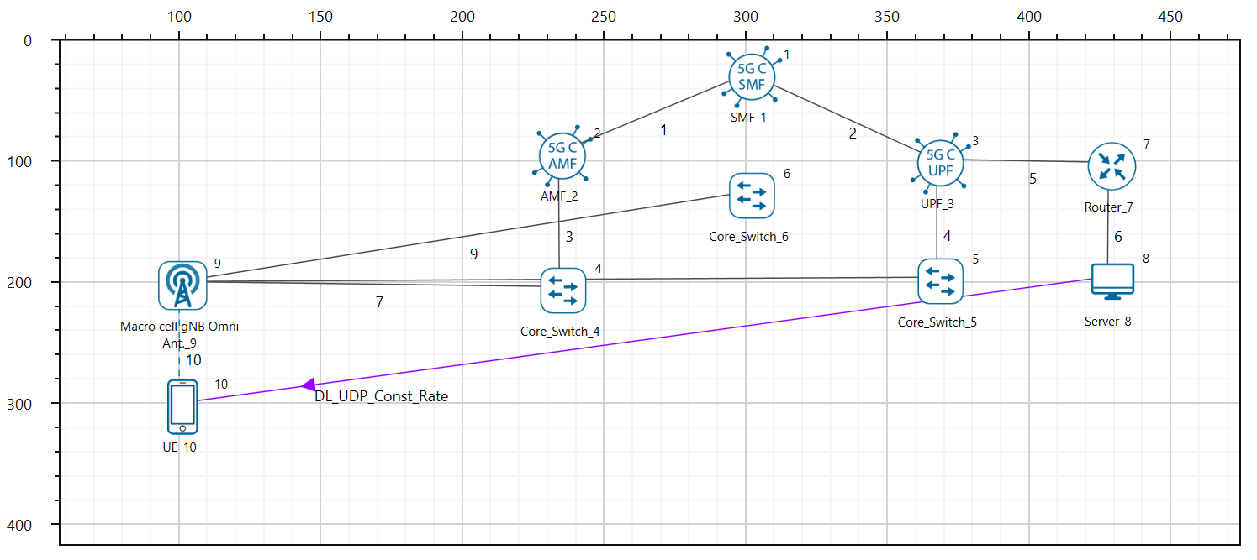

Figure 1‑6: Network topology in this experiment

1. The UE was placed 100m away from the gNB.
2. The following properties were set in Interface 5G RAN, Physical Layer of gNB.

|  |  |
| --- | --- |
| gNB Interface 5G RAN | |
| gNB Height (m) | 10 |
| Tx Power (dBm) | 31, 34, 37, 40, 43 (Varied) |
| Tx Antenna Count | 1* (varied from 1 to 8) |
| Rx Antenna Count | 4 |
| CA Type | Single Band |
| CA Configuration | n261 |
| DL: UL Ratio | 4:1 |
| Numerology | 3 |
| Channel Bandwidth (MHz) | 50, 100, 200, 400 (Varied) |
| MCS Table | QAM256 |
| CQI Table | TABLE2 |
| Outdoor Scenario | Rural Macro |
| Indoor Office Type | Mixed Office |
| Pathloss Model | 3GPPTR38.901-7.4.1 |
| LOS Mode | User Defined |
| LOS Probability | 0 |
| Shadow Fading Model | None |
| Fading and Beamforming | No Fading MIMO Unit Gain |

Table 1‑1: gNB properties

1. Tx Antenna Count =4 and Rx Antenna Count is varied from 1 to 8 in UE > Interface 5G RAN > Physical Layer
2. A downlink CBR application was configured from Wired Node to UE with Packet Size 1460B and IAT as 11.68 and the start time was set to 1s.
3. Run the simulation for 1.2s.
4. Run the simulation for different MIMO Layers and different Tx Powers in gNB and note down the throughput obtained.

### Analytical Estimation of Data Throughput

We derive the throughput for the setting involving $2×2$ MIMO (2-layers) with 100MHz Bandwidth and 31 dBm Transmit power. The procedure for TBS determination given in the steps below is per 3GPP TS 38.214 Section 5.1.3.2 (DL).

1. Initially, the Pathloss (dB) is calculated based on the Pathloss models specified in the 3GPP standards[1]. Pathloss in this example turns out to be $122.26 dB$
2. The Total Loss is then calculated using the following equation:

$$TotalLoss \left(dB\right)=Pathloss \left(dB\right)+ShadowFading Loss+O2I Loss+Additional Loss$$

In this example, $Shadow Fading Loss=0$, $O2I Loss=0$, $Additional Loss=0$

$$Total Loss=122.26+0+0+0=122.26 dB$$

1. The Received power (Per layer) is calculated, using the Tx Power (per layer), the Total Loss and the Beamforming Gain (per layer). Since fading is turned off the Beamforming (BF) gain per layer is 0 dB.
$$Rx Power_{Layer} \left(dBm\right)=Tx Power_{Layer} \left(dBm\right)-Total Loss \left(dB\right)+BFGain_{Layer}$$

$$Rx Power_{Layer 1}=27.98-122.26+0= -94.28 dBm$$

$$Rx Power_{Layer 2}=27.98-122.26+0= -94.28 dBm$$

2. Thermal Noise computation

$$Thermal Noise=k×T×B=-93.829 dBm$$

$k (Boltzmann^{'}s constant)= 1.38*{10}^{-23}$, $T \left(Temperature\right)=300 K, B=100 MHz$

$Thermal Noise=$ $4.14×{10}^{-13}W$

1. From the Rx Power and Thermal Noise, SNR is calculated
$Rx Power in dBm is converted into mW$

$$Rx Power, P= -94.28 dBm=3.73×{10}^{-10}mW$$

$Thermal Noise in dBm is converted into mW$

$$Thermal Noise, N= -93.82 dBm=4.14*{10}^{-10} mW$$

2. $SNR\left(Linear\right)=\frac{E_{b}}{N_{0}}=\frac{Rx Power}{Thermal Noise}=\frac{P}{N}$ = $\frac{{3.73×10}^{-10}}{4.14×{10}^{-10}}=0.902$
3. From SNR, the Spectral Efficiency is calculated as follows:
$$Spectral Efficiency_{Layer}=\log_{2}\left(1+\left(\frac{E_{b}}{N_{0}}\right)\right)$$

$$=\log_{2}\left(1+\left(0.902\right)\right)= 0.927$$

4. The CQI Index is then looked up from the respective CQI Table using the spectral efficiency obtained. The table is given below:

{0, Modulation_Zero, 0, 0}, //out of range

{1, Modulation_QPSK, 78, 0.1523},

{2, Modulation_QPSK, 193, 0.3770},

{3, Modulation_QPSK, 449, 0.8770},

{4, Modulation_16_QAM, 378, 1.4766},

{5, Modulation_16_QAM, 490, 1.9141},

{6, Modulation_16_QAM, 616, 2.4063},

{7, Modulation_64_QAM, 466, 2.7305},

{8, Modulation_64_QAM, 567, 3.3223},

{9, Modulation_64_QAM, 666, 3.9023},

{10, Modulation_64_QAM, 772, 4.5234},

{11, Modulation_64_QAM, 873, 5.1152},

{12, Modulation_256_QAM, 711, 5.5547},

{13, Modulation_256_QAM, 797, 6.2266},

{14, Modulation_256_QAM, 885, 6.9141},

{15, Modulation_256_QAM, 948, 7.4063},

Since the Spectral Efficiency is 0.927, from the CQI Table, $CQI Index=3$ is chosen.

1. Similarly, the MCS Index is taken from the respective MCS Table with respect to the spectral efficiency from the CQI Table:

{0, 2, Modulation_QPSK, 120, 0.2344},

{1, 2, Modulation_QPSK, 193, 0.3770},

{2, 2, Modulation_QPSK, 308, 0.6016},

{3, 2, Modulation_QPSK, 449, 0.8770},

{4, 2, Modulation_QPSK, 602, 1.1758},

{5, 4, Modulation_16_QAM, 378, 1.4766},

{6, 4, Modulation_16_QAM, 434, 1.6953},

{7, 4, Modulation_16_QAM, 490, 1.9141},

{8, 4, Modulation_16_QAM, 553, 2.1602},

{9, 4, Modulation_16_QAM, 616, 2.4063},

{10, 4, Modulation_16_QAM, 658, 2.5703},

{11, 6, Modulation_64_QAM, 466, 2.7305},

{12, 6, Modulation_64_QAM, 517, 3.0293},

{13, 6, Modulation_64_QAM, 567, 3.3223},

{14, 6, Modulation_64_QAM, 616, 3.6094},

{15, 6, Modulation_64_QAM, 666, 3.9023},

{16, 6, Modulation_64_QAM, 719, 4.2129},

{17, 6, Modulation_64_QAM, 772, 4.5234},

{18, 6, Modulation_64_QAM, 822, 4.8164},

{19, 6, Modulation_64_QAM, 873, 5.1152},

{20, 8, Modulation_256_QAM, 682.5, 5.3320},

{21, 8, Modulation_256_QAM, 711, 5.5547},

{22, 8, Modulation_256_QAM, 754, 5.8906},

{23, 8, Modulation_256_QAM, 797, 6.2266},

{24, 8, Modulation_256_QAM, 841, 6.5703},

{25, 8, Modulation_256_QAM, 885, 6.9141},

{26, 8, Modulation_256_QAM, 916.5, 7.1602},

{27, 8, Modulation_256_QAM, 948, 7.4063},

Since the Spectral Efficiency is 0.927, MCS Index 3 which corresponds to this spectral efficiency is chosen and the $Modulation Order=2$

1. The TBS size is then determined using the Modulation Order and code rate.
2. Determination of number of Resource Elements within the slot.
$$N_{RE}^{'}=N_{SC}^{RB}×N_{Symb}^{Sh}-N_{DMRS}^{PRB}-N_{OH}^{PRB}$$

$$N_{SC}^{RB}=12. Number of subcarriers in Physical Resource Block$$

$$N_{Symb}^{Sh}= 14. Number of Symbols per Slot$$

$$N_{DMRS}^{PRB}= 0→Number of Resource Elements for DM-RS per PRB$$

$$N_{OH}^{PRB}= 0. PDSCH overhead$$

$$N_{RE}^{'}=12×14-0-0=168$$

3. Total number of Resource Elements allocated for PDSCH
$$N_{RE}=\min\left(156, N_{RE}^{'}\right)×n_{PRB}$$

$$n_{PRB}= 1. Number of allocated PRBs for the UE$$

$$N_{RE}=\min\left(156, 168\right)×1=156×1=156$$

4. Intermediate number of information bits is calculated.

$$N_{info}=N_{RE}×R×Q_{m}$$

$R=\frac{MCS_{CodeRate}}{1024}=\frac{449}{1024}=0.438$ and $Q_{m}=2$ (Modulation order)

$$N_{info}=156×0.438×2=136.65$$

1. Since $N_{info}≤3824$, the TBS Size is calculated.

$$N_{info}^{'}=\max\left(24, 2^{n}×floor\left(\frac{N_{info}}{2^{n}}\right)\right)$$

Where $n=max⁡(3, floor(\log_{2}{(N_{info}))-6)}$

$$=max⁡(3, floor(\log_{2}{(136.65))-6)}=\max{ \left(3, 1\right)}=3$$

$$N_{info}^{'}=\max\left({24, 2}^{3}×floor\left(\frac{136.65}{2^{3}}\right)\right)=\max{ \left(24, 136\right)=136}$$

Hence, the TBS size will be 136, i.e., index 15.

1. The bits per PRB per layer is determined based on the TBS size.
2. For Layer 1,

$$bitsperPRB=bits per PRB (initial)+TBS Size$$

$$=0+136=136$$

For Layer 2,

$$bitsperPRB_{L2}=bitsperPRB_{L1}+TBS Size$$

$$=136+136=272$$

1. The Total PRB available is dependent on bandwidth and $μ$ and is shown in the GUI. In this example $PRB available=PRB Count=66$
2. The total PRB available is calculated.

$$Total PRB available=PRBCount-ceil(PRB count×OH_{Downlink})$$

$PRB Count=66$, $OH_{Downlink}=0.18$ (Per standard)

$$Total PRB available=66-ceil\left(66×0.18\right)$$

$$=66-11=54$$

1. Number of PRBs allocated is 54.
2. The slot allocation will then take place and the bits per slot is assigned.
$$bits per Slot=bits per PRB×allocated PRB$$

$$=272×54=14688 bits=1836 Bytes$$

$$i.e., a slot can transmit a maximum of 1836 Bytes$$

3. Throughput estimation. $DL UL Ratio=4:1,$ implies a DL fraction of $0.8$. Since $μ=3$, slot time $\frac{1}{2^{3}}$ ms.

$$DL MAC Throughput=\frac{1836×8×0.8}{{\left(\frac{1}{2^{3}}\right)×10}^{-3}}=94 Mbps$$

$$DL Application Throughput=DL MAC Throughput ×\left(\frac{ApplicationPacketSize}{MACPacketSize }\right)$$

$$=94×\left(\frac{1460}{1488}\right)=92.23 Mbps$$

(Matches with NetSim’s Result of 92.21 Mbps, which can be seen in Table 1‑2 entry pertaining to MIMO 2*2, Bandwidth 100MHz and Tx Power 31 dBm. The entry is marked in green.)

## Results and Discussion

The following throughputs were obtained after running simulations with different Antenna counts (MIMO layers), Bandwidths and Transmit Power values.

|  |  |  |  |  |  |
| --- | --- | --- | --- | --- | --- |
| **MIMO** | **Total Tx Power[2] (dBm)** | **Peak Application Throughput (Mbps)**  **for various** | | | |
| **Bandwidth (MHz)** | | | |
| **50** | **100** | **200** | **400** |
| 1*1 | 31 | 47.82 | 74.69 | 89.81 | 74.69 |
| 34 | 68.44 | 100.50 | 149.38 | 180.68 |
| 37 | 96.76 | 143.25 | 202.06 | 298.77 |
| 40 | 112.18 | 202.06 | 287.62 | 405.23 |
| 43 | 141.91 | 234.12 | 405.23 | 576.29 |
|  | | | | | |
| 2*2 | 31 | 71.01 | 89.81 | 74.69 | 84.50 |
| 34 | 96.76 | 149.38 | 180.68 | 149.38 |
| 37 | 137.94 | 202.06 | 298.77 | 362.43 |
| 40 | 194.58 | 287.62 | 405.23 | 597.66 |
| 43 | 225.42 | 405.23 | 576.29 | 811.46 |
|  | | | | | |
| 4*4 | 31 | 86.43 | 74.69 | 84.50 | 170.00 |
| 34 | 143.13 | 180.68 | 149.38 | 170.00 |
| 37 | 194.58 | 298.77 | 362.43 | 298.77 |
| 40 | 276.93 | 405.23 | 597.66 | 725.97 |
| 43 | 390.17 | 576.29 | 811.46 | 997.88 |
|  | | | | | |
| 8*8 | 31 | 71.01 | 84.50 | 170.00 | 0 |
| 34 | 174.26 | 149.38 | 170.00 | 341.05 |
| 37 | 287.26 | 362.43 | 298.77 | 341.05 |
| 40 | 390.17 | 597.66 | 725.97 | 597.66 |
| 43 | 554.91 | 811.46 | 997.88 | 997.88 |

Table 1‑2: Saturation throughput obtained for n261 band (gNB-UE distance of 100m, Rural macro pathloss) for various Bandwidth-MIMO-TxPower combinations. The blue entries show the doubling of throughput when power and BW is doubled. Red shows examples where throughput decreases with increase in bandwidth for fixed power and MIMO layers. Green entries are where throughput decreases with an increase in MIMO layers, for fixed BW and power.

In Table 1‑2 we observe entries marked in:

* Blue: When both the bandwidth and the power are doubled, with MIMO count kept constant, the peak throughput doubles. This is along expected lines.
* Red: In the high bandwidth and low power regime, when the bandwidth is doubled with the transmit power and MIMO count held constant, the peak throughput does not increase but rather decreases.
* Green: At low power when the MIMO layers are increased with fixed transmit power and bandwidth, the peak throughput surprisingly decreases.

Let us understand the red entries, i.e., throughput of 1*1 MIMO, 31 dBm Tx power for bandwidths of 200 and 400 MHz. We can simplify the PHY rate as equal to $k×L×Q×B×R$ where $k$ is some constant, $L$ is the number of layers (set to 2 here), $Q$ is the modulation order (2 in this case), $R$ is the code rate and $B$ is the bandwidth. From Table 1‑2 we see that when the bandwidth increases the spectral efficiency decreases due to an increase in thermal noise at higher bandwidths. The received power is constant since the transmit power is fixed. Since the drop in the MCS[3] (due to the reduced spectral efficiency) is larger than the bandwidth increase - $0.438×200$ vs. $0.188×400$- the net effect is a decline in the throughput.

|  |  |  |
| --- | --- | --- |
| BW (MHz) | 200 | 400 |
| Rx Power (dB) | -91.26 | -91.26 |
| Noise (KTB) | -90.81 | -87.80 |
| SNR | -0.44 | -3.45 |
| Spectral Efficiency | 0.927 | 0.537 |
| Spec Eff Table cut off | 0.8770 | 0.3770 |
| MCS Index |  | 1 |
| MCS Code Rate | 449 | 193 |
| R (Code rate/1024) | 0.438 | 0.188 |
| Throughput (Mbps) | 92.21 | 75.92 |

Table 1‑3: Rx Power, Noise, SNR, Spectral Efficiency obtained for different bandwidths with Tx power at 31 dBm.

Next, we turn to the green entries. In Table 1‑2 notice that when the MIMO layer count is increased from 4 to 8, the received power (per layer) decreases. This happens because the transmit power is equally divided among all the layers. As SNR reduces, the spectral efficiency per layer decreases. Since the MCS drop (due to lower spectral efficiency) is larger than the multiplexing gain got from multiple MIMO streams - $4×0.438$ vs $8×0.188$- the consequence is a decrease in throughput.

|  |  |  |
| --- | --- | --- |
| MIMO Layers | 4 | 8 |
| BW (MHz) | 50 | 50 |
| Rx Power (dB) | -97.28 | -100.29 |
| Noise (KTB) | -96.83 | -96.83 |
| SNR | -0.44 | -3.45 |
| Spec Efficiency | 0.927 | 0.537 |
| Spec Eff Table cut off | 0.877 | 0.377 |
| MCS Index | 3 | 1 |
| MCS Code Rate | 449 | 193 |
| R (Code rate/ 1024) | 0.438 | 0.188 |

Table 1‑4: Rx Power, Noise, SNR, Spectral Efficiency obtained for each MIMO layer with Tx power set to 31 dBm.

## Exercises

1. Estimate the data throughput analytically for different values of Transmit power, Bandwidth and MIMO layer count (Each student can be given a personalized experiment)

# MIMO Beamforming in 5G: A start with MISO and SIMO

## **Objective**

Consider 5G communication between a gNB and single UE, over a fading channel. Setup the simplest MIMO cases, namely MISO and SIMO, and investigate the questions:

* How does beamforming gain vary with antenna count?
* How does throughput vary with antenna count?

## **Introduction**

Multiple input multiple output (MIMO) is a method for increasing the capacity of the wireless channel using multiple transmitting and receiving antennas. Multiple antennas exploit the spatial dimension, i.e., multiple paths from transmitter to receiver, under suitable spacing within the antenna array, on each side, and channel scattering conditions.

Consider a $N_{t}×N_{r}$ MIMO system where $N_{t}$ is the number of transmit antennas and $N_{r}$ is the number of receive antennas. The simplest MIMO instantiations are when:

* $N_{r}=1$, a special case where the MIMO system reduces to a Multiple Input Single Output (MISO) channel, and
* Reciprocally when, $N_{t}=1$, a special case where the MIMO system simplifies into a Single Input Multiple Output (SIMO) channel.

In both SIMO and MISO, the number of layers (i.e., spatial streams with independent data) is $\min{(N_{t}, N_{r})},$ which equals 1.

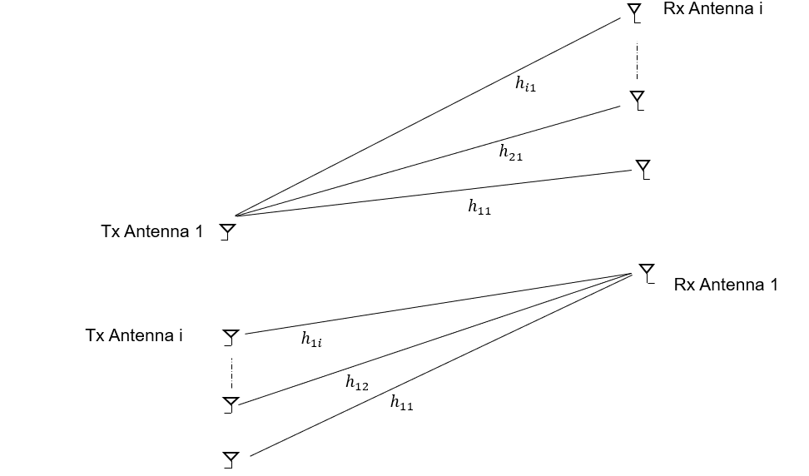

Figure 2‑1: Top - Single transmit antenna and multiple receive antennas. Bottom - Multiple Transmit and single receive antenna. In both, $h_{ij}$ represents the channel between the $i^{th}$ receive antenna and the $j^{th}$ transmit antenna.

**SIMO:** SIMO occurs where the transmitter has a single antenna, and the receiver has multiple antennas. The signal received on multiple antennas is combined in order to maximize an appropriate metric. For example, when the goal is to maximize the received SNR, under additive white Gaussian noise, the optimal receiver is called maximal ratio combining. In the case of fading channels (e.g., with Rayleigh fading, explained in the next section), the channels between the transmitter and the different receive antennas is modelled as independent and identically distributed with unit variance entries; this is shown in **Error! Reference source not found.** above. In this case, maximal ratio combining uses the channel coefficients as the weights to combine the signals, and in turn, this provides receive diversity gain. The average SNR at the receiver improves by $10 \log_{10}(N_{r})$. However, the improvement in SNR is not exactly the same for every channel instantiation, since the channel is random. In this experiment, we will quantify the improvement in the data rate as we vary $N_{r}$.

**MISO:** The phase of the signal from each of the transmit antennas is adjusted so that they add constructively at the receiver, yielding an $N_{t}$ fold power gain on average. As with SIMO, the instantaneous SNR gain, however, will differ from $N_{t}$ since the channel is random. So, the question is, given a choice between having multiple antennas at either the transmitter or the receiver, which option yields better improvement in the throughput? Or will they be the same? Note that, with a single-antenna receiver, only one data stream is transmitted, and therefore multiple antennas offer only a diversity gain, but not a multiplexing gain. Now, practically speaking, is it better to have multiple antennas at the base station or at the user? In terms of antenna placement, there is more space to install antennas at the base station. In addition, the signal processing capability of the base station is much higher than that of a mobile phone. Thus, multiple antennas at the base station are easier to implement than multiple antennas at the mobile phone.

**The Rayleigh Fading Channel:** For a transmitter (gNB) with $N_{t}$ antennas and a receiver with $N_{r}$ antennas, the $N_{r}×N_{t}$ baseband channel gain matrix (to model fading between every transmit-receive antenna pair) has complex Gaussian distributed elements. The standard model (under the assumption of Rayleigh fading) is that the complex elements are statistically independent across antennas, and each element is a circularly symmetric complex Gaussian distributed with zero mean and unit variance. We denote this matrix by $H.$

For the channel matrix $H$ defined as above, consider the complex Wishart Matrix defined as follows:

$W=H H^{†} r<t$,

$W= H^{†}H$ $r≥t$

Therefore, letting $m=\min\left(r,t\right),$ $W$ is an $m×m$ nonnegative definite matrix, with eigenvalues $λ_{1}≥λ_{2}≥λ_{3}≥⋯≥λ_{L}>0= λ_{L+1}=⋯= λ_{m}.$ It is these eigenvalues that determine the gains in the parallel SISO models that arise from eigen-beamforming at the transmitter and receiver[4].

NetSim permits the user to enable or disable a stochastic fading model. Fading is modelled by the elements of $H$ being time varying, with some coherence time. Such time variation results in the eigenvalues of $W$ also to vary over time. NetSim models such time variation by letting the user define a *coherence time* during which the eigenvalues are kept fixed. For each $\left(r,t\right)$ value, NetSim maintains a list of samples of eigenvalues for the corresponding Wishart matrix.

## Procedure

1. Use the following download Link to download a compressed zip folder which contains workspace [GitHub link](https://github.com/NetSim-TETCOS/5G_Advanced_Experiments_v14.0/archive/refs/heads/main.zip)
2. Extract the zip folder.
3. The extracted project folder consists of a NetSim workspace file (5G_advanced_experiments_with_NetSim.netsimexp).
4. Go to NetSim Home window, go to Your Work and click on Import.

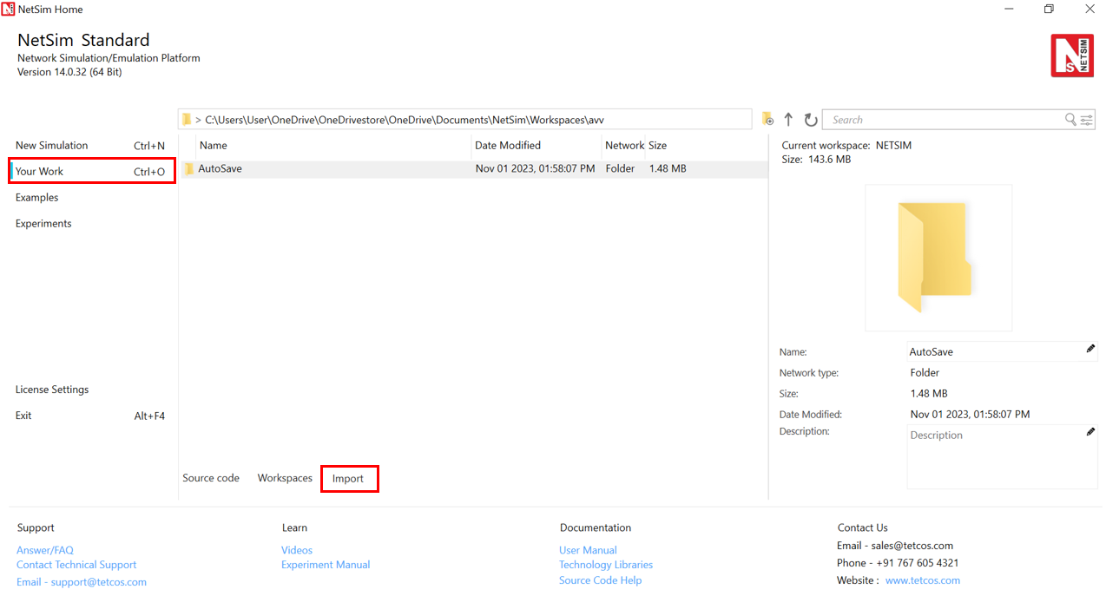

Figure 2‑2: NetSim Home page

1. In the Import Workspace Window, browse and select downloaded. netsimexp file from the extracted directory. Click on create a new workspace option and browse to select a path in your system where you want to set up the workspace folder.
2. Choose a suitable name for the workspace of your choice. Click Import.



Figure 2‑3: NetSim Import workspace window

1. The Imported Project workspace will automatically be set as the current workspace.
2. The list of experiments is now loaded onto the selected workspace.

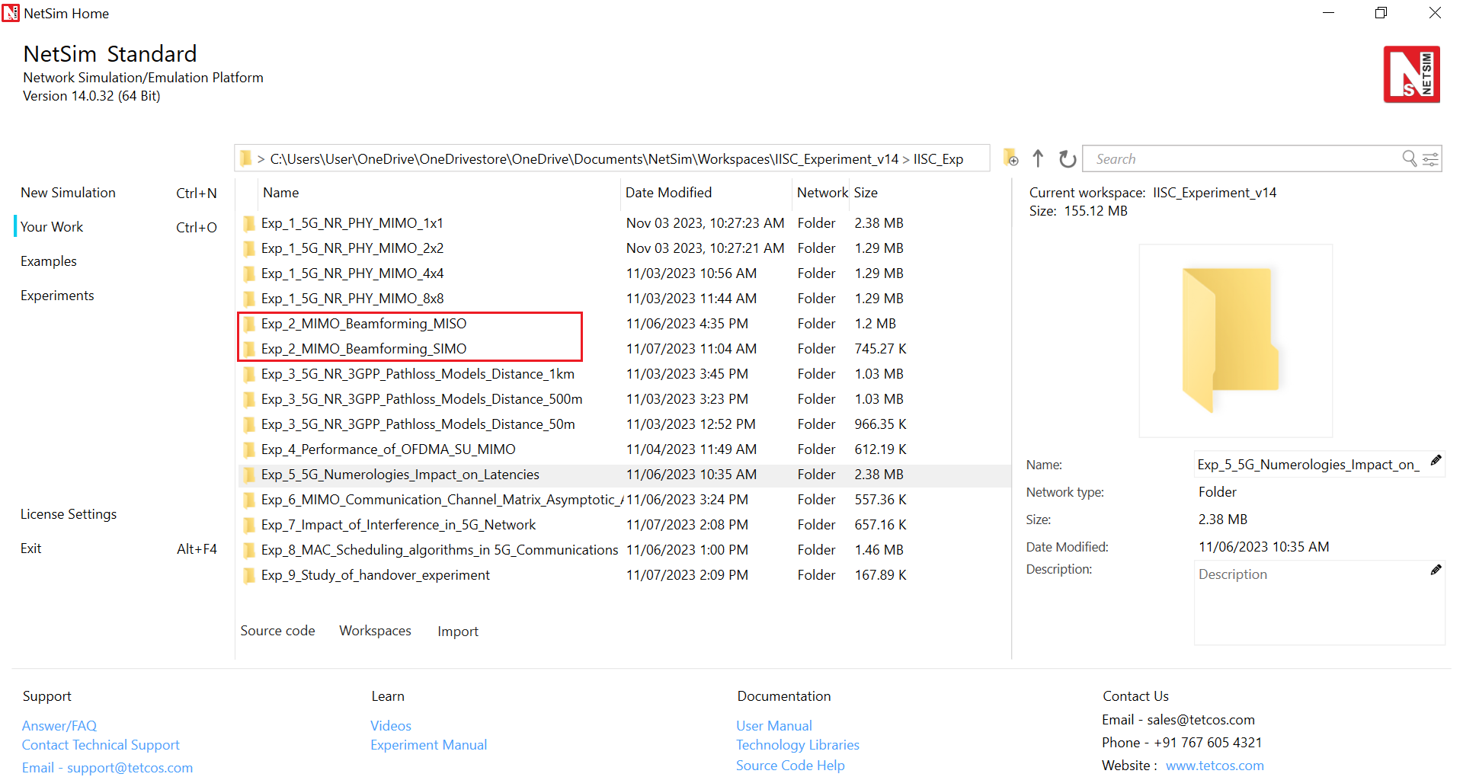

Figure 2‑4: NetSim Your Work Window with the experiment folders inside the workspace

## Network Setup

NetSim UI would display the network topology shown in the screenshot below when you open the example configuration file.

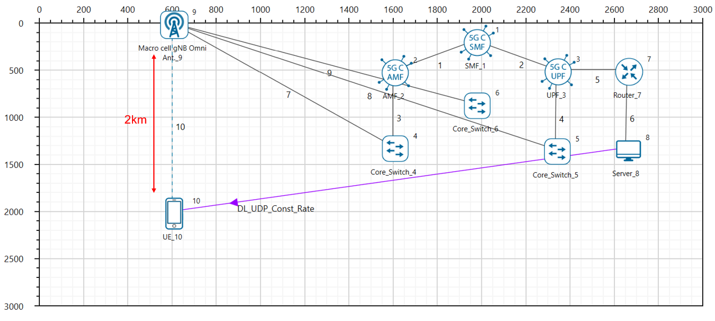

Figure 2‑5: Network topology in this experiment

### Part 1- MISO

**Network Configuration**

1. The gNB- Interface 5G_RAN were set with the following properties

|  |  |
| --- | --- |
| gNB Height | 10m |
| Tx Power | 40 dBm |
| Duplex Mode | TDD |
| CA Type | SINGLE BAND |
| CA Configuration | n78 |
| DL: UL Ratio | 4:1 |
| Numerology | 0 |
| Channel Bandwidth (MHz) | 10 |
| Tx Antenna Count | Varied from 1 to 128 |
| Rx Antenna Count | 1 |
| MCS Table | QAM64 |
| CQI Table | TABLE1 |
| Pathloss Model | 3GPPTR38.901-7.4.1 |
| Outdoor Scenario | Urban Macro |
| LOS NLOS Selection | User Defined |
| LOS Probability | 0 (NLOS) |
| Shadow Fading Model | None |
| Fading and Beam Forming | RAYLEIGH with EIGEN Beamforming |
| Coherence Time (ms) | 10 |
| Additional Loss Model | None |

Figure 2‑6: gNB properties

1. The UE properties were configured with the following parameters:

|  |  |  |
| --- | --- | --- |
| UE Interface 5G RAN | | |
| Tx Power | 23 dBm |
| UE Height | 1.5m |
| Tx Antenna Count | 1 |
| Rx Antenna Count | 1 |

Figure 2‑7: UE properties

1. The wired link speed was set to 10 Gbps and the Uplink and Downlink BER were set to 0 in the wired links.
2. A downlink CBR application was configured from wired node to UE with Transport protocol as UDP and Packet Size of 1460 Bytes and Inter Arrival time of 179.69 µs and the Start Time was set to 1s[5].
3. Click on the log icon in toolbar to enable LTENR Radio measurement as shown below.

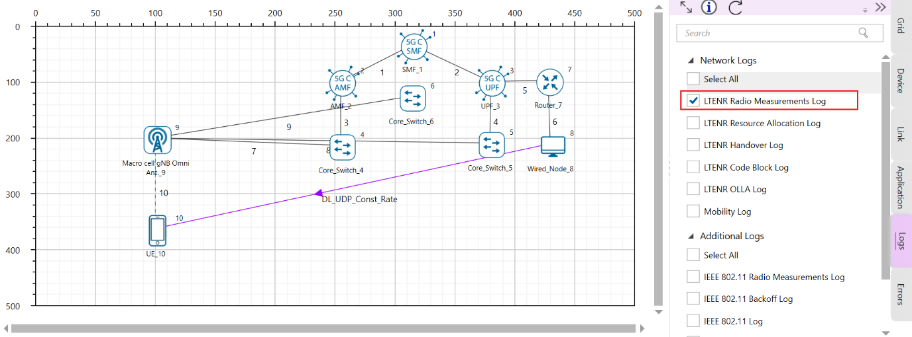

Figure 2‑8: Enabling the LTENR Radio measurement log

Run simulation for 10s, note down the Application Throughput obtained from the Application Metrics table in the NetSim Results dashboard. Similarly, note down the average Beamforming Gain in dB obtained for the DL application from the log file generated.

### Part 2- SIMO

**Network Configuration**

1. Set all the properties same as part 1- MISO.
2. Set the Tx Antenna count in 5G RAN interface of gNB to 1.
3. Vary the Rx Antenna count in 5G RAN interface of UE from 1 to 16.
4. Run simulation for 10s.

After the simulation, note down the Application Throughput obtained from the Application Metrics table in the NetSim Results dashboard. Similarly, note down the average Beamforming Gain in dB obtained for the DL application from the log file generated.

## Simulation Output

Steps to calculate the Throughput, Beamforming Gain, SNR, Pathloss and CQI Index:

1. After the simulation, open NetSim Result dashboard and note down the throughput from the Application Metrics Table as shown below.

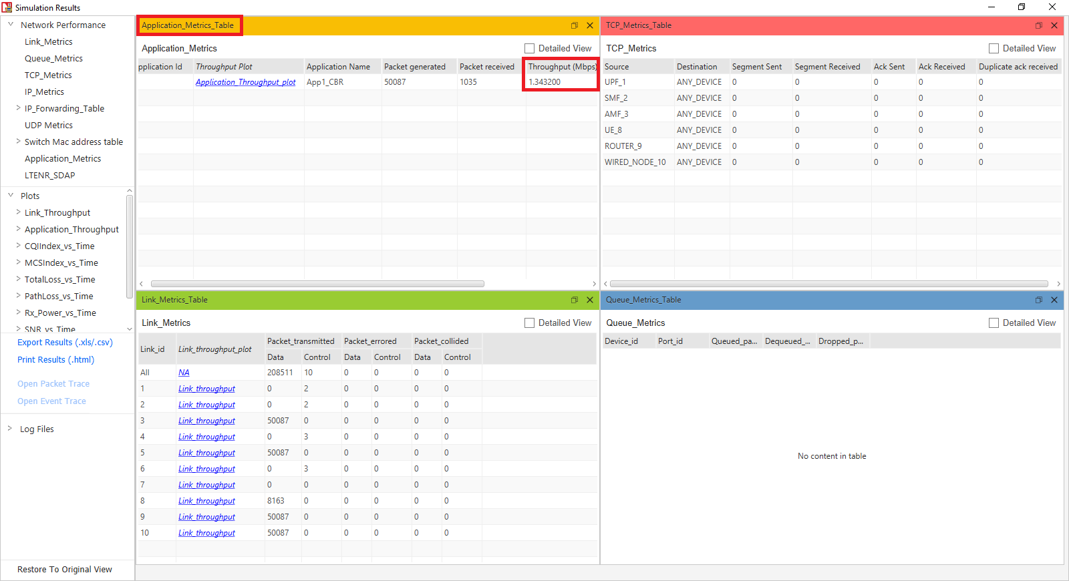

Figure 2‑9: NetSim Results window showing Application Throughput obtained after the simulation.

1. In the results window, expand the Log Files option in the left panel and select LTENR_Radio_Measurements_Log.csv file.

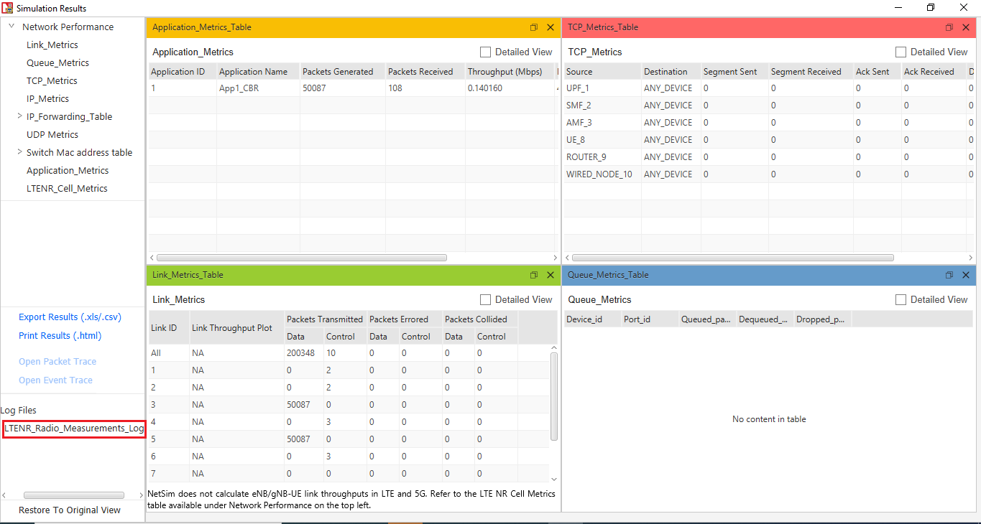

Figure 2‑10: NetSim Results window showing access to log file generated.

1. This will open the csv file which logs the parameters beamforming gain, CQI and MCS Indices, Pathloss etc. over time as shown below.

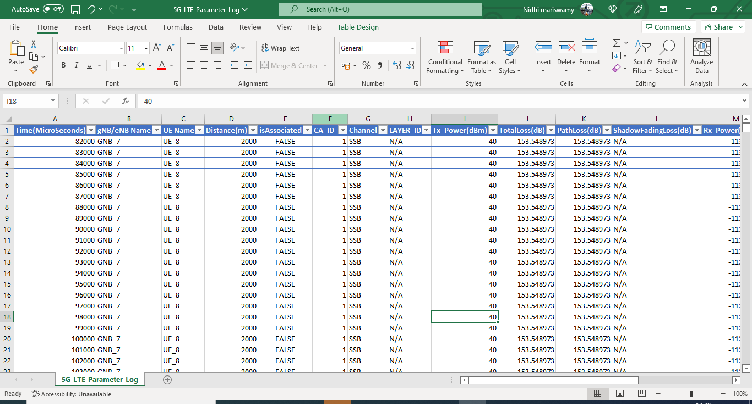

Figure 2‑11: LTENR Radio measurement log file created after simulation.

1. Filter the Channel to only PDSCH and click on ok since we have considered a DL application from server to UE.

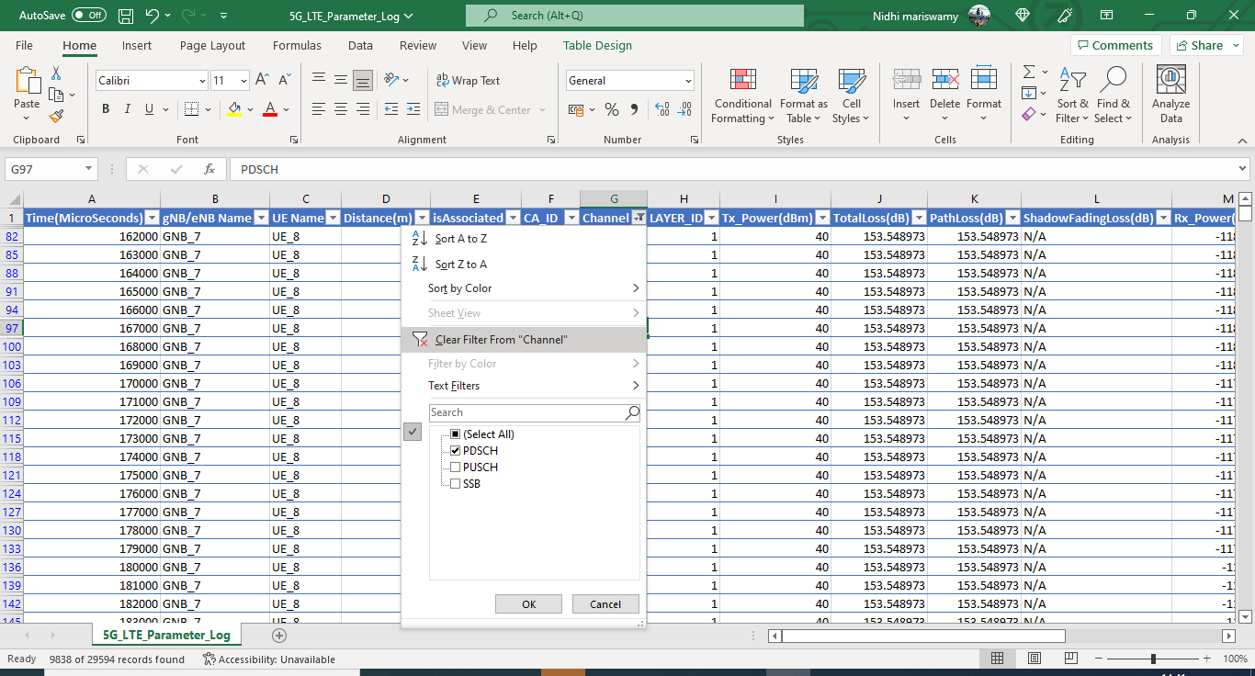

Figure 2‑12: LTENR Radio measurement log file showing the filtering process of PDSCH/PUSCH column.

1. Now select the Beamforming Gain column and note down the average Beamforming Gain in dB per layer.

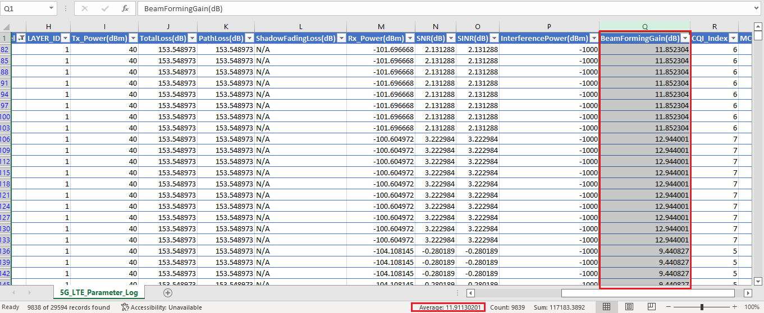

Figure 2‑13: LTENR Radio measurement log file showing average Beamforming Gain obtained.

1. Select the Pathloss column and note down the average pathloss value obtained.

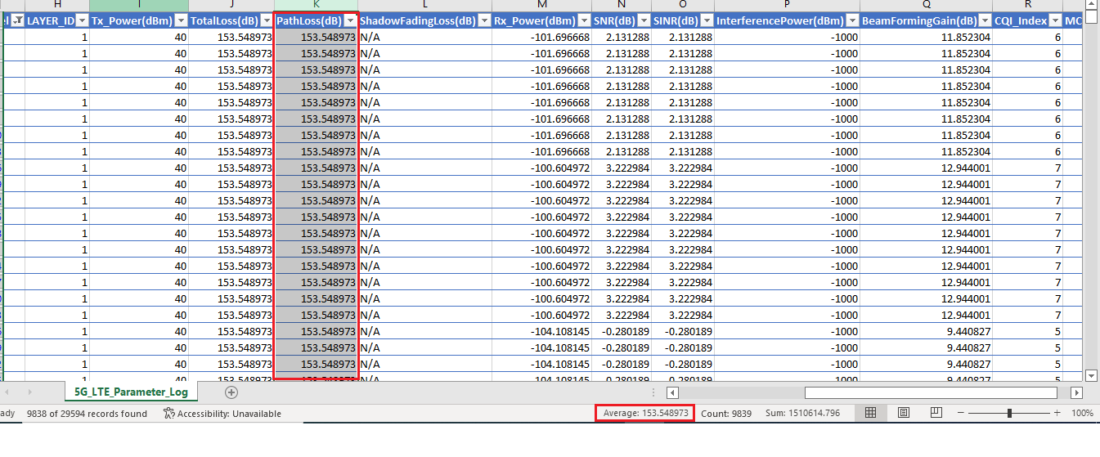

Figure 2‑14: LTENR Radio measurement log file showing average Pathloss obtained.

1. In the same way, select the SNR column and note down the average SNR obtained.

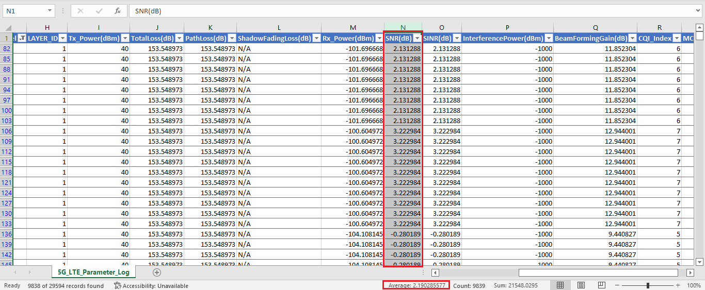

Figure 2‑15: LTENR Radio measurement log file showing average SNR obtained.

1. Similarly, calculate the average CQI Index and MCS Index.

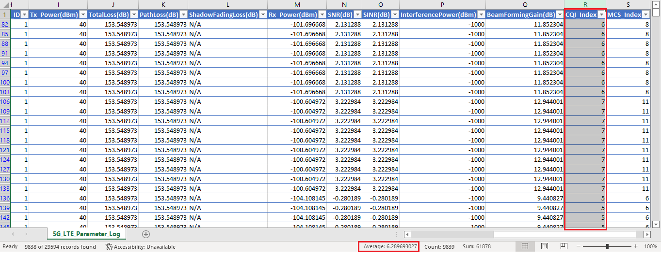

Figure 2‑16: LTENR Radio measurement log file showing average CQI Index obtained.

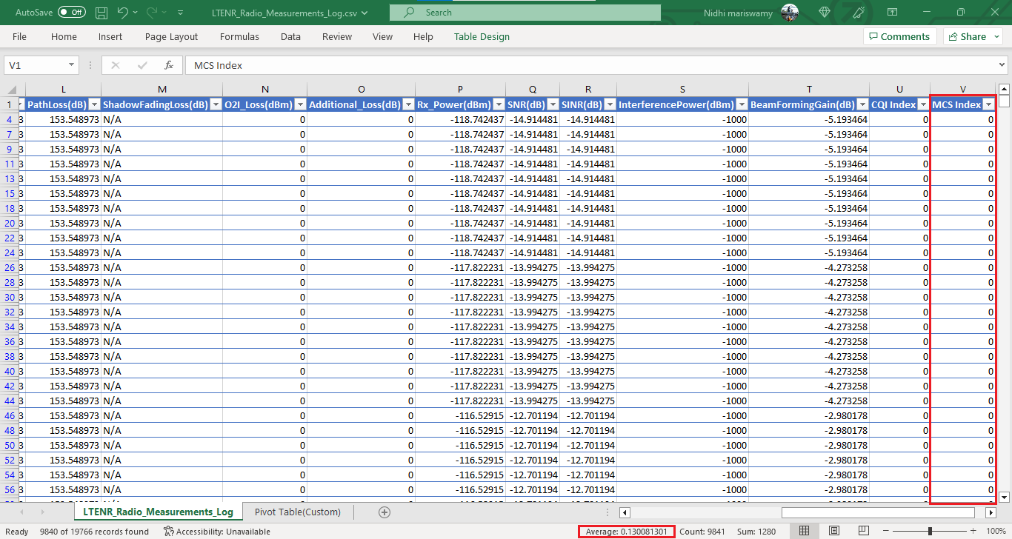

Figure 2‑17: LTENR Radio measurement log file showing average MCS Index obtained

## Results and Discussion

**MISO: Varying Tx Antenna count in the gNB and 1 Rx Antenna in the UE**

|  |  |  |  |  |  |  |  |  |
| --- | --- | --- | --- | --- | --- | --- | --- | --- |
| gNB_Tx Antenna Count | UE_Rx Antenna Count | Throughput (Mbps) | Average Beam Forming Gain (dB). Number of layers = 1 | Upper bound for beam forming gain (dB) | Pathloss (dB) | Average SNR (dB) | Average  CQI  Index | Average MCS  Index |
| 1 | 1 | 0.14 | -2.27 | 0 | 153.54 | -12.00 | 0.63 | 0.13 |
| 2 | 1 | 0.66 | 1.70 | 3.01 | 153.54 | -8.01 | 1.49 | 0.61 |
| 4 | 1 | 1.82 | 5.41 | 6.02 | 153.54 | -4.30 | 2.89 | 2.02 |
| 8 | 1 | 3.60 | 8.66 | 9.03 | 153.54 | -1.06 | 4.40 | 4.82 |
| 16 | 1 | 6.41 | 11.91 | 12.04 | 153.54 | 2.19 | 6.28 | 9.00 |
| 32 | 1 | 10.01 | 14.98 | 15.05 | 153.54 | 5.26 | 7.94 | 12.89 |
| 64 | 1 | 14.49 | 18.04 | 18.06 | 153.54 | 8.32 | 9.95 | 17.84 |
| 128 | 1 | 18.92 | 21.05 | 21.07 | 153.54 | 11.33 | 11.39 | 20.78 |

Table 2‑1: NetSim simulation output showing Throughput, Average beamforming gain and the upper bound (from Jensen’s inequality) on the beamforming gain for a $N_{t}×1$ channel.

**SIMO: Varying Rx Antenna count in the UE and 1 Tx Antenna in the gNB**

|  |  |  |  |  |  |  |  |  |
| --- | --- | --- | --- | --- | --- | --- | --- | --- |
| gNB_Tx Antenna Count | UE_Rx Antenna Count | Throughput (Mbps) | Average Beam Forming Gain (dB). | Upper bound for beam forming gain (dB) | Pathloss (dB) | Average SNR (dB) | Average  CQI Index | Average MCS Index |
| 1 | 1 | 0.14 | -2.27 | 0 | 153.54 | -12.00 | 0.63 | 0.13 |
| 1 | 2 | 0.66 | 1.70 | 3.01 | 153.54 | -8.01 | 1.49 | 0.61 |
| 1 | 4 | 1.82 | 5.41 | 6.02 | 153.54 | -4.30 | 2.89 | 2.02 |
| 1 | 8 | 3.60 | 8.66 | 9.03 | 153.54 | -1.06 | 4.40 | 4.82 |
| 1 | 16 | 6.41 | 11.91 | 12.04 | 153.54 | 2.19 | 6.28 | 9.00 |

Table 2‑2: NetSim simulation output showing Throughput, Average beamforming gain and the upper bound (from Jensen’s inequality) on the beamforming gain for a $1×N_{r}$ MIMO channel. $N_{r}$ is limited to 16 since this is the maximum antenna count supported in UEs in NetSim.

**Discussion**

From the tabulated results, we observe:

* An increase in beamforming gains as
* $N_{t}$ increases in the MISO case, and as
* $N_{r}$ increases in the SIMO case.
* The beamforming gain when $N_{t}$ varies (with $N_{r}$ fixed) is precisely the same as when $N_{r}$ varies (with $N_{t}$ fixed).

Next, we turn to the question a network engineer would be interested in: how does beamforming impact throughput? While link level simulators may perform the beamforming computations and provide the SNR at a link level, the power of a “system” level simulator like NetSim lies in its ability to compute the impact of link level factors (such as beamforming) on the system (or network). These computations are explained in an earlier experiment.

Since the distance between the gNB and UE is fixed, the common pathloss for all Tx-Rx antenna pairs is the same. This common pathloss value is factored (or “pulled out”) from the individual $N_{t}$- $N_{r}$ path loss calculations. With this factorization done, the only parameter affecting SNR is the *channel fading*, the effect of which shows up in the output as *beamforming gain*. Quite simply as the (average) beamforming gain increases, the (average) SNR proportionally increases. Notice that every time the *antenna count is doubled* the *SNR increases by $≈$ 3 dB* (which matches intuition). An increase in SNR improves the channel quality (the CQI), and thereby a higher modulation and coding scheme (MCS) is chosen for data transmission.

*Remark*. Note that these are “average” arguments: in practice, since the fading coefficients are random, one does not obtain a 3 dB improvement by doubling the number of antennas for every channel instantiation. Consequently, the improvement in the spectral efficiency (the reader should study and understand this terminology) is not exactly 1 bit/s/Hz on average. In other words, there is a difference between using the average SNR for computing the data rate versus computing the average data rate by averaging the rate obtained across different channel instantiations. The reader should carry out experiments with different values of $N_{t}$ and observe the variation in the rate obtained and understand this phenomenon.

Continuing from before the remark, from the MCS the PHY rate is calculated via the procedure for TBS determination per the 3GPP standard. Without getting into the details of these computations, the simplistic inference is that higher MCS leads to higher throughputs.

And finally, the underlying mathematics. The beamforming gains (in linear scale) are the Eigen values of the Wishart) matrix. In the MISO and SIMO cases the Wishart matrix has just one element, which itself is the eigenvalue, i.e., the beamforming gain is

$$μ= E\left(λ\right)=\sum_{i=1}^{N}{{\left|h_{i}\right|}^{2}}$$

Where $h_{i}$ are the elements of the Wishart matrix, and $N=N_{t}$ or $N=N_{r},$ as the case may be. Since $E{\left|h_{i}\right|}^{2}=1,$

$$μ≔E\left(λ\right)=\left\{\begin{aligned}N_{t} for a N_{t}×1 MIMO system \\ N_{r} for a 1×N_{r}MIMO system\end{aligned}\right.$$

Since the standard deviation of an exponentially distributed random variable is the square of its mean, and since the $\left|h_{i}\right| 1≤i≤N,$ are independent,

$$VAR (λ)= \left\{\begin{aligned}N_{t} for a N_{t}×1 MIMO system \\ N_{r} for a 1×N_{r} MIMO system\end{aligned}\right.$$

However, the beamforming gains output by NetSim are in dB (log) scale. How does one analytically verify its correctness? The answer lies in Jensen’s inequality. Since the log function is concave, Jensen’s inequality leads to

$$E\log_{10}\left(λ\right)≤\log_{10}\left(E(λ)\right)$$

Here $λ$ is the eigen value of the Wishart matrix, and $10\log_{10}{λ}$ is the beamforming gain in dB scale. Therefore, the beamforming gains (in the dB domain) are bounded as

$$BFGain \left(dB\right)≤10\log_{10}\left(E\left(λ\right)\right)$$

$$E\left(λ\right)= N$$

$$BFGain \left(dB\right)≤10\log_{10}{N}$$

In this experiment (and in NetSim), the number of antennas, N, is of the form $2^{p}$,where $p=0, 1, 2…$ and therefore the upper bound on the beam forming gain is

$$BFGain \left(dB\right)≤10×p\log_{10}{2}≤3.01×p$$

### Beamforming Gain Plot

To generate the beamforming gain plot, Open the Radio measurements log file, create a pivot table for this log file by clicking the pivot option present at the top of the ribbon under insert section a shown below.

|  |  |
| --- | --- |
| Table  Description automatically generated  Figure 2‑18: Inserting pivot table | Graphical user interface, application  Description automatically generated  Figure 2‑19: Creating pivot table. |

In the pivot table drop gNB/eNB Name, UE Name, Channel and IsAssociated field under filters area, drop Time(milliseconds) in Row area and drop Beamforming gain in Value area. set Beamforming gain values to average by clicking arrow icon present end of the field ->value filed setting->average as shown below.

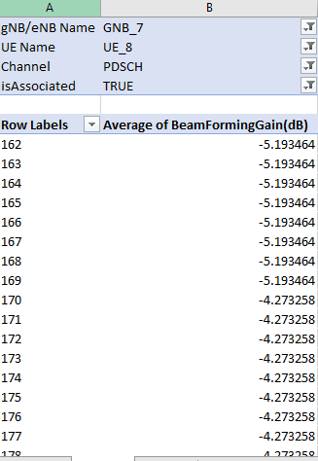

Figure 2‑20: Average beamforming gain for SIMO

Copy the values of Row Labels and Average of BeamFormingGain(dB) header and paste it into another sheet and generate plot.

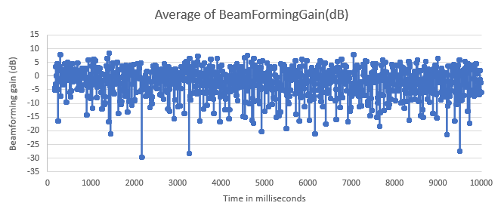

Figure 2‑21: NetSim simulation output showing variation in beamforming gain (dB) over the course of simulation. The beamforming gain changes every “coherence time”.

## Exercises

1. Quantify the improvement in data rate as a function of $N_{t}$ (MISO) and $N_{r}$ (SIMO) in
   1. Low SNR case (SNR << 1), and
   2. High SNR case (SNR >> 1).
2. (For the Instructor or TA) Assign a set of *personalized* questions that will require each student to run the simulator and generate the results needed to write their reports. For example, different distances between the gNB and UE (which will vary the path loss), different Tx powers, different ranges for $N_{t}$ and $N_{r}$, etc.

# Understanding 5G NR (3GPP) pathloss models

## Objective

In the elementary case of 1gNB communicating with 1UE over a 5G NR network, in a rural setting, we study the question: How does the UE-gNB pathloss vary with the distance between the UE and the gNB and the gNB height? What is the optimal height of a gNB?

## Introduction

We start with a non-technical explanation of the objective. A mobile phone (in the hands of an individual) is the UE; the cell tower is the gNB. Assume the person is in a rural area and is outdoors. Pathloss would determine the signal strength displayed on the phone; a higher loss means a lower signal strength. Mobile network operators (think of the top service providers in our country) invest large sums in setting-up the towers. They wish to know the tower height[6] that gives users the highest signal strength. The answer is not obvious: the more the height of the gNB, the more likely it is that there exists a line-of-sight path to a given UE, but the signal has to traverse a longer distance, incurring a higher path loss. The cell radius might also play a role here: perhaps a lower height is better for smaller sized cells, and a greater height is better for large cells. In this experiment, we will understand these trade-offs.

## 5G pathloss equations

To answer these questions, we look at the 5G pathloss equations for a rural scenario as defined in the 3GPP 38.901 standards:

|  |  |  |  |  |  |
| --- | --- | --- | --- | --- | --- |
| Scenario | | LOS/ NLOS State | Pathloss (dB) $(f_{c}$ in GHz and d in meters) | Shadow Fading ( $σ)$ | Parameter values and ranges |
| Rural Macro | LOS | | $$P{L_{RMA}}_{LOS}=\left\{\begin{aligned}PL_{1}, 10m≤d_{2D}≤d_{BP} \\ PL_{2}, d_{BP}≤d_{2D}≤10Km\end{aligned}\right.$$ $PL_{1}=20\log_{10}\left(40πd_{3D}f_{c}/3\right)+\min\left(0.03h^{1.72},10\right)\log_{10}\left(d_{3D}\right)-\min\left(0.044h^{1.72}, 14.77\right)+ 0.002\log_{10}\left(h\right)d_{3D}$ $$PL_{2}=PL_{1}\left(d_{BP}\right)+40\log_{10}{(\frac{d_{3D}}{d_{BP}})}$$ | $$σ_{SF}=4$$ $$σ_{SF}=6$$ | $$h_{BS}=35m$$ $$h_{UT}=1.5m$$ $$W=20m$$ $$h=5m$$ $$5m≤h≤50m$$ $$5m≤W≤50m$$ $${10m≤h}_{BS}≤150m$$ $$1m≤h_{UT}≤10m$$ |
| NLOS | | $$P{L_{RMa}}_{NLOS}=max⁡(P{L_{RMa}}_{LOS} , P{L_{RMa}}_{NLOS}^{'})$$ For |  |
| NOTE:   1. Break point distance[7] , where fc is the centre frequency in Hz, $c=3.0*10^{8} m/s$  is the propagation velocity in free space, and hBS and hUT are the antenna heights at the BS and the UT, respectively.   1. fc denotes the centre frequency normalized by 1 GHz, all distance related values are normalized by 1 m, unless stated otherwise. | | | | | |

Table ‑**:** Pathloss equations for Rural Macro environment for LOS and NLOS states

|  |  |
| --- | --- |
|  |  |
| Figure 3‑1: Definition of d2D and d3D  for outdoor UEs | Figure 3‑2: Definition of d2D-out, d2D-in  and d3D-out, d3D-in for indoor UEs |

Note that,

$${d_{3D}}_{out}+{d_{3D}}_{in}= \sqrt{{\left(d_{2D_{out}}+{d_{2D}}_{in}\right)}^{2}+{\left(h_{BS}-h_{UT}\right)}^{2} }$$

Observing the above equations, we see that the pathloss is not a simple expression in terms of gNB height. The other parameters affecting the pathloss are a) the UE-gNB 2D distance and b) the UE state[8].

Consequently, we investigate the revised question: how does the UE-gNB pathloss vary for combinations of gNB height, UE-gNB 2D distance, and UE states (LOS/NLOS)?

## Procedure

1. Use the following download Link to download a compressed zip folder which contains the workspace [GitHub link](https://github.com/NetSim-TETCOS/5G_Advanced_Experiments_v14.0/archive/refs/heads/main.zip)
2. Extract the zip folder.
3. The extracted project folder consists of a NetSim workspace file 5G_advanced_experiments_with_NetSim.netsimexp.
4. Go to NetSim Home window, go to Your Work and click on Import.



Figure 3‑1: NetSim Home Window

1. In the Import Workspace Window, browse and select the 5G_advanced_experiments_with_NetSim.netsimexp file from the extracted directory. Click on create a new workspace option and browse to select a path in your system where you want to set up the workspace folder.
2. Choose a suitable name for the workspace of your choice. Click Import.



Figure 3‑2: NetSim Import workspace window.

1. The Imported Project workspace will automatically be set as the current workspace.
2. The list of experiments is now loaded onto the selected workspace.

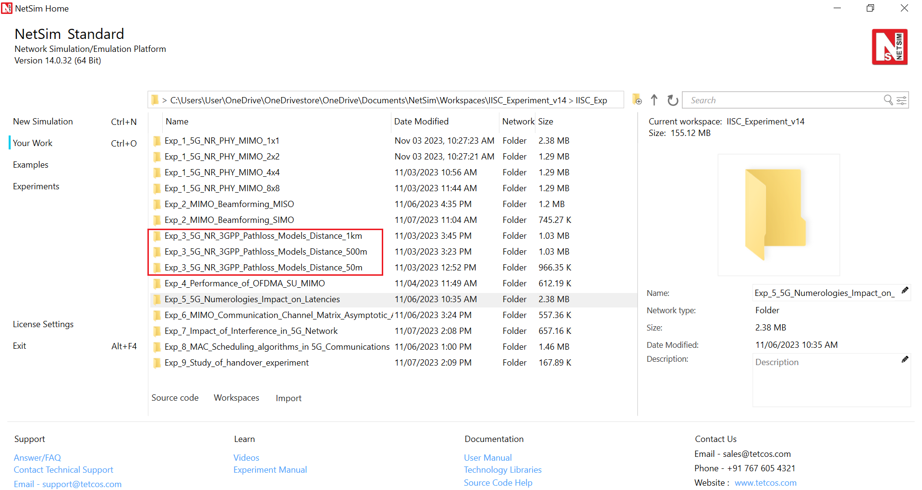

Figure 3‑3: NetSim Your Work Window with the experiment folders inside the workspace

## Network Setup

### Case 01: 5G NR 3GPP Pathloss Models Distance 50m

NetSim UI would display the following network topology when you open the example configuration file as shown below screenshot.

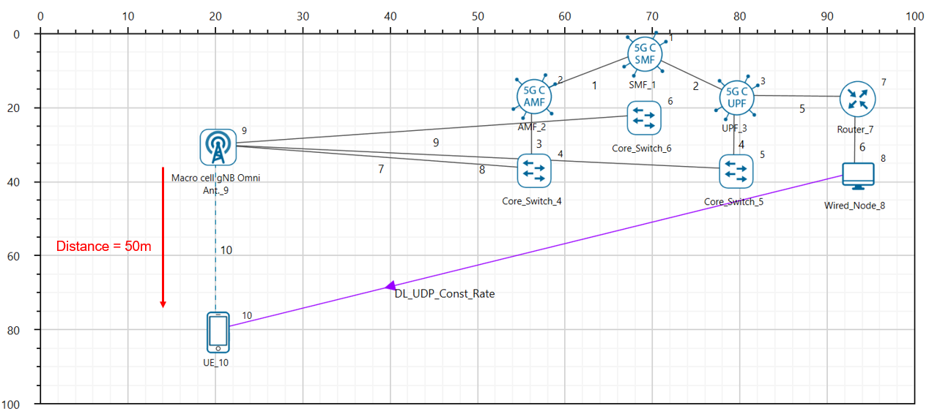

Figure 3‑4: Network topology in this experiment

The following settings were configured in the network setup.

1. The UE was placed 50m away from the gNB.
2. The following properties were set in Interface 5G RAN, Physical Layer of gNB.

|  |  |
| --- | --- |
| gNB Interface 5G RAN | |
| gNB Height (m) | Varied from 10 to 150 |
| Tx Power (dBm) | 40 |
| Tx Antenna Count | 2 |
| Rx Antenna Count | 2 |
| CA Type | Single Band |
| CA Configuration | n78 |
| DL: UL Ratio | 4:1 |
| Numerology | 0 |
| Channel Bandwidth (MHz) | 10 |
| MCS Table | QAM64 |
| CQI Table | TABLE1 |
| Outdoor Scenario | Rural Macro |
| Indoor Office Type | Mixed Office |
| Pathloss Model | 3GPPTR38.901-7.4.1 |
| LOS Mode | User Defined |
| LOS Probability | 0 or 1 (Varied) |
| Shadow Fading Model | None |
| Fading and Beamforming | No Fading MIMO Unit Gain |

Table ‑**:** gNB properties

1. Tx Antenna Count = Rx Antenna Count = 2 in UE > Interface 5G RAN > Physical Layer
2. A downlink CBR application was configured from Wired Node to UE with Packet Size 1460B and IAT 1168µs and the start time was set to 1s.
3. Run simulation for 2s.
4. In case 2, set the LOS probability to 0 and run simulation for various gNB heights.
5. In case 3, place the UE 1000m away from the gNB and repeat the above procedure.
6. In case 4, set the LOS probability to 0 and run simulation for 2s.
7. Click on the log tab in the right, enable LTENR Radio measurement as shown below.

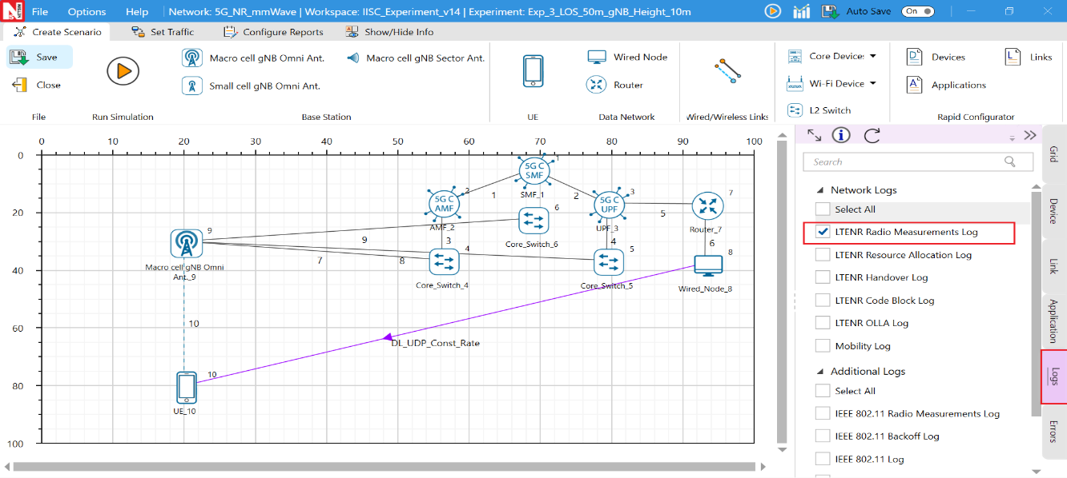

Figure 3‑5: Enabling the LTENR Radio measurement log*.*

1. After the simulation, note down the Pathloss from the log file generated for various gNB heights.

### Case 02: 5G NR 3GPP Pathloss Models Distance 500m

1. The grid setting is 1000m x1000m.
2. Distance between gNB and UE is 500m.

### Case 03: 5G NR 3GPP Pathloss Models Distance 1000m

1. The grid setting is 2000m x2000m.
2. Distance between gNB and UE is 1000m.

## Results and Discussion

1. After simulation, open LTENR Radio measurement Log file from NetSim Result dashboard.

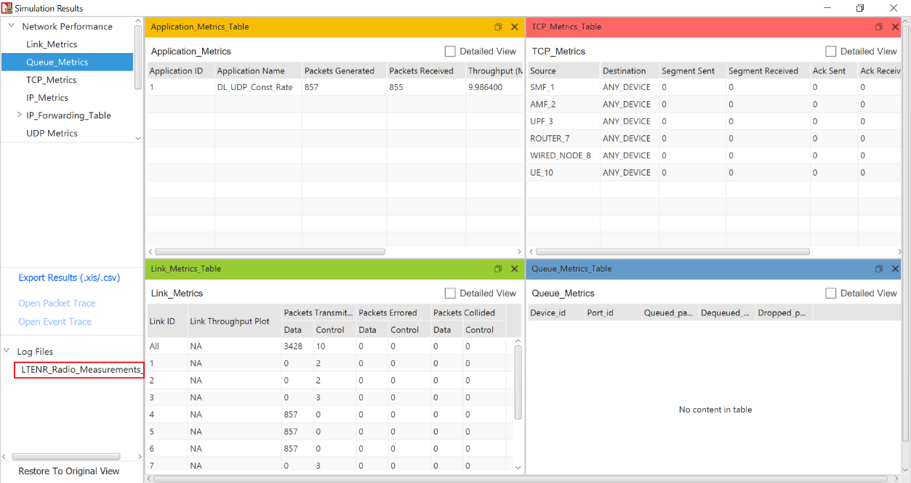

Figure 3‑6: NetSim Results window

1. Note down the Pathloss value by filtering the channel to PDSCH, for each gNB height setting.

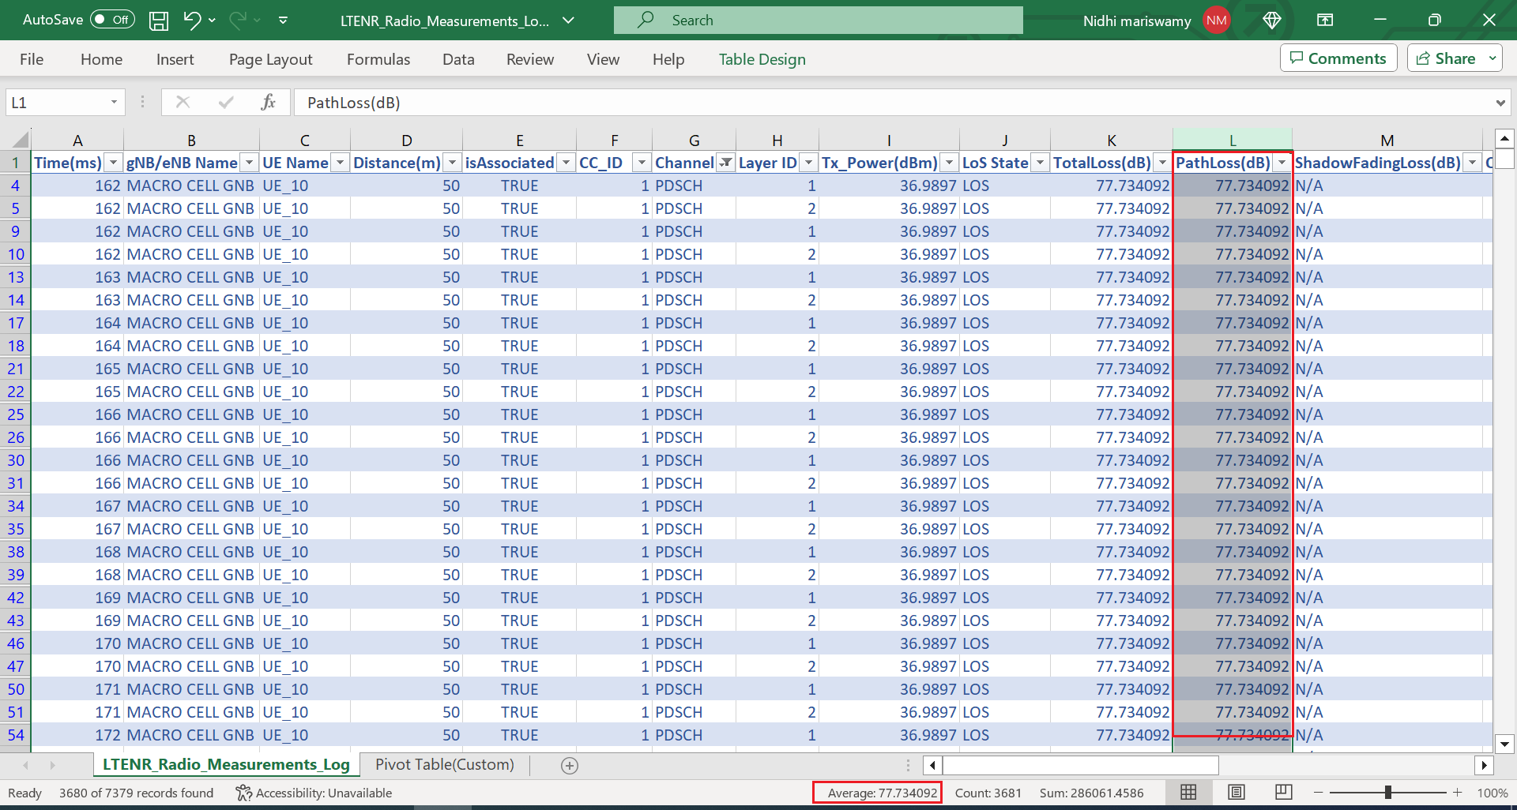

Figure 3‑7: NetSim LTENR Radio measurement Log file

Upon running simulations, we can obtain the following table below which contains pathloss values for:

* gNB height varying from 10m to 150m in steps of 20m.
* UE placed at 50m, 500m and 1000m away from gNB, and
* UE states: LOS, NLOS

|  |  |  |  |  |  |  |  |
| --- | --- | --- | --- | --- | --- | --- | --- |
| gNB Height(m) | | Pathloss (dB) | | | | | |
|  | **UE 50m, LOS** | | **UE 50m, NLOS** | **UE 500m, LOS** | **UE 500m, NLOS** | **UE 1 km, LOS** | **UE 1km, NLOS** |
| 10 | 77.73 | | 92.39 | 98.71 | 132.47 | 105.57 | 144.60 |
| 30 | 78.86 | | 84.04 | 98.72 | 120.53 | 105.58 | 132.21 |
| 50 | 80.58 | | 82.56 | 98.75 | 115.30 | 105.58 | 126.72 |
| 70 | 82.35 | | 82.72 | 98.80 | 111.92 | 105.60 | 123.15 |
| 90 | 83.98 | | 83.98 | 98.86 | 109.45 | 105.61 | 120.51 |
| 110 | 85.44 | | 85.44 | 98.93 | 107.52 | 105.63 | 118.41 |
| 130 | 86.75 | | 86.75 | 99.02 | 105.95 | 105.66 | 116.67 |
| 150 | 87.91 | | 87.91 | 99.11 | 104.66 | 105.68 | 115.20 |

Table ‑: Pathloss values for various combinations. The gNB heights are shown in Column 1. Other columns show the gNB-UE 2D distance (50m, 500m and 1Km) and the UE state (LOS/NLOS)

### Discussion

We explain the results in the plots above from the specifics of the pathloss formulas.

* In the LOS plots, the pathloss is flat for different gNB heights when the gNB-UE distance is high, i.e 500m and 1 km. When the gNB-UE distance is low i.e 50m, the pathloss increases with gNB height.
* Observe from the LOS pathloss formula that pathloss is proportional to $\log{(D_{3d})}$. $D_{3d}$ of the 3D distance between the UE and the gNB and is defined as $d_{3D}=\sqrt{{\left(d_{2D}\right)}^{2}+{\left(h_{BS}-h_{UT}\right)}^{2}}$. It is the hypotenuse of the right triangle with the base being the gNB-UE 2D distance.
  + Since the length of the hypotenuse is sensitive to the height of the triangle, when the base is small, we see the pathloss increasing with gNB height when the UE is 50m away.
  + Inversely, the length of the hypotenuse is almost insensitive to the triangle height when the base is much larger than the height. Therefore, when the UE is far, the gNB’s height does not have a noticeable impact. Pathloss is flat when the UE is 500m and 1 km away.
* Let us turn to the NLOS results.
  + The NLOS pathloss decreases with gNB height when the gNB-UE distance is high i.e 500m and 1000m.
  + When the UE is near, i.e 50m, the NLOS pathloss first decreases and then increases with gNB height.
  + The reason for this kind of variation is the NLOS pathloss formulas in which that pathloss has terms proportional to:
    - $\log\left(h_{BS}\right)$, ${\log{(\left(h_{BS}\right)}}^{2})$
 $\log{(d_{3d})}$

   - The reciprocal of ${\left(h_{BS}\right)}^{2}$
* We see that at larger distances LOS pathloss is almost flat and NLOS pathloss decreases, as gNB height increases. From the plots one sees that the optimal gNB height would be between 125m to 150m in the example discussed above.

## Numerical verification of two cases:

In this section we numerically calculate the pathloss per the 5G pathloss formula for two cases to verify NetSim’s output.

|  |  |  |  |
| --- | --- | --- | --- |
| Symbol | | Description | Value |
|  |  | |  |
|  |  | |  |
|  |  | |  |
|  |  | |  |
|  |  | |  |
|  |  | |  |
|  |  | |  |

Table ‑: Various parameters used in the pathloss calculations and their values

**Case 1: gNB height = 10m, UE State is LOS and UE-gNB 2D Distance = 50m**

Breakpoint Distance:

$f_{c}=\frac{F_{Low}+F_{High}}{2}$ $=\frac{3300+3800}{2}=3550 MHz=3550*{10}^{6}Hz$

$$d_{Bp}=2* π*h_{BS}*h_{UT}*(f_{c}* 1000000000) / c)$$

$$d_{BP}=2*3.14*10*1.5*\left(\frac{3.55*1000000000}{3*{10}^{8}}\right)=1114.7m$$

Pathloss Calculation

$d_{2D}=50m$, $d_{3D}=\sqrt{{\left(d_{2D}\right)}^{2}+{\left(H_{BS}-H_{UT}\right)}^{2}}$ $= \sqrt{{\left(50\right)}^{2}+{\left(10-1.5\right)}^{2}}=50.71m$

If $(10≤d_{2D}≤d_{BP})$

$$PL1 = (20 * log10(40 * PI * distance3D * fc_{(GHz)} / 3)) + fmin((0.03 * pow(h, 1.72)), 10) * log10(distance3D) - fmin((0.044 * pow(h, 1.72)), 14.77) + (0.002 * log10(h) * distance3D)$$

$$=\left(20*log_{10}\left(40*3.14*50.71*\frac{3.55}{3}\right)\right)+f_{min}\left(\left(0.03*pow\left(5,1.72\right)\right),10\right)*log_{10}\left(50.71\right)-f_{min}\left(\left(0.044*pow\left(5,1.72\right)\right),14.77\right)+\left(0.002*log_{10}\left(5\right)*50.71\right)=77.73 dB$$

Pathloss = 77.73 dB (matches NetSim result)

**Case 2: gNB height = 10m, UE State is NLOS and UE-gNB 2D Distance = 50m**

Breakpoint Distance:

$f_{c}=\frac{F_{Low}+F_{High}}{2}$ $=\frac{3300+3800}{2}=3550 MHz=3550*{10}^{6}Hz$

$$d_{Bp}=2* π*h_{BS}*h_{UT}*(f_{c}* 1000000000) / c)$$

$$d_{BP}=2*3.14*10*1.5*\left(\frac{3.55*1000000000}{3*{10}^{8}}\right)=1114.7m$$

Pathloss Calculation

$$d_{2D}=50m$$

$d_{3D}=\sqrt{{\left(d_{2D}\right)}^{2}+{\left(H_{BS}-H_{UT}\right)}^{2}}$ $= \sqrt{{\left(50\right)}^{2}+{\left(10-1.5\right)}^{2}}=50.71m$

If $(10≤d_{2D}≤5Km)$

$$PL_{NLOS} = max⁡(PL_{LOS}, PL_{NLOS}^{'})$$

Where,

$$PL_{NLOS}^{'}=161.04-7.1{* log}_{10}\left(W\right)+7.5*\log_{10}\left(h\right)-\left(24.37-3.7*{\left(\frac{h}{h_{BS}}\right)}^{2}\right)*\log_{10}\left(h_{BS}\right)+(43.42-(3.1*\log_{10}{(h_{BS}))*(\log_{10}\left(d_{3D}\right)-3)+20*(\log_{10}{(f_{c}))-(3.2*(\log_{10}{{\left(11.75*h_{UT})\right)}^{2}}} -4.97)}$$

$$=161.04-(7.1*\log_{10}{(20))+7.5*(\log_{10}\left(5\right))-(24.37-3.7*{\left(\frac{5}{10}\right)}^{2})*(\log_{10}{(10))}+(43.42-(3.1*\log_{10}{(10))*(\log_{10}\left(50.71\right)-3)+20*(\log_{10}{(3.55))-(3.2*(\log_{10}{{\left(11.75*1.5)\right)}^{2}-4.97)=92.39 dB }}}}$$

$$PL_{LOS} = (20 * log10(40 * PI * distance3D * fc_{(GHz)} / 3)) + fmin((0.03 * pow(h, 1.72)), 10) * log10(distance3D) - fmin((0.044 * pow(h, 1.72)), 14.77) + (0.002 * log10(h) * distance3D)$$

$=\left(20*log_{10}\left(40*3.14*50.71*\frac{3.55}{3}\right)\right)+f_{min}\left(\left(0.03*pow\left(5,1.72\right)\right),10\right)*log_{10}\left(50.71\right)-f_{min}\left(\left(0.044*pow\left(5,1.72\right)\right),14.77\right)+\left(0.002*log_{10}\left(5\right)*50.71\right)=77.73 dB$ $$PL_{NLOS} = max⁡(PL_{LOS}, PL_{NLOS}^{'}) =max⁡(77.73,92.39)$$

Pathloss = 92.39 dB (matches NetSim result)

Figure 3‑8: Plots of Pathloss vs. gNB height for different UE-gNB 2D Distances and UE States (LOS, NLOS)

## Exercises

1. Make a separate plot with the UE distance on the X-axis and show the behavior for three different values of the gNB height. Recommend the gNB height for different cell radii. Does your recommendation make practical sense?
2. Use MATLAB or Python to plot similar curves from the standard pathloss formulas. Compare your results against the NetSim results.
3. (For the Instructor or TA) Generate *personalized* exercises where the student can be asked to
   1. Recommend the gNB height given the cell radius
   2. Recommend gNB height given the transmit power.
   3. Find the cell radius given the gNB height, transmit power and noise figure.

# Performance of OFDMA SU-MIMO in 5G

The 5G cellular system utilizes OFDMA MIMO technology at the physical layer. This technology permits degrees of freedom in frequency, time, and “space” for multiplexing the data of multiple users. Let us consider the down-link direction, i.e., from the base-station (gNB) to the users (UE). The system bandwidth (e.g., 100 MHz), has several OFDM carriers, separated by a carrier spacing (e.g., 60 KHz, yielding 132 physical resource blocks (PRBs) or carriers). Each PRB has 12 consecutive sub carriers. These carriers (set of usable PRBs) have time-division framing (e.g., 0.25 ms), each frame carrying 14 symbols of which 18% on average is modeled as overheads in NetSim. When the above system is used to carry data to multiple users, it is called OFDMA. In addition, MIMO technology exploits spatial multiplexing, thereby effectively carrying multiple (spatially multiplexed) symbols for each time-symbol in the OFDM carrier. In MIMO all the spatially multiplexed symbols for an OFDM symbol can be destined to one user, in which case it is called Single User MIMO, or SU-MIMO.

In this experiment we study the performance of OFDMA along with SU-MIMO to carry downlink data to multiple UEs. Since we have SU-MIMO, multiple users are multiplexed by OFDMA, and SU-MIMO is used to obtain spatial multiplexing gain, depending on the number of antennas available at the UE. In Multi User MIMO (MU-MIMO) different spatial layers within the same resource block, can be allotted to different UEs.

## Objective

Simulate a maximum data transmission rate[9], using OFDMA and SU-MIMO, for the following 4 cases.

* 1 gNB with 8 Tx antennas transmitting to 1 UE with 8 Rx antennas using all the 132 resource blocks
* 1 gNB with 8 Tx antennas transmitting to 2 UEs each with 4 Rx antennas, each using $\frac{132}{2}$ resource blocks on average
* 1 gNB with 8 Tx antennas transmitting to 4 UEs each with 2 Rx antennas, each using $\frac{132}{4}$ resource blocks on average,
* 1 gNB with 8 Tx antennas transmitting to 8 UEs each with 1 Rx antennas, each using $\frac{132}{8}$ resource blocks on average

Repeat the above cases with the number of UEs now set to 1 for each case, while the antenna counts remain the same. Show that there is no difference in maximum capacity between a single user and a multi-user transmission, when using SU-MIMO. And finally, explain the results obtained for different number of receive antennas by using matrix theory to compute the eigen values of the associated Gram matrices.

## Introduction

We begin with a description of the channel model. Consider a transmitter with $N_{t}$ transmit antennas, and a receiver with $N_{r}$ receive antennas. The channel can be represented by the $N_{r}×N_{t}$ matrix $H$ of channel gains $h_{ij}$ representing the gain from transmit antenna $j$ to receive antenna $i.$ The $N_{r} × 1$ received signal $y$ is equal to

$$y = Hx + n$$

The channel state information is the channel matrix $H$ and/or its distribution.

Under rich scattering conditions the MIMO channel can be decomposed into parallel non-interfering channels. The number of such parallel streams is known as the layer count and is equal to $Min(N_{t}, N_{r})$. These parallel channels are commonly referred to as the *eigenmodes* of the channel because the singular values of $H$ are equal to the square root of the eigenvalues of the Wishart matrix $W=H H^{†}$ (for $N_{t}≥N_{r}$).

Since each layer is reduced to a flat fading SISO channel, i.e., for layer $j, 1≤j≤LayerCount$,

$$y_{j}=\sqrt{λ_{j}} x_{j}+w_{j}$$

where, $x_{j}$ is the symbol transmitted, $λ_{j}$ is the corresponding eigenvalue of the Wishart matrix obtained as in the previous section, $w_{j}$ is circular symmetric complex Gaussian noise, and $y_{j}$ is the complex valued baseband received symbol.

If fast fading with eigen-beamforming is enabled in NetSim’s GUI, then the MIMO link is modelled by parallel SISO channels with the symbol level beamforming gain derived from the eigenvalues[10] of the Wishart matrix.

$$BeamFormingGain (dB)=10\log_{10}{(λ)}$$

Three assumptions made in NetSim are:

1. Perfect CSIT and CSIR: The channel matrix $H$ is assumed to be known perfectly, at the start of each frame, at the transmitter and receiver, respectively. With perfect CSIT the transmitter can adapt its transmission rate (MCS) relative to the instantaneous channel state (SNR).
2. No channel errors.
3. The transmit power is equally split between all layers transmitted. The justification lies in the fact that at a high SNR, (iterative) water-filling will lead to nearly equal power allocation across all subcarriers and all layers.

Note that the *LOS probability* parameter in NetSim is solely used to compute the large scale pathloss per the 3GPP 38.901 standard. This parameter is not used in the channel rank (MIMO layers) computations. The *Fading and Beam Forming* parameter is used to determine (i) the number of MIMO layers and (ii) the gains in each layer, as shown in the table below.

|  |  |  |
| --- | --- | --- |
| Parameter drop down option | No. of MIMO layers | Beamforming Gain |
| No fading MIMO unit gain | Min ${(N}_{t}, N_{r})$ | Unity (0 dB) |
| No fading MIMO array gain | Min ${(N}_{t}, N_{r})$ | Max ${(N}_{t}, N_{r})$ |
| Rayleigh with Eigen Beamforming | Min ${(N}_{t}, N_{r})$ | Eigen values of the Wishart Matrix |

Table 4‑1: Fading and Beam Forming parameter.

## Procedure

1. Use the following download Link to download a compressed zip folder which contains the workspace: [GitHub link](https://github.com/NetSim-TETCOS/5G_Advanced_Experiments_v14.0/archive/refs/heads/main.zip)
2. Extract the zip folder.
3. The extracted project folder consists of a NetSim workspace 5G_advanced_experiments_with_NetSim.netsimexp
4. Go to NetSim Home window, go to Your Work and click on Import.



Table 4‑2: NetSim Home Window

1. In the Import Workspace Window, browse and select 5G_advanced_experiments_with_NetSim.netsimexp file from the extracted directory. Click on create a new workspace option and browse to select a path in your system where you want to set up the workspace folder.
2. Choose a suitable name for the workspace of your choice. Click Import.



Table 4‑3: NetSim Import workspace window.

1. The Imported Project workspace will automatically be set as the current workspace.
2. The list of experiments is now loaded onto the selected workspace.

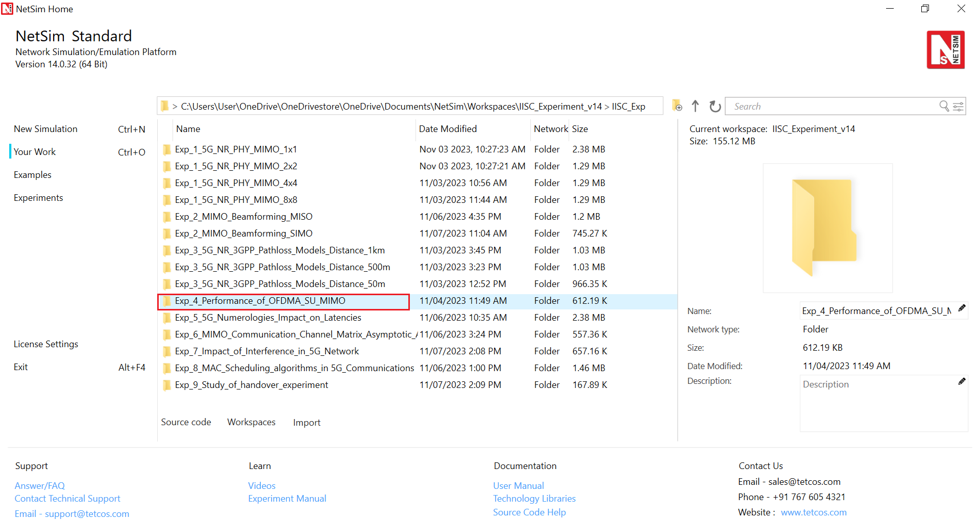

Table 4‑4: NetSim Your Work Window with the experiment folders inside the workspace

## Network Setup

1. The following parameters were configured in Interface 5G RAN- Physical Layer of gNB and UE:

|  |  |
| --- | --- |
| gNB- Interface 5G_RAN Parameters | |
| gNB Height | 10m |
| Tx Power | 40 dBm |
| Duplex Mode | TDD |
| CA Type | SINGLE BAND |
| CA Configuration | n78 |
| DL: UL Ratio | 4:1 |
| Numerology | 2 |
| Channel Bandwidth (MHz) | 100 |
| Tx Antenna Count | 8 |
| Rx Antenna Count | 1 |
| MCS Table | QAM256 |
| CQI Table | TABLE2 |
| Pathloss Model | 3GPPTR38.901-7.4.1 |
| Outdoor Scenario | Urban Macro |
| LOS NLOS Selection | User Defined |
| LOS Probability | 1 |
| Shadow Fading Model | None |
| Fading and Beam Forming | RAYLEIGH with EIGEN Beamforming |
| Coherence Time (ms) | 10 |
| Additional Loss Model | None |
| UE Interface 5G RAN | |
| Tx Power | 23 dBm |
| UE Height | 1.5m |
| Tx Antenna Count | 1 |
| Rx Antenna Count | <varied> |

Table ‑: gNB and UE properties

1. The following parameters were configured in the wired link properties.

|  |  |
| --- | --- |
| Wired Link Parameters | |
| Wired Link Speed | 10 Gbps |
| Wired Link BER | 0 |
| Wired Link Propagation Delay | 5 µs |

Table ‑: Wired link properties

1. Run simulation for 1.1s.

**Case 1: 1 gNB - 8 Tx antennas, 1 UE - 8 Rx antennas**

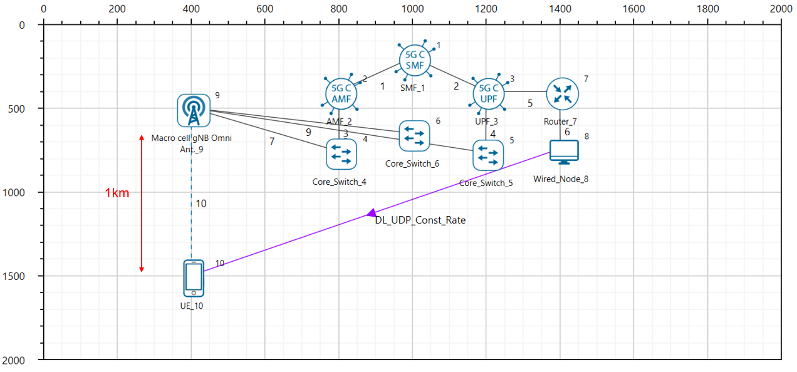

Figure 4‑1: Network topology in this experiment

**Additional Settings**

1. The Tx Antenna Count was set to 1 and Rx Antenna Count was set to 8 in Interface 5G RAN- Physical Layer in the UE
2. The following parameters were set in Application Properties:

|  |  |
| --- | --- |
| Application Parameters | |
| Application | CBR |
| Packet Size | 1460 |
| Inter Packet Arrival Time (µs) | 3.33 |
| Start Time | 1 |
| Transport Protocol | UDP |

Table ‑: Application properties

**Result**

|  |  |
| --- | --- |
| Application | Throughput (Mbps) |
| App_1_CBR | 1909.09 |

Table ‑: Throughput obtained per UE

**Case 2: 1 gNB- 8 Tx antennas, 2 UEs with 4 Rx antennas each**

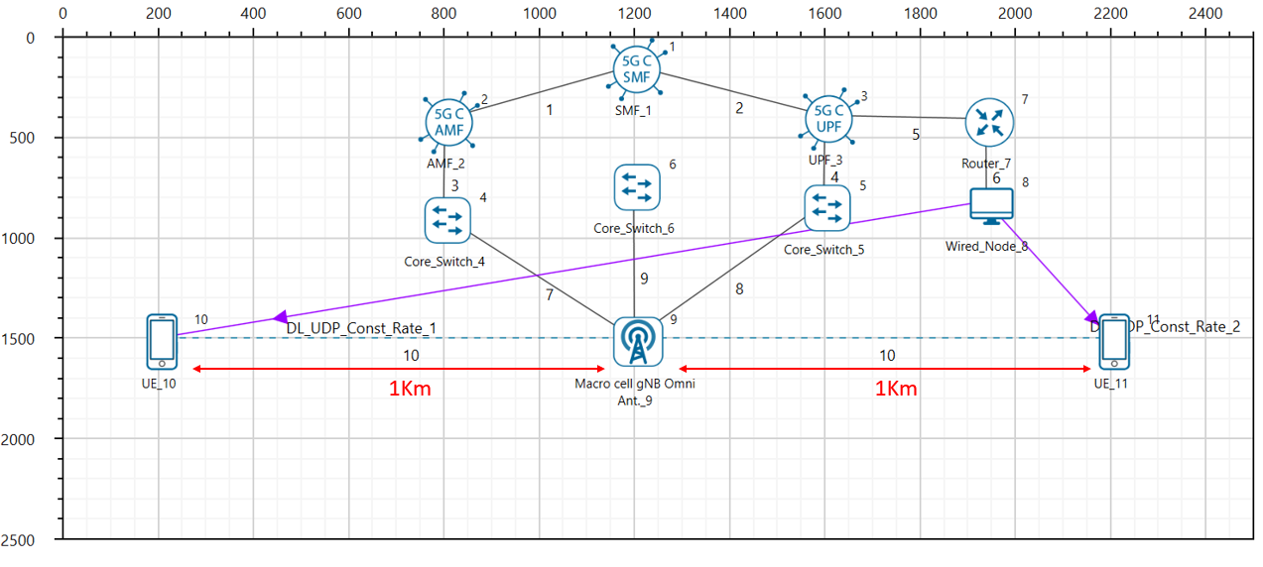

Figure 4‑2: Network topology in this experiment

**Additional Settings**

1. The Tx Antenna Count was set to 1 and Rx Antenna Count was set to 4 in Interface 5G RAN- Physical Layer in both the UEs.
2. The following parameters were set in Application Properties:

|  |  |  |
| --- | --- | --- |
| Application Parameters | | |
|  | **Wired Node- UE_8** | **Wired Node- UE_9** |
| Application | CBR | CBR |
| Packet Size | 1460 | 1460 |
| Inter Packet Arrival Time (µs) | 12.97 | 12.97 |
| Start Time | 1 | 1 |
| Transport Protocol | UDP | UDP |

Table ‑: Application properties

**Result**

|  |  |  |
| --- | --- | --- |
| Throughput Obtained (Mbps) | |  |
| UE_10 | **UE_11** | **Aggregate Throughput (Mbps)** |
| 666.92 | 673.35 | 1340.28 |

Table ‑: Throughput obtained per UE.

**Case 3: 1 gNB 8- Tx antennas, 4 UEs with 2 Rx antennas each**

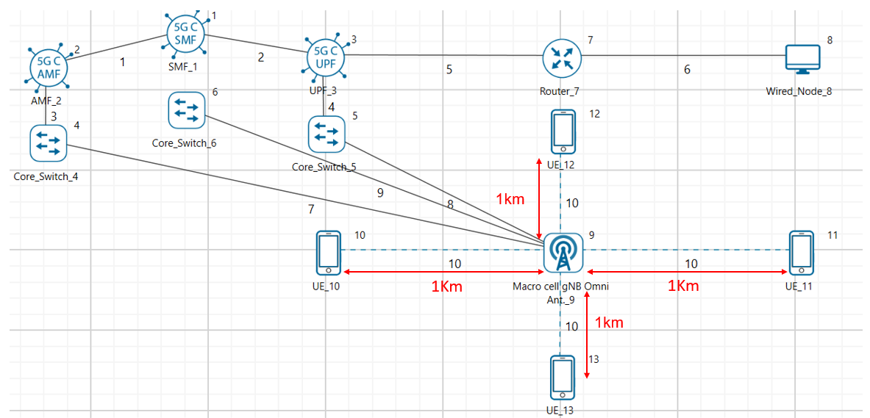

Figure 4‑3: Network topology in this experiment

**Additional Settings**

1. The Tx Antenna Count was set to 1 and Rx Antenna Count was set to 2 in Interface 5G RAN- Physical Layer in all the UEs.
2. The following parameters were set in Application Properties:

|  |  |  |  |  |
| --- | --- | --- | --- | --- |
| Application Parameters | | | | |
|  | **Wired Node- UE_8** | **Wired Node- UE_9** | **Wired Node- UE_10** | **Wired Node- UE_11** |
| Application | CBR | CBR | CBR | CBR |
| Packet Size | 1460 | 1460 | 1460 | 1460 |
| Inter Packet Arrival Time (µs) | 53.09 | 53.09 | 53.09 | 53.09 |
| Start Time | 1 | 1 | 1 | 1 |
| Transport Protocol | UDP | UDP | UDP | UDP |

Table ‑: Application properties

**Result**

|  |  |  |  |  |
| --- | --- | --- | --- | --- |
| Throughput (Mbps) | | | |  |
| UE_10 | UE_11 | UE_12 | UE_13 | Aggregate  Throughput (Mbps) |
| 187.81 | 196.10 | 190.26 | 197.27 | 771.464 |

Table ‑: Throughputs obtained per UE

**Case 4: 1 gNB 8 tx antennas, 8 UEs with 1 Rx antennas each**

**Network Scenario:**

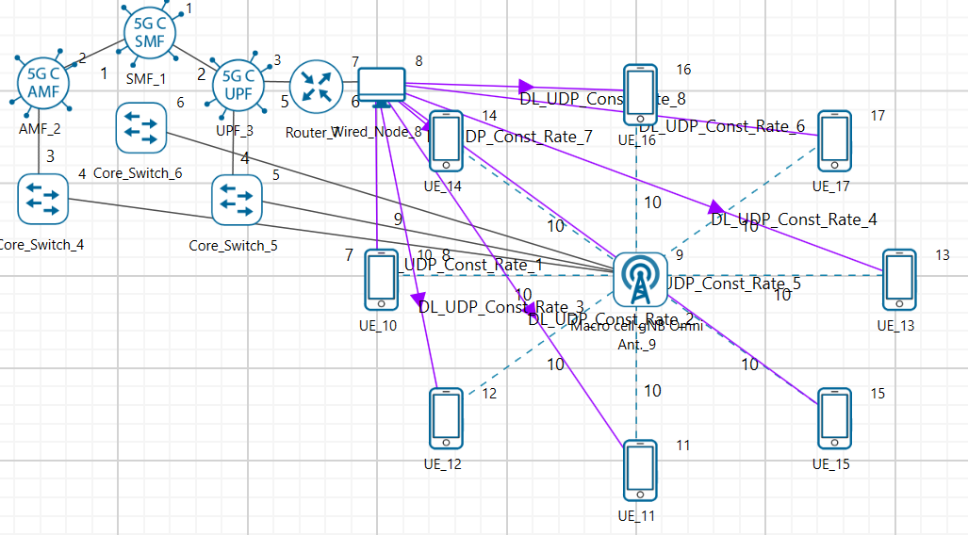

Figure 4‑4: Network topology in this experiment

**Additional Settings**

1. The Tx Antenna Count was set to 1 and Rx Antenna Count was set to 1 in Interface 5G RAN- Physical Layer in all the UEs.
2. The following parameters were set in Application Properties:

|  |  |  |  |  |  |  |  |  |
| --- | --- | --- | --- | --- | --- | --- | --- | --- |
| Application Parameters | | | | | | | | |
|  | **Wired Node- UE_8** | **Wired Node- UE_9** | **Wired Node- UE_10** | **Wired Node- UE_11** | **Wired Node- UE_12** | **Wired Node- UE_13** | **Wired Node- UE_14** | **Wired Node- UE_15** |
| Application | **CBR** | **CBR** | **CBR** | **CBR** | **CBR** | **CBR** | **CBR** | **CBR** |
| Packet Size | 1460 | 1460 | 1460 | 1460 | 1460 | 1460 | 1460 | 1460 |
| Inter Arrival Time (µs) | 212.36 | 212.36 | 212.36 | 212.36 | 212.36 | 212.36 | 212.36 | 212.36 |
| Start Time | 1 | 1 | 1 | 1 | 1 | 1 | 1 | 1 |
| Transport Protocol | UDP | UDP | UDP | UDP | UDP | UDP | UDP | UDP |

Table ‑: Application properties

**Results**

|  |  |  |  |  |  |  |  |  |
| --- | --- | --- | --- | --- | --- | --- | --- | --- |
| Throughput Obtained (Mbps) | | | | | | | |  |
| UE_10 | **UE_11** | **UE_12** | **UE_13** | **UE_14** | **UE_15** | **UE_16** | **UE_17** | **Aggregate Throughput (Mbps)** |
| 51.04 | 51.74 | 51.50 | 51.62 | 51.39 | 51.39 | 51.74 | 51.15 | 411.60 |

Table ‑: Throughputs obtained per UE

## Discussion

We combine the results of the four cases and present it in the table below.

|  |  |  |  |  |  |  |  |  |  |
| --- | --- | --- | --- | --- | --- | --- | --- | --- | --- |
| Rx Antenna Count per UE | Throughput (Mbps) | | | | | | | | Aggregate Throughput (Mbps) |
| **UE_1** | **UE_2** | **UE_3** | **UE_4** | **UE_5** | **UE_6** | **UE_7** | **UE_8** |
| 8 | 1909.09 | - | - | - | - | - | - | - | 1909.09 |
| 4 | 666.92 | 673.35 | - | - | - | - | - | - | 1340.28 |
| 2 | 187.81 | 196.10 | 190.26 | 197.27 | - | - | - | - | 771.464 |
| 1 | 51.04 | 51.74 | 51.50 | 51.62 | 51.39 | 51.39 | 51.74 | 51.15 | 411.60 |

Table ‑: Throughput comparison table for different Rx Antenna Counts

We compare the aggregate throughputs (from Table 4‑15) with single UE peak throughputs.

|  |  |  |
| --- | --- | --- |
| UE Rx Antenna Count per UE | Aggregate Throughput (Mbps) | Single UE Peak Throughput (Mbps) |
| 8 | 1909.09 (1 UE 8 Rx Antennas) | 1909.09 (1 UE 8 Rx Antennas) |
| 4 | 1340.28 (2 UEs with 4 Rx Antennas) | 1330.46 (1 UE 4 Rx Antennas) |
| 2 | 771.464 (4 UEs with 2 Rx Antennas) | 754.52 (1 UE 2 Rx Antennas) |
| 1 | 411.72 (8 UEs with 1 Rx Antennas) | 414.75 (1 UE 1 Rx Antennas) |

Table 4‑16: Throughputs obtained for different Rx Antenna counts in multi and single UE cases.

From Table 4‑16 it becomes clear that the bandwidth is shared across the UEs by OFDMA. It is just like having one UE use the entire bandwidth.

**Theoretical analysis**

**8*8 SU-MIMO**

* $2^{k}$ carriers in the OFDMA system
* $S:$ symbol rate per carrier (assuming the same numerology for all carriers)
* $L:$ is the large-scale pathloss, including shadowing (not including the fading). Note that, $L$ is modelled as $c{\left(\frac{d}{d_{0}}\right)}^{-η}$ where $η$ is the pathloss coefficient.

Then the expected rate to the single SU-MIMO user is given by

$$E\left(R_{1}\right)=2^{k}×S×E\left(\sum_{j=1}^{8}{log}\left(1+\frac{P_{j}×L×λ_{j}}{ σ^{2}}\right)\right)$$

where $P_{j}$ is the power allotted to the $j^{th}$ equivalent channel, with $\sum_{j=1}^{8}{P_{j}=P, }$ the total transmit power. We assume equal power allocation, so that $P_{j}=\frac{P}{8},$ so that

$$E\left(R_{1}\right)=2^{k}×S×E\left(\sum_{j=1}^{8}{log}\left(1+\frac{P×L×λ_{j}}{ {8σ}^{2}}\right)\right)$$

**8*1 SU-MIMO, with 8 such UEs**

* $2^{k-3}$ OFDMA carriers per UE

Then, for the same OFDMA symbol rate, $S,$ and large-scale pathloss, $L,$ the total expected rate for the 8 UEs is given by

$$E\left(R_{2}\right)=2^{k-3}×S×\left(\sum_{j=1}^{8}{E log}\left(1+\frac{P×L×‖h_{j}^{2}‖}{ σ^{2}}\right)\right)=2^{k}×S×E\log\left(1+\frac{P×L}{σ^{2}}×\left\|h_{1}^{2}\right\|\right)$$

From matrix theory we know that the sum of the eigenvalues of a matrix is equal to its trace. Therefore

$$\sum_{i=1}^{8}{λ_{i}=\left\|h_{1}^{2}\right\|+ \left\|h_{2}^{2}\right\|…+ \left\|h_{8}^{2}\right\|}$$

We know that when $a, λ_{1}, λ_{2}>0$

$$1+a\left(λ_{1}+λ_{2}\right)≤\left(1+aλ_{1}\right)\left(1+aλ_{2}\right)$$

and by monotonicity of log function, it follows that

$$\log\left(1+a\left(λ_{1}+λ_{2}\right)\right)≤\log\left(1+aλ_{1}\right)+\log\left(1+aλ_{2}\right)$$

Extending this inequality recursively, we get

$$\log\left(1+a\left(λ_{1}+λ_{2}…λ_{8}\right)\right)≤\log\left(1+aλ_{1}\right)+\log\left(1+aλ_{2}\right)…+log⁡(1+aλ_{8})$$

Using the above expressions, we can compare the expected total downlink throughputs for one 8x8 SU-MIMO UE, with eight 8x1 SU-MIMO UEs, as follows:

$${ER_{1}= 2}^{k}×S×E\left(\sum_{j=1}^{8}{log}\left(1+\frac{P×L×λ_{j}}{ {8σ}^{2}}\right)\right)≥ 2^{k}×S×E{log\left(1+\frac{P×L}{8σ^{2}}×\sum_{j=1}^{8}{λ_{j} }\right)}$$

$$=2^{k}×S×E log⁡( 1+ \frac{P×L}{{8σ}^{2}}× \sum_{j=1}^{8}{‖h_{j}^{2}‖) }$$

$$≥2^{k}×S×\sum_{j=1}^{8}{\frac{1}{8}}E\log\left(1+\frac{P×L}{σ^{2}}×\left\|h_{j}^{2}\right\|\right)$$

$$=2^{k}×S×E\log\left(1+\frac{P×L}{σ^{2}}×\left\|h_{1}^{2}\right\|\right)=E R_{2}$$

where the first inequality arises from the argument given earlier, and the second equality follows from the equality between the trace of a matrix and the sum of its eigenvalues. Physically, the first inequality captures the performance gain obtained by splitting the power over the different spatial degrees of freedom. The second inequality follows from the fact the fact that the logarithm function is concave and by an application of Jensen’s inequality. We see from Table 4‑15 that $ER_{1}=1942.26 Mbps,$ whereas $ER_{2}=418.46 Mbps$, showing the large effect of the two inequalities in the above argument.

## Exercises

1. Carefully explain your observations. Also, place the UEs at different distances from the gNB and see how the throughput changes. Again, explain your observations.
2. Vary the height of UEs (as this also effects pathloss) and see how the throughput changes. Again, explain your observations.

# 5G Numerologies and their impact on end-to-end latencies

## Objective

5G NR supports flexible numerology with a range of subcarrier spacings, based on scaling a baseline subcarrier spacing of 15 kHz to support diverse spectrum bands/types and deployment models. The numerology, $μ$, can take values from 0 to 4 and specifies the Sub-Carrier Spacing (SCS) as $15×2^{µ}$ kHz and a slot length of $\frac{1}{2^{µ}}$ ms. With $μ$ varying from 0 to 4, Sub- Carrier Spacing (SCS) varies from 15 to 240 kHz.

We investigate the impact of numerology on latency and throughput in two cases.

* A simple case where one UE is transmitting and receiving UDP traffic from a server
* A complex 5G scenario with Sensors, Cameras, Laptops and Smartphones having DL and UL, TCP and UDP flows[11].

## Introduction

In NetSim, for data channels FR1 supports $μ=0, 1, 2$ and FR2 supports $μ=2, 3$. The setting $μ=0$ corresponds to the LTE (4G) system configuration. In the time domain (to support backwards compatibility with LTE) the frame length in 5G NR is set to 10 ms, and each frame is composed of 10 subframes of 1 ms each. The 1 ms subframe is then divided into one or more slots in 5G, whereas LTE had exactly two slots in a subframe. The slot size is defined based on $μ$, and the number of slots is $2^{μ}$. The number of OFDM symbols per slot is 14 for a configuration using normal cyclic prefix. For extended cyclic prefix, the number of OFDM symbols per slot is 12.

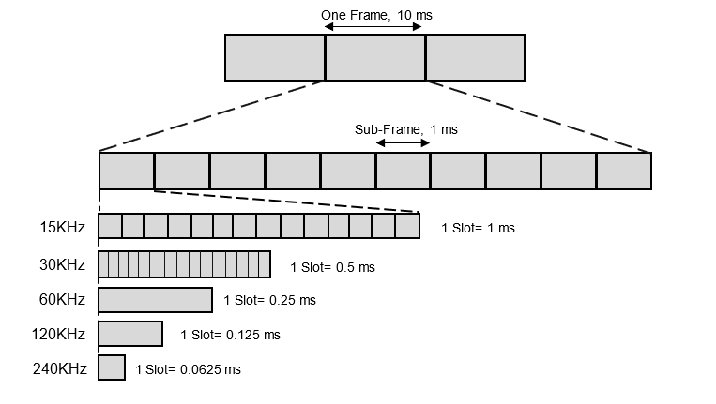

Figure 5‑1: Frame, subframe and slot structure for different numerologies

For $μ=0$ there are 1 slot per subframe, for $μ=1$ there are 2 slots per subframe, for $μ=2$ there are 4 slots per subframe and so on. Number of slots per frame is ten times of number of slots per sub frame. Hence for $μ=2$, there are 40 slots/frame.

|  |  |  |  |  |
| --- | --- | --- | --- | --- |
| Numerology | Sub-Carrier  Spacing  (KHz) | OFDM  Symbols  per Slot | Slots  per  Frame | Slots  per  Sub-frame |
| 0 | 15 | 14 | 10 | 1 |
| 1 | 30 | 14 | 20 | 2 |
| 2 | 60 | 14 | 40 | 4 |
| 3 | 120 | 14 | 80 | 8 |
| 4 | 240 | 14 | 160 | 16 |

Table 5‑1: Sub-carrier spacing, number of OFDM symbols per slot, slots

per frame and sub-frame for different Numerologies.

## Procedure

1. Use the following download Link to download a compressed zip folder which contains the workspace:  [GitHub link](https://github.com/NetSim-TETCOS/5G_Advanced_Experiments_v14.0/archive/refs/heads/main.zip)
2. Extract the zip folder.
3. The extracted project folder consists of a NetSim workspace file 5G_advanced_experiments_with_NetSim.netsimexp.
4. Go to NetSim Home window, go to Your Work and click on Import.



Figure 5‑2: NetSim Home Window

1. In the Import Workspace Window, browse and select the 5G_advanced_experiments_with_NetSim.netsimexp file from the extracted directory. Click on create a new workspace option and browse to select a path in your system where you want to set up the workspace folder.
2. Choose a suitable name for the workspace of your choice. Click Import.



Figure 5‑3: NetSim Import workspace window

1. The Imported Project workspace will automatically be set as the current workspace.
2. The list of experiments is now loaded onto the selected workspace.

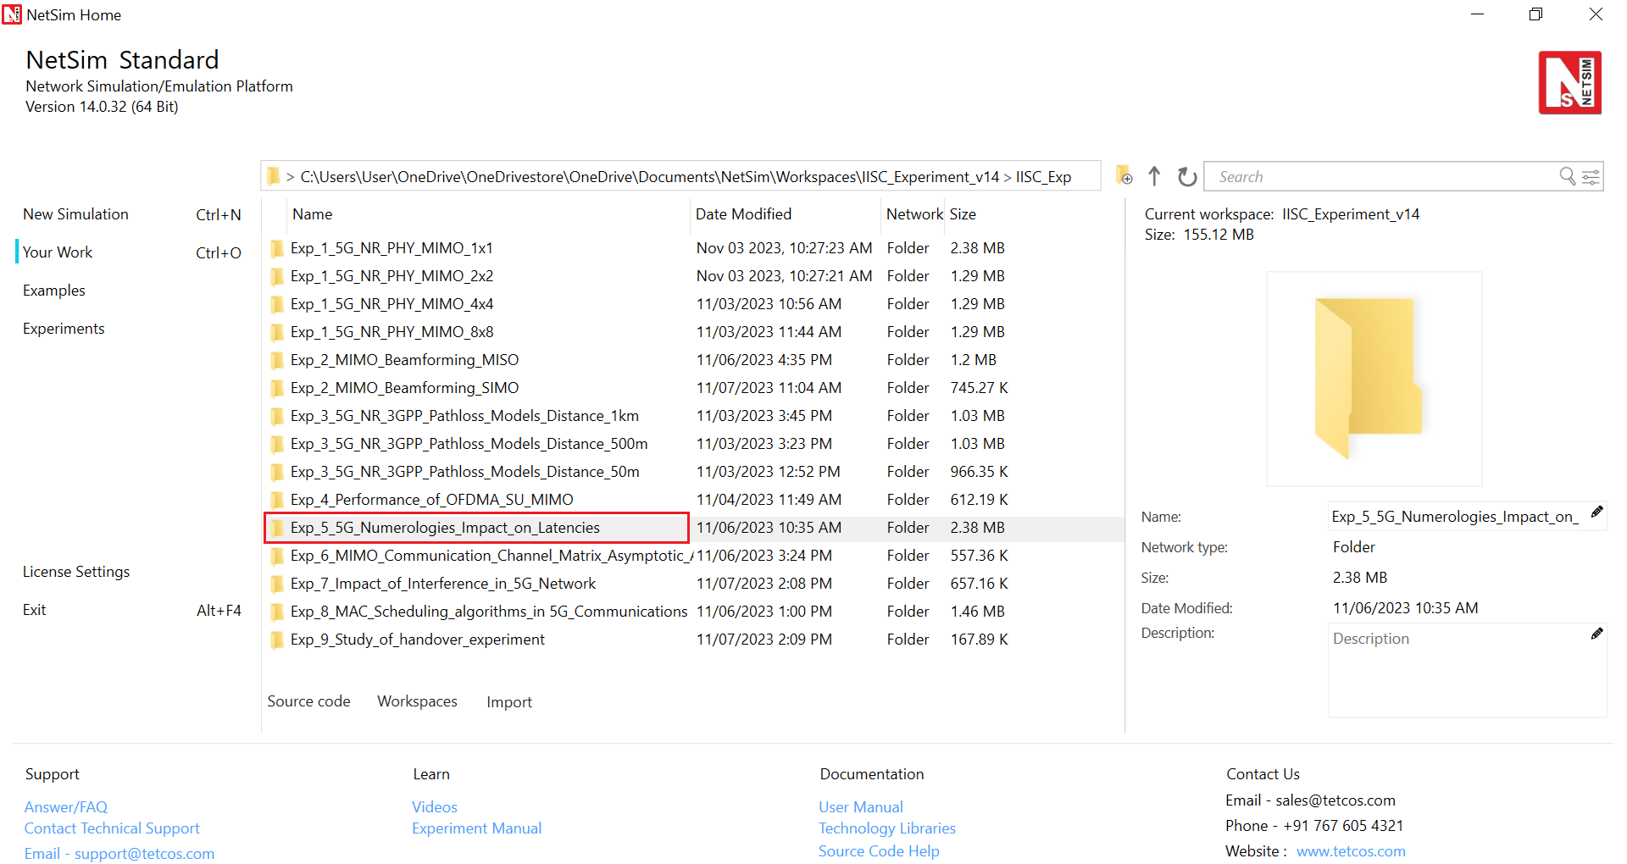

Figure 5‑4: NetSim Your Work Window with the experiment folders inside the workspace

## Network Setup

### Case 1: One UE is transmitting and receiving UDP traffic from a server.

This is a simple scenario whereby the UE is transmitting and receiving UDP traffic from a server as shown below.

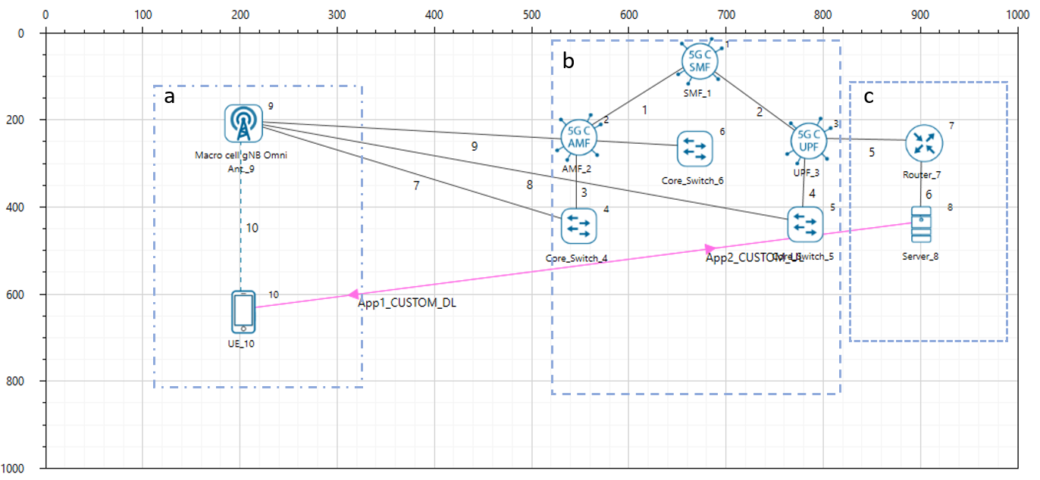

Figure 5‑5: Network scenario. a) The RAN with a User Equipment b) 5G Core and C) Cloud Server. The device in the RAN has both UL and DL communication with the cloud server.

The UE connects to the gNB which connects to the 5G core. The 5G core then connects to the remote server over the cloud (represented by the router and WAN links).

Keeping all other parameters fixed, we vary the numerology $μ$, as 0, 1, 2 and see its impact on end-to-end latency and application (user) throughput. In terms of application data traffic, the User Equipment (UE) has two UDP flows, one Uplink and one Downlink, that goes in the UL towards a remote node on the Internet. These flows are fixed rate.

**Procedure**

1. For the above scenario set the following properties

|  |  |  |  |  |  |  |  |  |  |  |  |  |  |  |  |  |  |  |  |  |  |  |  |  |  |  |  |  |  |
| --- | --- | --- | --- | --- | --- | --- | --- | --- | --- | --- | --- | --- | --- | --- | --- | --- | --- | --- | --- | --- | --- | --- | --- | --- | --- | --- | --- | --- | --- |
| |  |  | | --- | --- | | gNB Properties -> Interface (5G_RAN) | | | Pathloss Model | None | | Frequency Range | FR1 | | CA Type | Single Band CA | | CA Configuration | n78 | | Numerology | 0,1 and 2 | | Channel Bandwidth | 10 MHz | | DL: UL Ratio | 1:1 | | MCS Table | QAM64 | | CQI Table | Table 1 |   Table 5‑2: The Physical Layer properties set in 5G RAN interface of gNB | |  |  | | --- | --- | | Link Properties (All wired links) | | | Uplink/ Downlink Speed (Mbps) | 10000 | | Uplink/ Downlink BER | 0 | | Uplink/ Downlink  Propagation Delay (µs) | 0 |   Table 5‑3: Wired Link Properties setin this experiment |
| |  |  |  | | --- | --- | --- | | CUSTOM UL UDP | | | | Generation Rate (Mbps) | 5.8 | | Transport Protocol | UDP | | Application Type | Custom | | Packet Size (Bytes) | 1460 | | IAT Distribution | Exponential | | Inter Arrival Time (μs) | 2000 |   Table 5‑4: Custom application properties for UL UDP | |  |  |  | | --- | --- | --- | | CUSTOM DL UDP | | | | Generation Rate (Mbps) | 5.8 | | Transport Protocol | UDP | | Application Type | Custom | | Packet Size (Bytes) | 1460 | | IAT Distribution | Exponential | | Inter Arrival Time (μs) | 2000 |   Table 5‑5: Custom application properties for DL UDP |

1. The Tx_Antenna_Count was set to 2 and Rx_Antenna_Count was set to 2 in gNB > Interface 5G_RAN >Physical Layer.
2. The Tx_Antenna_Count was set to 2 and Rx_Antenna_Count was set to 2 in UE > Interface 5G_RAN >Physical Layer.
3. Run simulation for 10 sec. After simulation completes go to metrics window and note down throughput and delay value from application metrics.

### Case 2: A complex 5G scenario with Sensors, Cameras, Laptops and Smartphones having DL and UL, TCP and UDP flows.

To model a real-world scenario, we base our simulation on the setup shown in **.** The link between the gNB and the L2_Switches that represents the Core Network (CN) is made with a point-to-point 10 Gb/s link, without propagation delay. The Radio Area Network (RAN) is served by 1 gNB, in which different UEs share the connectivity. We have 25 smartphones, 6 sensors, and 3 IP cameras. The bandwidth is 100MHz and Round Robin MAC Scheduler.

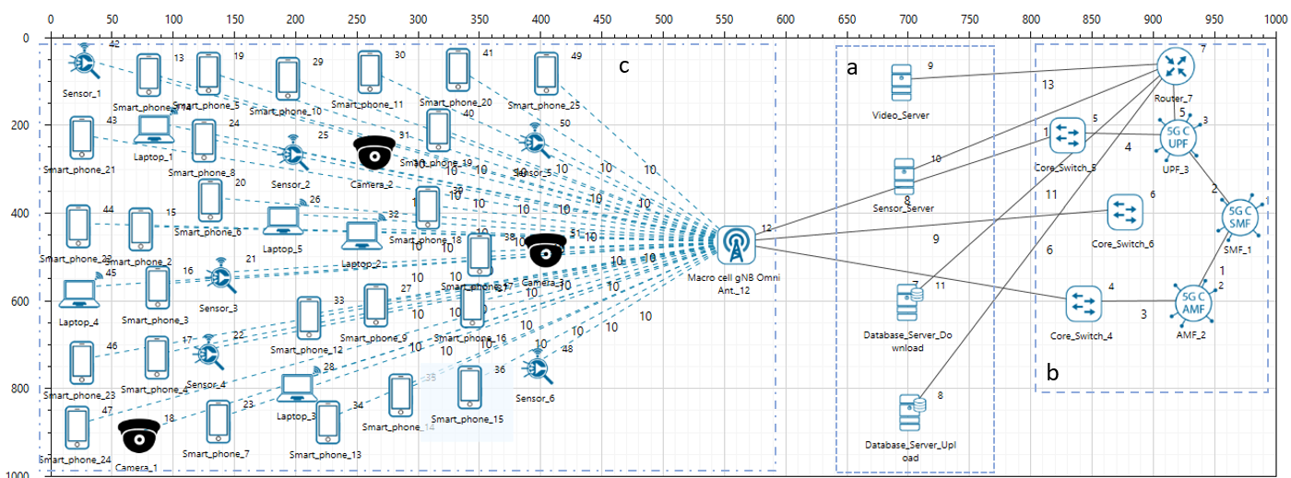 Table 5‑6: Network scenario. a) Cloud servers b) 5G Core and C) The RAN with 25 smartphones, 6 sensors and 3 cameras communicating. The devices in the RAN communicate with respective cloud servers for both Downloads and Uploads.

In terms of data traffic, the camera (video) and sensor nodes have one UDP flow each, that goes in the UL towards a remote node on the Internet. These flows are fixed-rate flows: we have a continuous transmission of 5 Mb/s for the video nodes, to simulate a 720p24 HD video, and the sensors transmit a payload of 500 bytes each 2.5 ms, that gives a rate of 1.6 Mb/s. For smartphones, we use TCP as the transmission protocol. These connect to data base servers. Each phone uploads a 1.5MB file. These flows start at different times: the upload starts at a random time between the 25th and the 75th simulation second. For the laptops download videos at a payload of 1460 bytes every 2.33 ms, that gives a rate of 1.6 M

|  |  |  |  |  |  |
| --- | --- | --- | --- | --- | --- |
| Camera (UDP) | 3 | 5 | 500 | UL | - |
| Sensor (UDP) | 6 | 1.6 | 500 | UL | - |
| Smartphone Upload (TCP) | 25 | - | 1,500,000 | UL | DL |
| Laptop  Download (UDP) | 5 | 5 | 1460 | DL | - |

Table 5‑7:Various parameters of the Traffic flow models for all the devices.

The numerology $μ$ can take values from 0 to 3 and specifies an SCS of $15×2^{μ}$ kHz and a slot length of $\frac{1}{2^{μ}}$ ms. FR1 support $μ=0, 1$ and $2$, while FR2 supports $μ=2, 3.$ We study the impact of different numerologies, and how they affect the end-to-end performance. The metrics measured and analyzed are a) Throughput of TCP uploads and b) Latency of the UDP uploads and downloads.

**Procedure:**

1. For the above scenario set the following properties

|  |  |  |  |  |  |  |  |  |  |  |  |  |  |  |  |  |  |  |  |  |  |  |  |  |  |  |  |  |  |  |  |  |  |  |  |  |  |  |  |  |  |  |  |  |  |  |  |  |  |  |  |
| --- | --- | --- | --- | --- | --- | --- | --- | --- | --- | --- | --- | --- | --- | --- | --- | --- | --- | --- | --- | --- | --- | --- | --- | --- | --- | --- | --- | --- | --- | --- | --- | --- | --- | --- | --- | --- | --- | --- | --- | --- | --- | --- | --- | --- | --- | --- | --- | --- | --- | --- | --- |
| |  |  | | --- | --- | | gNB Properties -> Interface (5G_RAN) | | | Pathloss Model | None | | Frequency Range | FR1 | | CA Type | Inter Band CA | | CA Configuration | CA_2DL_2UL_n40_n41 | | CA1 | | | Numerology | 0, 1 and 2 | | Channel Bandwidth | 50 MHz | | DL: UL Ratio | 1:4 | | CA2 | | | Numerology | 0, 1 and 2 | | Channel Bandwidth | 50 MHz | | DL: UL Ratio | 1:4 | | MCS Table | QAM64 | | CQI Table | Table 1 |   Table 5‑8: The Physical Layer properties set in 5G Ran interface of gNB | |  |  | | --- | --- | | Link Properties (All wired links) | | | Uplink/ Downlink Speed (Mbps) | 10000 | | Uplink/ Downlink BER | 0 | | Uplink/ Downlink Propagation Delay (μs) | 5 |   Table 5‑9: Wired Link Properties   |  |  | | --- | --- | | Sensor UL UDP | | | Generation Rate (Mbps) | 1.6 | | Transport Protocol | UDP | | Application Type | Custom | | Packet Size (Bytes) | 500 | | Inter Arrival Time (μs) | 2500 |   Table 5‑10: Sensor Application Properties for UL UDP |
| |  |  | | --- | --- | | Camera UL UDP | | | Generation Rate (Mbps) | 5 | | Transport Protocol | UDP | | Application Type | Custom | | Packet Size (Bytes) | 500 | | Inter Arrival Time (μs) | 800 |   Table 5‑11: Camera application properties for UL UDP | |  |  | | --- | --- | | Laptop DL UDP | | | Generation Rate (Mbps) | 5 | | Transport Protocol | UDP | | Application Type | Custom | | Packet Size (Bytes) | 1460 | | Inter Arrival Time (μs) | 2336 |   Table 5‑12: Laptop application properties for UL UDP |
| |  |  | | --- | --- | | Phone UL TCP | | | Application Type | FTP | | Transport Protocol | TCP | | Start Time (s) |  | | Stop Time (s) | 95 | | File Size (B) | 1,500,000 | | Inter Arrival Time (μs) | 200 (simulation ends at 100s and hence only one file is sent) |   Table 5‑13: Phone applications for UL TCP | |

1. The Tx_Antenna_Count was set to 2 and Rx_Antenna_Count was set to 2 in gNB > Interface 5G_RAN >Physical Layer.
2. The Tx_Antenna_Count was set to 2 and Rx_Antenna_Count was set to 2 in UE > Interface 5G_RAN >Physical Layer.
3. Run simulation for 100 sec. After simulation completes go to metrics window and note down throughput and delay value from application metrics.

## Results and Discussion

**Case 1**

|  |  |  |  |
| --- | --- | --- | --- |
| Application Type | Throughput (Mbps) | | |
| Numerology, $μ=0$ | Numerology, $μ=1$ | Numerology, $μ=2$ |
| Custom DL (UDP) | 5.76 | 5.77 | 5.77 |
| Custom UL (UDP) | 5.82 | 5.82 | 5.82 |

Table 5‑14: Throughputs obtained for UL and DL UDP flows when numerology is varied from 0 to 2.

|  |  |  |  |  |
| --- | --- | --- | --- | --- |
| Application Type | Delay (ms) | | | |
| Numerology, $μ=0$ | Numerology, $μ=1$ | Numerology, $μ=2$ |
| Custom DL (UDP) | 2.000 | 1.140 | 0.604 |
| Custom UL (UDP) | 1.997 | 1.119 | 0.599 |

Table 5‑15: Delay obtained for UL and DL UDP applications when numerology is varied from 0 to 2.

Figure 5‑6: Custom DL and UL throughput vs numerology. Numerology has no impact on throughput.

Figure 5‑7: Custom DL and UL delay vs numerology. The delay for both DL and UL decreases as numerology is increased.

**Case 2**

|  |  |  |  |
| --- | --- | --- | --- |
| Application Type | Average Throughput (Mbps) | | |
| Numerology, $μ=0$ | Numerology, $μ=1$ | Numerology, $μ=2$ |
| Camera Video UL (UDP) | 4.99 | 4.99 | 4.99 |
| Sensor UL (UDP) | 1.6 | 1.6 | 1.599 |
| Smartphone UL (TCP) | 86.27 | 171.41 | 309.93 |
| Laptop Video DL (UDP) | 3.77 | 3.66 | 3.505 |

Table 5‑16: Average and aggregate throughputs obtained for Camera, Sensors and Smartphones, when numerology is varied from 0 to 2.

|  |  |  |  |
| --- | --- | --- | --- |
| Application Type | Average Delay (ms) | | |
| Numerology, $μ=0$ | Numerology, $μ=1$ | Numerology, $μ=2$ |
| Camera Video UL (UDP) | 99.82 | 2255.32 | 6108.42 |
| Sensor UL (UDP) | 2.278 | 1.510 | 223.55 |
| Smartphone UL (TCP) | 80.36 | 40.31 | 22.06 |
| Laptop Video DL (UDP) | 9261.16 | 9420.62 | 10375.76 |

Table 5‑17: Average delay obtained for Camera, Sensors and Smartphones, when numerology is varied from 0 to 2

Figure 5‑8:The average uplink throughputs for Cameras and Sensors remains the same as the numerology is increased. This is because the flow is UDP.

Figure 5‑9: The average uplink delays for cameras and sensors decreases as the numerology is increased.

Figure 5‑10: The average downlink throughput for Laptop remains the same as the numerology is increased. This is because the flow is UDP. The average downlink delay decreases as the numerology is increased.

Figure 5‑11:The average uplink throughput for Smartphone increases as the numerology is increased. The average uplink delay decreases as the numerology is increased. This is because the flow is TCP

**Discussion:**

For UDP applications, the Numerology, $μ$ does not impact the throughput.

The TCP throughput is inversely proportional to round trip time. Therefore, for applications running over TCP the throughput increases with higher numerology since a higher Numerology leads to reduced round-trip times.

Therefore, the selection of the numerology in an NR system should be carefully made by considering the traffic patterns.

## **References**

1. Edelman, A. (1988). Eigenvalues and Condition Numbers of Random Matrices. SIAM Journal on Matrix Analysis and Applications, 543-560.
2. Patriciello, N., Lagen, S., Giupponi, L., & Bojovic, B. (2018). 5G New Radio Numerologies and their Impact on the End-To-End Latency. IEEE 23rd International Workshop on Computer Aided Modeling and Design of Communication Links and Networks (CAMAD).

# MIMO Communication: Channel Matrix Asymptotic Analysis

## Objective

In this experiment, properties of MIMO channel matrices in 5G wireless communications are studied in the asymptotic number of antennas. In particular, the condition number of a large MIMO matrix, which dictates the performance of spatial multiplexing and subsequently the behavior of the eigen spectrum of large MIMO matrices, are investigated through simulations setup in NetSim v14.0.

## Introduction

A MIMO channel matrix in wireless communications is, in general, a random matrix. Hence, all the parameters obtained out of matrix entries are essentially random variables. For e.g., the eigen values, the condition number are all random variables. In particular, the condition number of a MIMO channel matrix is of significant importance in characterizing the capacity of a MIMO channel. For example, by virtue of Jensen’s inequality we have,

$\sum_{i}{\log\left(1+\frac{Pσ_{i}}{N}\right)} ≤ r log\left(1+\frac{1}{r}\sum_{i}{\frac{Pσ_{i}}{N}}\right)$,

with equality holding true iff condition number of the MIMO matrix is 1 and other parameters have usual meanings, and with $r$ being the rank of the MIMO channel matrix. Thus, for a given rank and SNR of the channel, condition number of the matrix determines how close to the upper bound the achievable rate is. In this view, the eigen spectrum and condition number distribution of large MIMO matrices are investigated. By means of theory, it will be shown that the condition number of a large MIMO matrix stabilizes near unity, indicating superior spatial multiplexing capability in the asymptotic number of antennas.

## Procedure

1. Use the following download Link to download a compressed zip folder which contains the workspace: [GitHub link](https://github.com/NetSim-TETCOS/5G_Advanced_Experiments_v14.0/archive/refs/heads/main.zip)
2. Extract the zip folder.
3. The extracted project folder consists of a NetSim workspace file 5G_advanced_experiments_with_NetSim.netsimexp.
4. Go to NetSim Home window, go to Your Work and click on Import.



Figure 6‑1: NetSim Home Window

1. In the Import Workspace Window, browse and select the 5G_advanced_experiments_with_NetSim.netsimexp file from the extracted directory. Click on create a new workspace option and browse to select a path in your system where you want to set up the workspace folder.
2. Choose a suitable name for the workspace of your choice. Click Import.



Figure 6‑2: NetSim Import workspace window/

1. The Imported Project workspace will automatically be set as the current workspace.
2. The list of experiments is now loaded onto the selected workspace.

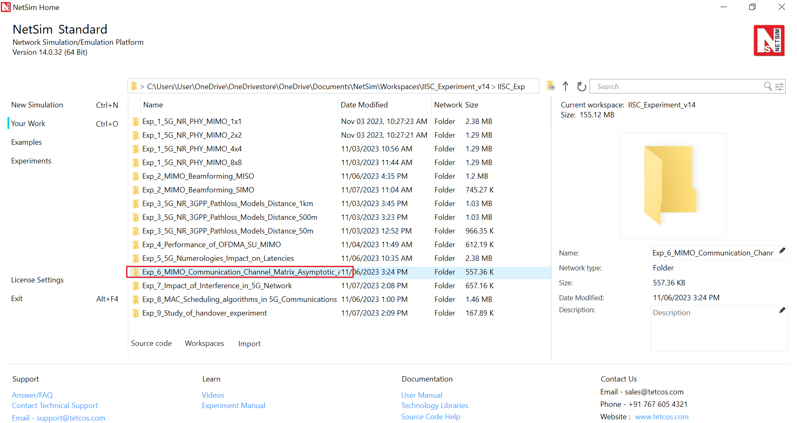

Figure 6‑3: NetSim Your Work Window with the experiment folders inside the workspace

## Network Setup

NetSim UI would display the network topology shown in the screenshot below when you open the example configuration file.

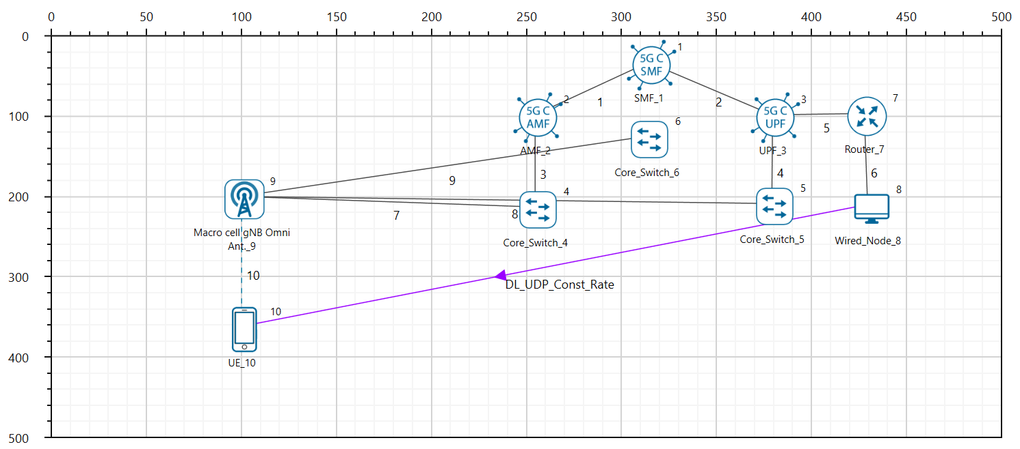

Figure 6‑4: Network topology in this experiment

The following parameters were configured in the network setup:

1. The gNB - Interface 5G_RAN were set with the following properties:

|  |  |
| --- | --- |
| gNB- Interface 5G_RAN Parameters | |
| gNB Height | 10m |
| Tx Power | 40 dBm |
| Duplex Mode | TDD |
| CA Type | SINGLE BAND |
| CA Configuration | n78 |
| DL: UL Ratio | 4:1 |
| Numerology | 0 |
| Channel Bandwidth (MHz) | 10 |
| Tx Antenna Count | Varied from 16 to 128 |
| Rx Antenna Count | 16 |
| MCS Table | QAM64LOWSE |
| CQI Table | TABLE3 |
| Pathloss Model | 3GPPTR38.901-7.4.1 |
| Outdoor Scenario | Rural Macro |
| LOS NLOS Selection | User Defined |
| LOS Probability | 1 (LOS) |
| Shadow Fading Model | 3GPPTR38.901-7.4.1 |
| Fading and Beam Forming | RAYLEIGH with EIGEN Beamforming |
| Coherence Time (ms) | 10 |
| Additional Loss Model | None |

Table 6‑1: gNB properties

1. The UE properties were configured with the following parameters:

|  |  |
| --- | --- |
| UE Interface 5G RAN | |
| Tx Power | 23 dBm |
| UE Height | 1.5m |
| Tx Antenna Count | 16 |
| Rx Antenna Count | 16 |

Table 6‑2: UE properties

1. A downlink CBR application was configured from wired node to UE with Transport protocol as UDP and Packet Size of 1460 Bytes and Inter Arrival time of 2000 µs and the Start Time was set to 1s[12].
2. Click on the log tab in the right to enable LTENR Radio measurement as shown below.

Figure 6‑5: Enabling LTENR Radio measurement log file.

Run simulation for 10s. After the simulation, note down the average linear Beamforming Gain (eigen value) obtained for the DL application from the log file generated and then condition number can be obtained.

### Part 1: Asymptotic Condition Number Mean

Steps to calculate the condition number through Eigen value (BeamForming Gain Linear):

1. In the results window, expand the Log Files option in the left panel and select LTENR_Radio_Measurements_Log.csv file.

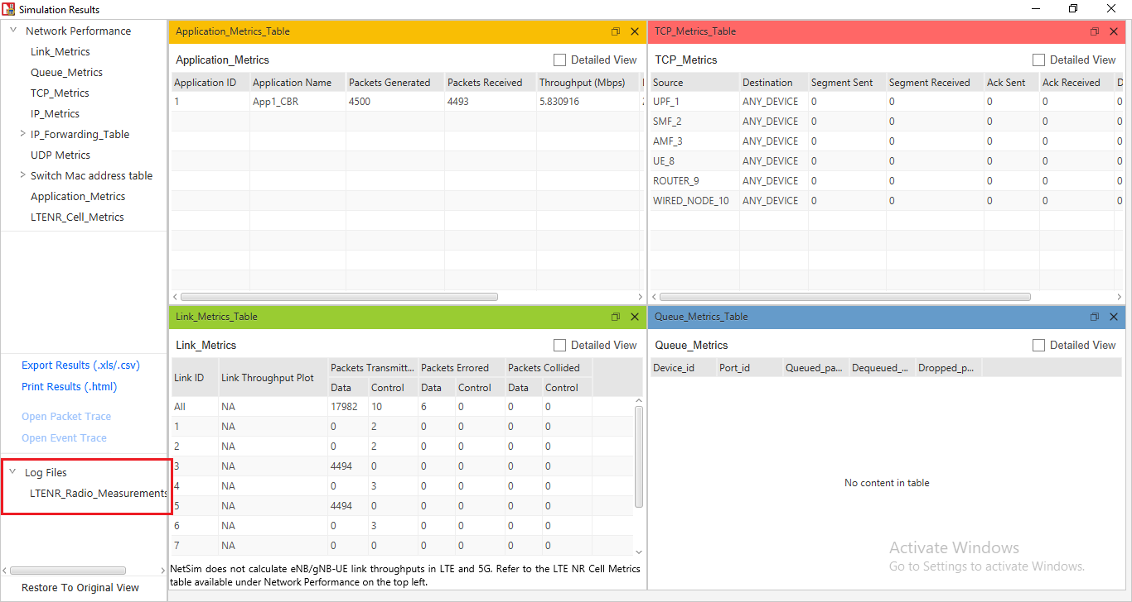

Figure 6‑6:NetSim Results window showing access to log file generated.

1. This will open a csv file which logs the parameters beamforming gain, over time as shown below.

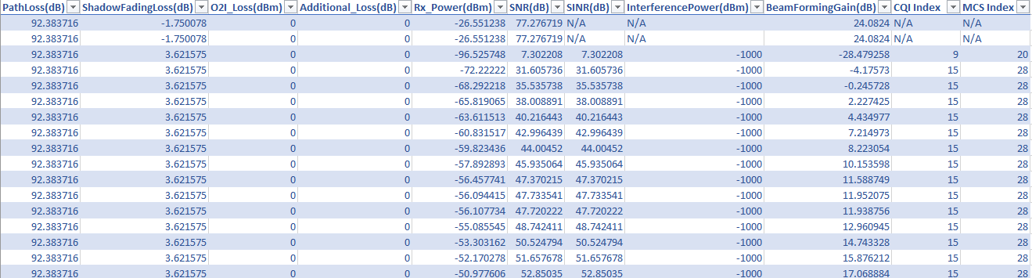

Figure 6‑7: LTENR Radio Measurements log file created after simulation.

1. To change the beamforming gain from dB scale to linear, the following method is used:

$$Eigen Value \left(Beam Forming Gain, Linear\right)= {10}^{\left(\frac{BeamFormingGain_{dB}}{10}\right)}$$

In a new column, enter the following function to calculate the linear Beamforming gain:

$$=POWER(10,[@[BeamFormingGain(dB)]]/10)$$

1. Now go to Insert, select Pivot table option, and then select new sheet option and click ok.

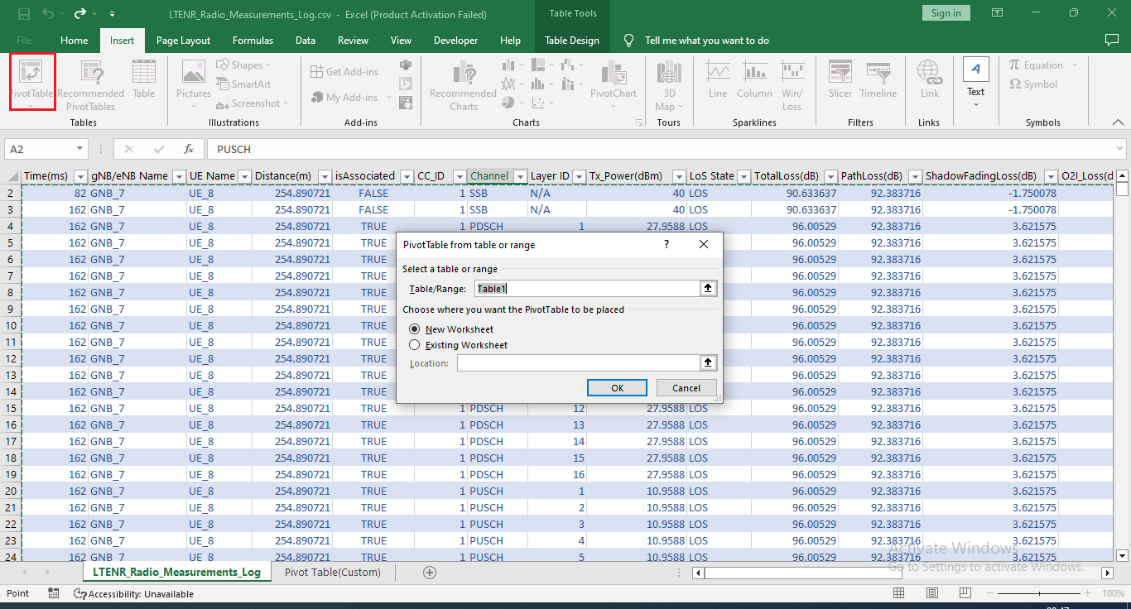

Figure 6‑8: Create pivot table

1. Drag and drop the Channel and LAYER_ID field to filter block. Filter the Channel to only PDSCH since we have considered a DL application from server to UE. Similarly, drag and drop the linear beamforming gain to values field and Time to Rows field.

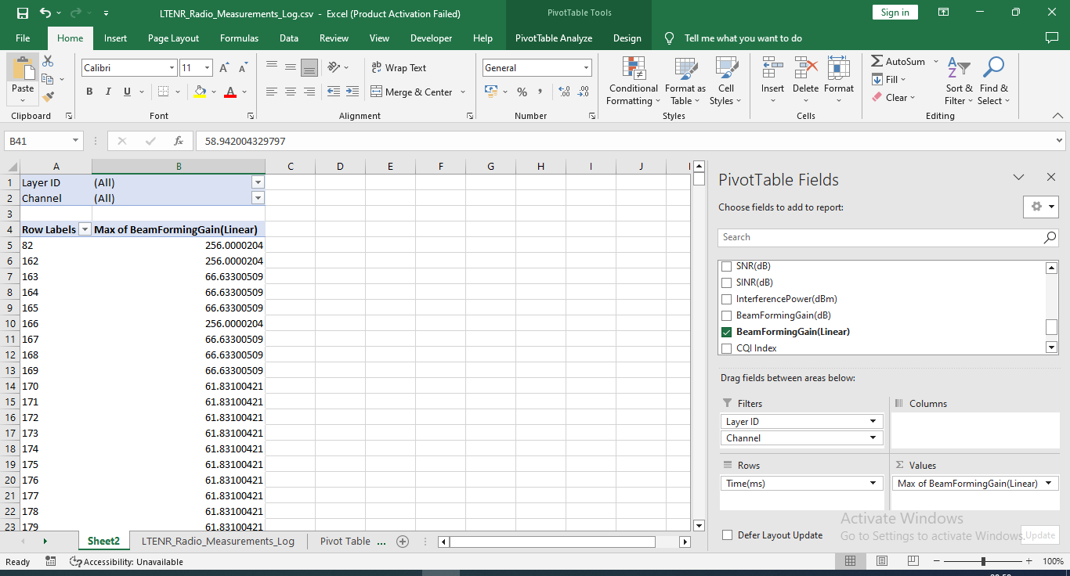

Figure 6‑9: LTENR Radio Measurements Log file pivot table showing the filtering process of DL/UL column

1. Now, filter the Layer_Id to layer 1. Now, copy the beamforming values and paste the values in new sheet with column name as Layer1.

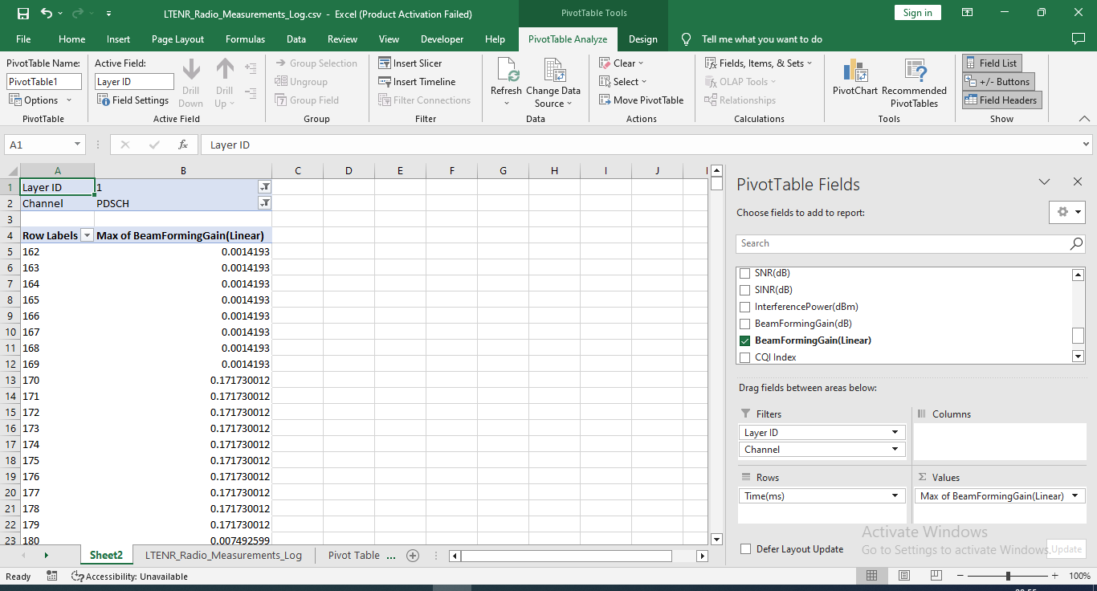

Figure 6‑10: LTENR Radio Measurements Log file showing eigen value obtained for layer1.

1. Similarly, filter the LAYER_ID as 16 and copy all the eigen values and paste in new sheet with column name Layer16 as below.

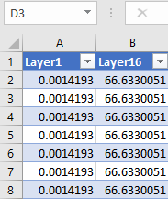

Figure 6‑11: Layer 1 and layer 16 eigen value in new table

1. Now in the next column, enter the formula, $=[@Layer16]/[@Layer1]$ to calculate $EV_max/EV_min$. Note that the eigenvalues of Layer 16 are $λ_{max}$ while the eigenvalue of Layer1 is $λ_{min}.$ Rename the column suitably.

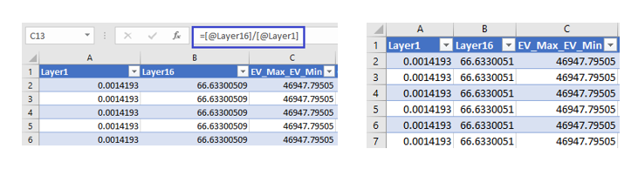

Figure 6‑12: Showing $\sqrt{\frac{λ_{max}}{λ_{min}}}$ obtained

1. Now in the next column, enter the formula, $=SQRT([@[EV_Max_EV_Min]])$. This will calculate square root of the ratio $\sqrt{\frac{λ_{max}}{λ_{min}}}$ which is known as the condition number.

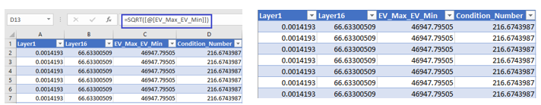

Figure 6‑13:Condition Number obtained

1. In a new cell, enter the formula $=AVERAGE(Table2[Condition_Number])$ to calculate the average of condition number.

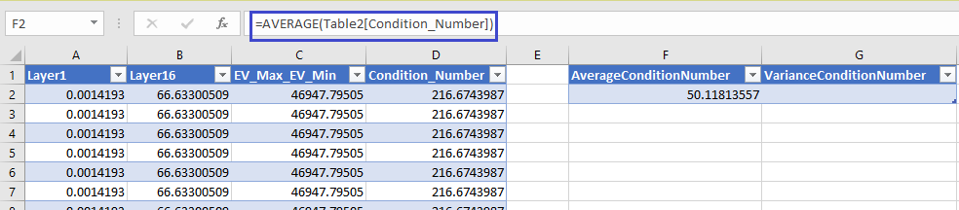

Figure 6‑14: Average eigen value obtained

1. Similarly, enter the formula, $=VAR.P(Table2[Condition_Number])$ in a new cell, to calculate the variance of condition number.

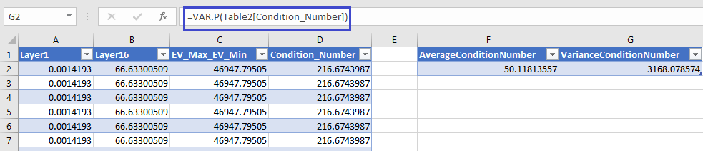

Figure 6‑15: Variance of eigen value obtained.

1. Repeat the steps 1 to 10 with varying Tx antenna count in gNB as 32, 64, and 128. Note down the mean and variance of condition number.

**Results**

|  |  |  |
| --- | --- | --- |
| Tx, Rx | Condition Number Mean | Condition Number Variance |
| 16, 16 | 50.122 | 3168.247 |
| 32, 16 | 4.423 | 0.259643 |
| 64, 16 | 2.561 | 0.026433 |
| 128,16 | 1.878 | 0.005593 |

Table ‑: Showing Mean and Variance of Condition Number with varying Tx

1. **Case1: gNB Tx = 32, UE Rx = 16**

From theory $K =\frac{\left(1 + \sqrt{\frac{16}{32}}\right)}{1 - \sqrt{\frac{16}{32}}} = 5.82$. NetSim result = 4.423.

$$Difference=\frac{5.82-4.423}{4.423}= 31.58 \%$$

1. **Case2: gNB Tx = 64, UE Rx = 16**

From theory $K =\frac{\left(1 + \sqrt{\frac{16}{64}}\right)}{1 - \sqrt{\frac{16}{64}}}=3.0$. NetSim result = 2.561.

$$Difference=\frac{3-2.561}{2.561}= 17.1 \%$$

1. **Case3: gNB Tx = 128, UE Rx = 16**

From theory $K =\frac{\left(1 + \sqrt{\frac{16}{128}}\right)}{1 - \sqrt{\frac{16}{128}}}=2.09$. NetSim result = 1.878

$$Difference=\frac{2.09-1.878}{1.878}= 11.28\%$$

Since theory is for the asymptotic mean, we will not get an exact match. The results show the trend that as N increases simulation outputs approach theoretical predictions.

### Part 2: Asymptotic Condition Number Distribution

**Theory**

Consider a i.i.d $N_{r}×N_{t}$ complex Gaussian random matrix $H$. Define the Wishart matrix $W=H×H^{†}$ with parameters $n=\min{(N_{t}, N_{r})}$ and $N=\max{(N_{t}, N_{r})}$, and eigenvalues as $λ_{max}=λ_{1}≥λ_{2}≥…≥λ_{min}≥0$.

The condition number of $H$ is defined as

$$K\left(H\right)=\sqrt{\frac{λ_{max}}{λ_{min}}}$$

From (Edelman, 1988), if $n=N$, and $N→ ∞$ then $\frac{K\left(H\right)}{n}$ converges in distribution to a random variable whose PDF is given by

$$f\left(x\right)=\left(\frac{8}{x^{3}}\right)×e^{-\left(\frac{4}{x^{2}}\right)}$$

We simulate the case $N_{r}=N_{t}= 16$, since the antenna count is limited to 16, in the UEs in NetSim. Figure 6‑16 is a comparison of the normalized histogram of $\frac{K}{N}$ from NetSim vs. the asymptotic pdf equation. At $N_{r}=N_{t}= 16$ itself, there seems to be a reasonable fit.

Comparison of NetSim Results with asymptotic function

**Steps to plot histogram of condition number:**

1. Calculate the Condition Number using the LTENR_Radio_Measurements_Log.
2. In a new column, divide the Condition_Number by 16 using the following excel function:
$$=[@Condition_Number]/16)$$

3. Click on Insert-> Pivot Table, drag and drop Column1 to Rows field.
4. Copy the values in Row Labels column.
5. In MATLAB create a new file, create an array **Condition_Number_array**, paste the values to it as

**Condition_Number_array** = [c1

c2

c3

….

cn];

1. Now use below MATLB code to plot the normalized histogram plot with the function.

$$f(x) = \left(\frac{8}{x^{3}}\right)×e^{-\frac{4}{x^{2}}}$$

hold on;

c = histogram(Condition_Number_array,'Normalization','probability');

x = 0:0.1:50; %x varies from 0 to 50 in steps of 0.2.

y = (8./x.^3).*(exp(-4./x.^2));

plot(x,y,'r');

hold off;

% For CDF plot use below MATLB code

cdfplot(Condition_Number_array);

Program 1: MATLAB code for plotting condition number from NetSim and comparing against the asymptotic PDF from analysis.

**Histogram Plot for 16 Tx Layer Count (gNB) and 16 Rx Layer Count (UE)**

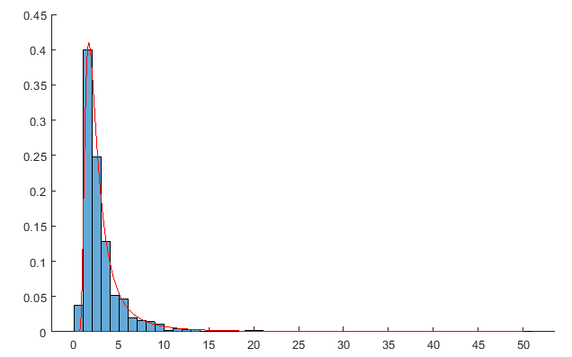

Normalized histogram of $\frac{1}{n}×\sqrt{\frac{λ_{max}}{λ_{min}}}$ from NetSim

$$f\left(x\right)= \left(\frac{8}{x^{3}}\right)×e^{-\frac{4}{x^{2}}}$$

Figure 6‑16: The normalized histogram $\frac{1}{n}×\sqrt{\frac{λ_{max}}{λ_{min}}}$ for $N_{t}=N_{r}=16$ itself fits well with the asymptotic distribution of $\frac{ K\left(H\right)}{n}$

### Part 3: Marchenko-Pasteur Distribution

**Theory**

The Marchenko Pasteur distribution for $\frac{N_{r}}{N_{t}}=y$ with $N_{t}→ ∞$ is

$$f\left(x\right)=\frac{1}{2πxy}×\sqrt{\left(b-x\right)\left(x-a\right)}$$

where $b={\left(1+\sqrt{y}\right)}^{2}$ and $a={\left(1-\sqrt{y}\right)}^{2}$.

Let us consider the case where, the number of transmit antennas $N_{t}$ and the number of receive antennas $N_{r}$, are related as $\frac{N_{r}}{N_{t}}=\frac{1}{8}=y.$ Substituting for $y$ we get the MP distribution as

$$f\left(x\right)=\left\{\begin{aligned}\frac{4}{πx}\sqrt{\left(\frac{1}{2}\right)-{\left(x-\frac{9}{8}\right)}^{2}} , { \left(1-\frac{1}{2\sqrt{2}}\right)}^{2}≤{x≤\left(1+\frac{1}{2\sqrt{2}}\right)}^{2} \\ 0, & All other x\end{aligned}\right.$$

Comparison of NetSim Results with Marchenko- Pasteur function

**Steps to plot the histogram:**

1. Create a scenario with Tx antenna count as 128 and Rx antenna count as 16.
2. Now open the file LTENR_Radio_Measurements_Log.csv file.
3. Filter the PDSCH/PUSCH to PDSCH.
4. Now, in LTENR Radio Measurements Log file compute Eigen values (Linear Beamforming Gain) for all layers, Layer Id 1 to Layer Id 16.
5. Select the eigen values in Beamforming Gain column and copy all the values.
6. Create a new file in MATLAB. Create an array Eigen_value_array and paste the copied values from the 5G parameter log csv file as shown.

Eigen_value_array = [ev1

ev2

…

evN];

1. Use below MATLAB code to plot the MP distribution function along with the normalized histogram.

For the MP distribution function, the x varies from 0.418 to 1.832 in steps of 0.001.

x = 0.418:0.001:1.832;

y = (1.27324./x).*sqrt(0.5 - (x-9/8).^2);

hold on;

plot(x,y);

histogram(Eigen_value_array /128,'Normalization','pdf');

hold off;

Program 2: MATLAB code for plotting the MP distribution for $y=\frac{1}{8}$ and pooled eigenvalues histogram, from NetSim simulation results.

## Result

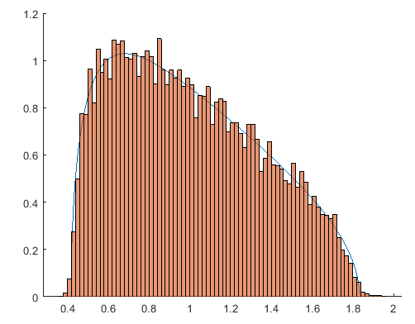

Pooled eigen value normalized histogram

MPdistribution for

Fig ‑: NetSim Results vs. Marchenko-Pasteur distribution for $N_{r}=16$ and $N_{t}=128$

## **References**

1. Edelman, A. (1988). Eigenvalues and Condition Numbers of Random Matrices. SIAM Journal on Matrix Analysis and Applications, 543-560.
2. Patriciello, N., Lagen, S., Giupponi, L., & Bojovic, B. (2018). 5G New Radio Numerologies and their Impact on the End-To-End Latency. IEEE 23rd International Workshop on Computer Aided Modeling and Design of Communication Links and Networks (CAMAD).

# Impact of Interference in 5G Networks

## Objective

In this experiment, we will simulate and study the impact of downlink interference on the signal-to-interference ratio (SINR) in Netsim **v14.0**. We will study the following aspects.

1. We consider a handover procedure in a cellular system and analyse the following cases:
2. The handover of a UE without any interference, with pathloss exponent, $η=2.5$,
3. The handover of a UE without any interference, with pathloss exponent $η=4$,
4. The handover of a UE with interference, with pathloss exponent $η=2.5$, and
5. The handover of a UE with interference, with pathloss exponent $η=4$.
6. To understand the effect of path loss exponents with and without interferences on the point of handovers in cellular systems.

In this experiment, we consider the following handover scenario: A UE starts from $BS_{1}$ and moves in a straight line to $BS_{2}$. While the UE is attached to $BS_{1}$ it experiences interference from $BS_{2}$. Once it gets handed over to $BS_{2}$ the UE experiences interference from $BS_{1}$. There is always thus only one interferer, and we analyse the SINR as the UE moves a straight line from $BS_{1}$ to $BS_{2}$.

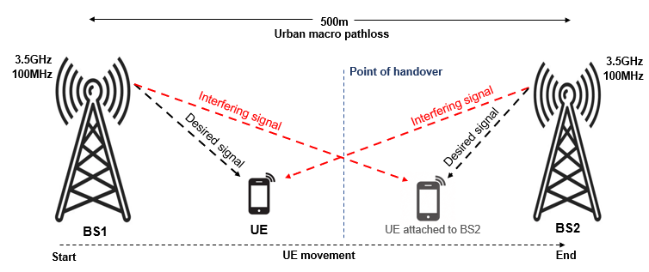

Figure 7‑1: UE1 is initially attached to BS1. The signal from BS1 is the desired signal while the signal from BS2 is the interfering signal. Post-handover, the desired signal is transmitted from BS2 while signal from BS1 is the interfering signal. We assume omni-directional antennas at both BSs and consider cases with $η=2.5, 4$.

## **Introduction**

Due to the scarcity of the wireless spectrum, it is not possible in 5G networks to separate concurrent transmissions completely in frequency. Some transmissions will necessarily occur at the same time in the same frequency band, separated only in space, and the signals operating on the same time-frequency resources from many undesired or interfering transmitters are added to the desired transmitter’s signal at a receiver. The main determinants of the interference are,

* The network geometry, i.e., the location of the receivers and the transmitters
* Base stations’ (or gNBs’) transmit power, and
* The path loss model (signal attenuation with distance).

The performance and coverage of a 5G network critically depends on the signal-to-interference-and-noise ratios (SINRs) level at the receivers. This is defined as

$$SINR=\frac{P_{r}}{N_{0}W+I}$$

Where $P_{r}$ is the received power of the desired signal, $W$ is the bandwidth, $N_{0}W$ is the thermal noise and $I$ is the received power of interfering signals. In 5G, the modulation and coding scheme (MCS) is computed from the SINR. The higher the SINR, the higher the MCS, and hence the higher the date rate. Interference is therefore an important performance-limiting factor in wireless networks and hence it is crucial to characterize the effect of interference.

**A. Network setup: ISD = 500m, C Band, 100 MHz, Urban Macro**

In our network scenario, the inter-site distance (ISD) between $BS_{1}$ and $BS_{2}$ is 500m. Both base stations (gNB) operate in the 3.5 GHz band, called the C band, with a bandwidth of 100 MHz. The environment is assumed to be urban with signal attenuation as per the 3G PP Urban Macro pathloss model. Shadow-fading and fast fading are turned off to avoid sources of randomness.

## Case 1: No interference in both base stations with $η=2.5$

**Procedure**

1. Use the following download Link to download a compressed zip folder which contains the workspace: [GitHub link](https://github.com/NetSim-TETCOS/5G_Advanced_Experiments_v14.0/archive/refs/heads/main.zip)
2. Extract the zip folder.
3. The extracted project folder consists of a NetSim workspace file 5G_advanced_experiments_with_NetSim.netsimexp.
4. Go to NetSim Home window, go to Your Work and click on Import.



Figure 7‑2: NetSim Home Window

1. In the Import Workspace Window, browse and select the 5G_advanced_experiments_with_NetSim.netsimexp file from the extracted directory. Click on create a new workspace option and browse to select a path in your system where you want to set up the workspace folder.
2. Choose a suitable name for the workspace of your choice. Click Import.



Figure 7‑3: NetSim Import workspace window/

1. The Imported Project workspace will automatically be set as the current workspace.
2. The list of experiments is now loaded onto the selected workspace.



Figure 7‑4: NetSim Your Work Window with the experiment folders inside the workspace

**Network Scenario**

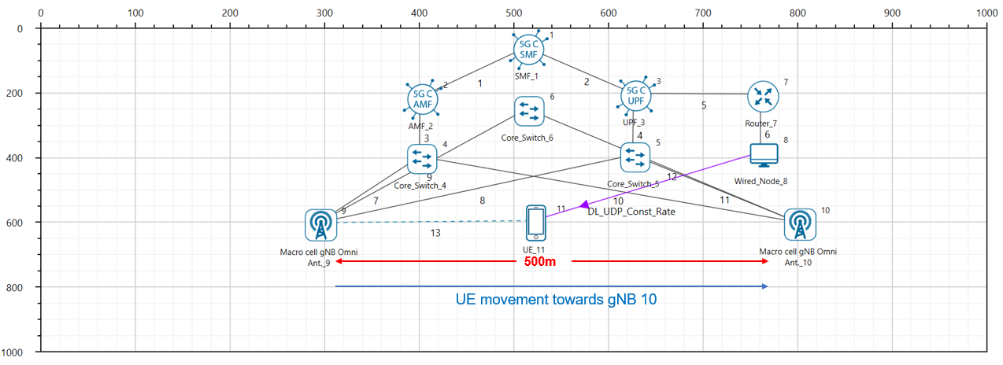Figure 7‑5: NetSim Scenario during mobility.

**Simulation parameters:**

Consider the grid environment as 700 m. Place the two gNBs in the grid environment. The distance between two gNBs is 500m.

|  |  |  |
| --- | --- | --- |
| Devices | X | Y |
| gNB_9 | 300 | 600 |
| gNB_10 | 800 | 600 |
| UE_11 | 300 | 600 |
| UE_12 | 735 | 600 |

Table 7‑1:Device Co-ordinates

1. Go to gNB properties. In the RAN interface set physical layer properties as shown in the below table. Similarly set the same properties in another gNB.

|  |  |
| --- | --- |
| gnb> Interface 5G RAN | |
| gNB Height (m) | 10 |
| Tx Power (dBm) | 40dBm |
| Tx Antenna Count | 1 |
| Rx Antenna Count | 1 |
| CA Type | Single Band |
| CA Configuration | n78 (C Band) |
| F_Low (MHz) | 3300 |
| F_High (MHz) | 3800 |
| DL: UL Ratio | 4:1 |
| Numerology | 2 |
| Channel Bandwidth (MHz) | 100MHZ |
| MCS Table | QAM64 |
| CQI Table | TABLE1 |
| Outdoor Scenario | Urban Macro |
| Indoor Office Type | Mixed Office |
| PathLoss Model | LOG_DISTANCE |
| PathLoss Exponent | 2.5 |
| Shadow Fading Model | None |
| Fading and Beamforming | NO FADING MIMO UNIT GAIN |
| Downlink interference model | No interference |

Table 7‑2: Values set for different parameters in simulation.

1. Go to UE properties. In the RAN Interface set physical layer properties in both UEs as shown below.

|  |  |
| --- | --- |
| UE > Interface 5G RAN | |
| UE Height | 1.50 |
| Tx Power | 23 dBm |
| Tx Antenna Count | 1 |
| Rx Antenna Count | 1 |

Table 7‑3: Properties set for UE

1. In the Position layer, set UE X and Y coordinates as the gNB1’s X and Y coordinates. That is, the initial position of UE must be the position of gNB1.
2. Set the mobility model as file-based mobility and configure the mobility that UE needs to be travel straight towards to the gNB2. So, configure the mobility file according to the distance that UE needs to travel. For example, in the above scenario, UE needs to travel 500m from gNB1 to gNB2 So, it is travelling straight towards to another gNB since it’s Y coordinate is fixed. Hence, give input in the excel sheet as shown below.

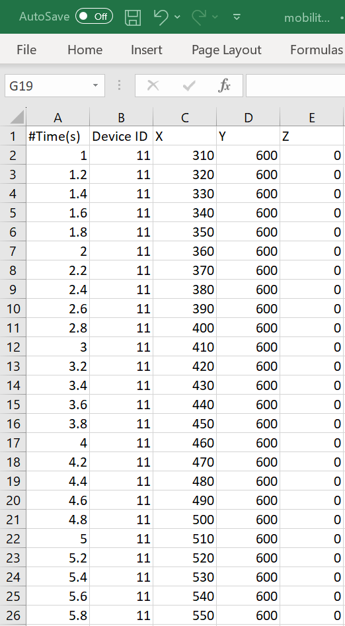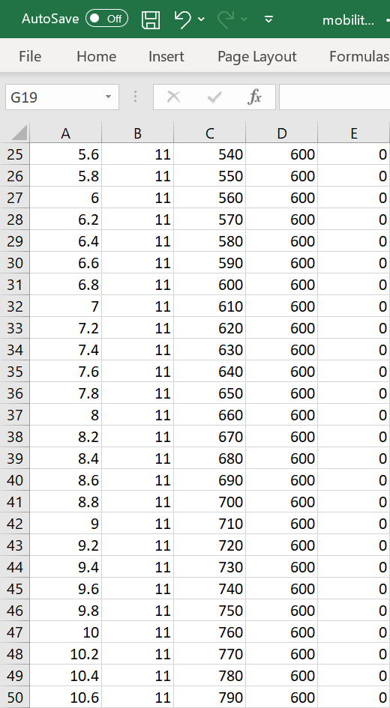

Figure 7‑6: UE mobility file for 500m

1. Before clicking on Run, select the “logs” tab in right, and check “LTENR Radio Measurements Log” as shown below.

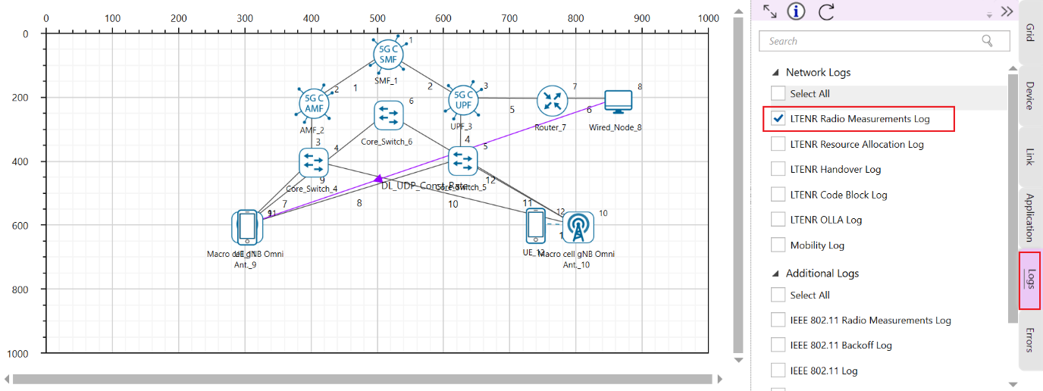

Figure 7‑7: Enabling the Log options.

1. Now, Run the Simulation for 12 s.
2. After simulation, open LTENR Radio measurement log present under the Log files section in the Results Dashboard as shown **Error! Reference source not found.**

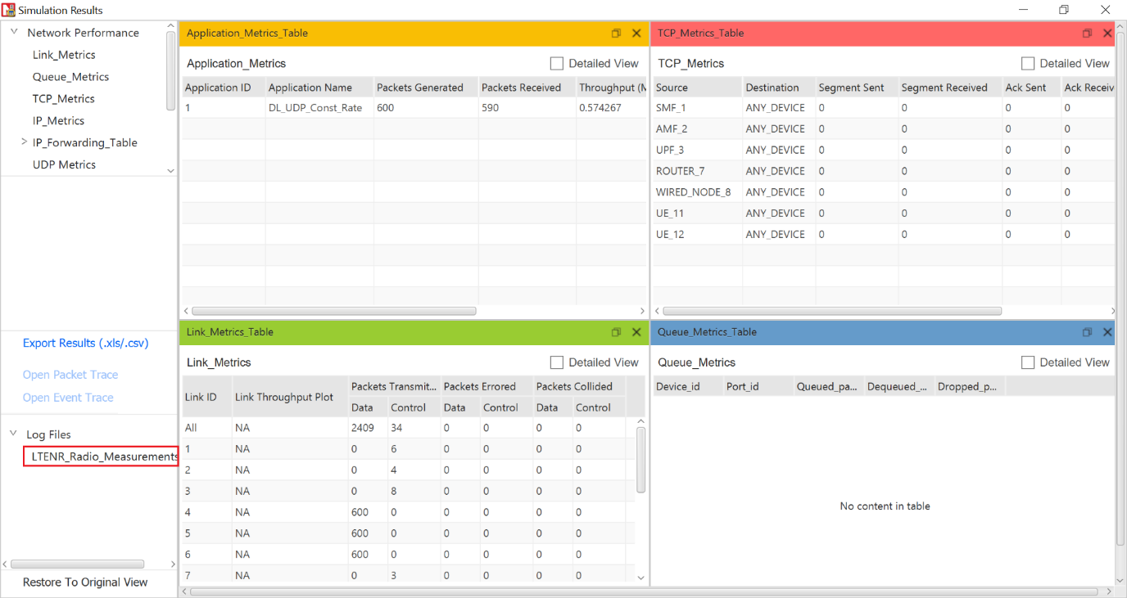

Figure 7‑8: ISD 500m simulation result Dashboard.

1. Create a pivot table for this log file by clicking the pivot option present at the top of the ribbon under insert section as shown below.

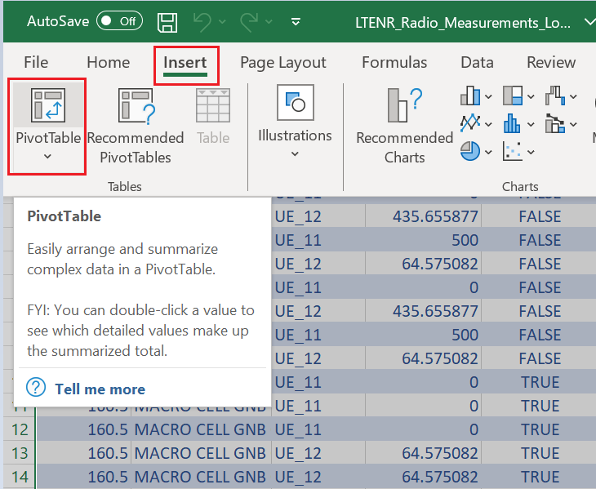

Figure 7‑9: Inserting Pivot Table

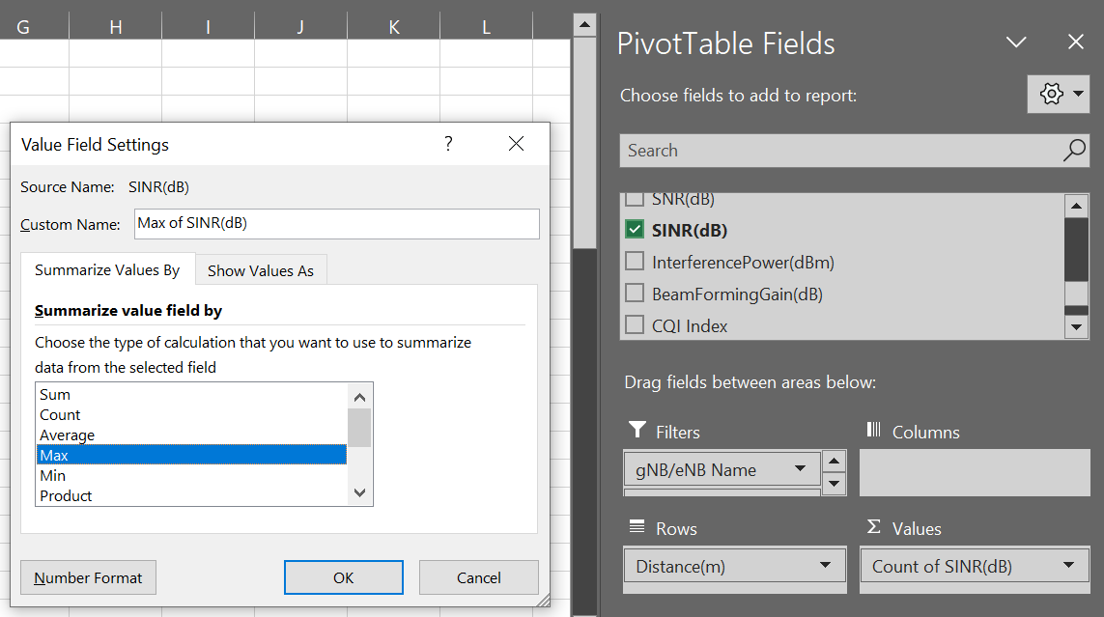

Figure 7‑10: Creating pivot table

1. In the pivot table drop ‘gNB/eNB Name’, ‘UE Name’, ‘Channel’ fields under filters area, drop ‘Distance’ in Row area and drop ‘SINR’ in Value area. Set the SINR values to max by clicking on the arrow icon present at the end of the field ->value field setting->max as shown below as shown in **Error! Reference source not found.**
2. Now filter gNB as gNB9, UE name as UE_11, Channel as PDSCH.
3. Copy the values from 0 to 290 along with Row Labels and Max_SINR_dB header and paste it into another sheet. Similarly filter gNB/eNB name to GNB_10 and copy the row label value along with SINR and paste it into next to the previously created new sheet.
4. NetSim calculates the distance of a UE from its attached gNB. In the plot that we eventually wish to obtain the X axis has distance from the initial attached gNB which is gNB9. In our experiment, UE11 is initially attached to gNB9 and post-handover it gets attached to gNB10. Since gNB9 to gNB10 distance is 500m, post-handover the distance of UE11 from the initial gNB9 is $500-d_{gNB\left(8\right)}^{UE\left(9\right)}$ i.e., $d_{gNB\left(7\right)}^{UE\left(9\right)}=500-d_{gNB\left(8\right)}^{UE\left(9\right)}$
5. Copy the Row table and distance to the empty cells after filtering that gNB/eNB Name to gNB10 and UE Name to UE11 as shown in **Error! Reference source not found.**
6. In the adjacent cell calculate the UE_11 distance from gNB_9 as shown below as shown in **Error! Reference source not found.**. Observe that it is initially $d_{gNB\left(7\right)}^{UE\left(9\right)}$ and post-handover it is $500-d_{gNB\left(8\right)}^{UE\left(9\right)}$
7. Distance between UE11 and gNB9, $d_{gNB\left(7\right)}^{UE\left(9\right)}$, along with the SINR value and copy them into new cells
8. Filter it from the ascending order/ smallest to largest, copy these values to the paste it below the previously created new sheet as shown in **Error! Reference source not found.**

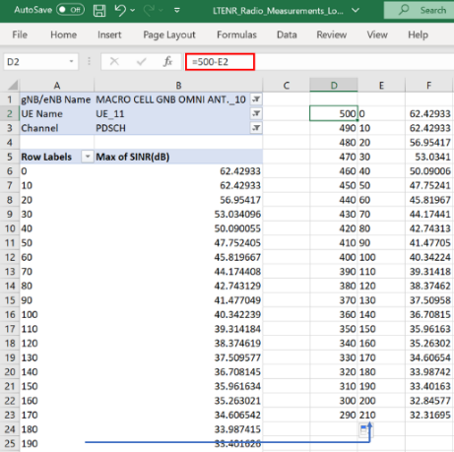

Figure 7‑11: Copying the Distance and SINR values into new cells.

**Error! Reference source not found.**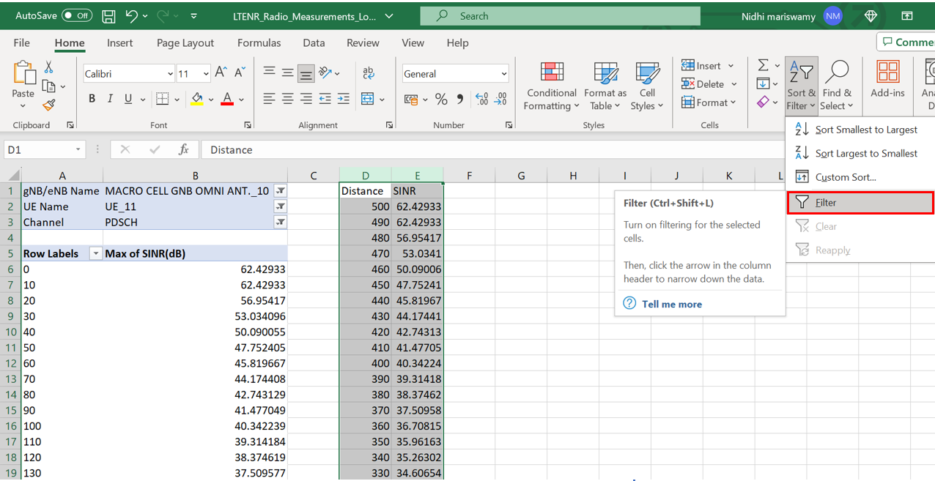

Figure 7‑12: Inserting filter

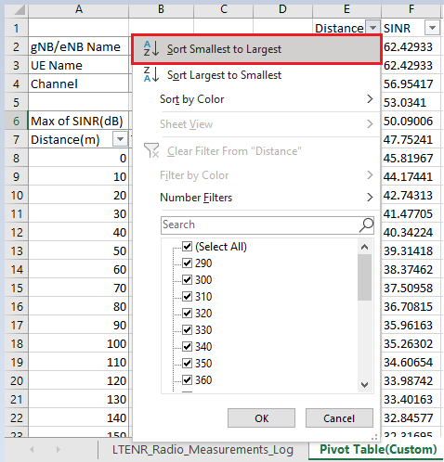

Figure 7‑13: Sorting from smallest to largest

**Results**

|  |  |  |  |  |  |  |  |  |  |  |  |  |  |  |  |  |  |  |  |  |  |  |  |  |  |  |  |  |  |  |  |  |  |  |  |  |  |  |  |  |  |  |  |  |  |  |  |  |  |  |  |  |  |  |  |  |  |  |  |  |  |  |  |  |  |  |  |  |  |  |  |  |  |  |  |  |  |  |  |  |  |  |  |  |  |  |  |  |  |  |  |  |  |  |  |  |  |  |  |  |  |  |  |  |  |  |  |  |  |
| --- | --- | --- | --- | --- | --- | --- | --- | --- | --- | --- | --- | --- | --- | --- | --- | --- | --- | --- | --- | --- | --- | --- | --- | --- | --- | --- | --- | --- | --- | --- | --- | --- | --- | --- | --- | --- | --- | --- | --- | --- | --- | --- | --- | --- | --- | --- | --- | --- | --- | --- | --- | --- | --- | --- | --- | --- | --- | --- | --- | --- | --- | --- | --- | --- | --- | --- | --- | --- | --- | --- | --- | --- | --- | --- | --- | --- | --- | --- | --- | --- | --- | --- | --- | --- | --- | --- | --- | --- | --- | --- | --- | --- | --- | --- | --- | --- | --- | --- | --- | --- | --- | --- | --- | --- | --- | --- | --- | --- | --- |
| |  |  | | --- | --- | | Distance | Max of SNR(dB) | | 0 | 62.43 | | 10 | 62.43 | | 20 | 56.95 | | 30 | 53.03 | | 40 | 50.09 | | 50 | 47.75 | | 60 | 45.82 | | 70 | 44.17 | | 80 | 42.74 | | 90 | 41.48 | | 100 | 40.34 | | 110 | 39.31 | | 120 | 38.37 | | 130 | 37.51 | | 140 | 36.71 | | 150 | 35.96 | | 160 | 35.26 | | 170 | 34.61 | | 180 | 33.99 | | 190 | 33.40 | | 200 | 32.85 | | 210 | 32.32 | | 220 | 31.81 | | 230 | 31.33 | | 240 | 30.87 | | 250 | 30.43 | | 260 | 30.00 | | 270 | 29.59 | | 280 | 29.20 | | 290 | 28.82 |   Table 7‑4: Downlink SINR values for gNB_9, with ISD = 500m | |  |  | | --- | --- | | Distance | Max of SNR(dB) | | 290 | 32.32 | | 300 | 32.85 | | 310 | 33.40 | | 320 | 33.99 | | 330 | 34.61 | | 340 | 35.26 | | 350 | 35.96 | | 360 | 36.71 | | 370 | 37.51 | | 380 | 38.37 | | 390 | 39.31 | | 400 | 40.34 | | 410 | 41.48 | | 420 | 42.74 | | 430 | 44.17 | | 440 | 45.82 | | 450 | 47.75 | | 460 | 50.09 | | 470 | 53.03 | | 480 | 56.95 | | 490 | 62.43 | | 500 | 62.43 |   Table 7‑5: Downlink SINR results gNB_10, with ISD = 500m |

## Case 2: No interference in both base stations with $η=4$

|  |  |
| --- | --- |
| gNB9 > Interface 5G RAN | |
| PathLoss Model | LOG_DISTANCE |
| PathLoss Exponent | 4 |
| Downlink Interference | No Interference |
| gNB 10 > Interface 5G RAN | |
| PathLoss Model | LOG_DISTANCE |
| PathLoss Exponent | 4 |
| Downlink interference | No Interference |

Table 7‑6: Properties set for Case 02.

Set the above property values and simulate the scenario for 12 sec. Tabulate the results obtained from LTENR Radio measurement log in the simulation metrics window.

## **Case 3: UE to Both Base stations is in $η=2.5$** .

|  |  |
| --- | --- |
| gNB 9 > Interface 5G RAN | |
| PathLoss Model | LOG_DISTANCE |
| PathLoss Exponent | 2.5 |
| Downlink Interference | Exact geometric model |
| gNB 10 > Interface 5G RAN | |
| PathLoss Model | LOG_DISTANCE |
| PathLoss Exponent | 2.5 |
| Downlink interference | Exact geometric model |

Table 7‑7: Properties set for Case 03.

Set the above property values and simulate the scenario for 12 sec. Tabulate the results obtained from LTENR Radio measurement log in the simulation metrics window.

## Case 4: UE to Both Base stations with $η=4$.

|  |  |
| --- | --- |
| gNB 9 > Interface 5G RAN | |
| PathLoss Model | LOG_DISTANCE |
| PathLoss Exponent | 4 |
| Downlink Interference | Exact geometric model |
| gNB 10 > Interface 5G RAN | |
| PathLoss Model | LOG_DISTANCE |
| PathLoss Exponent | 4 |
| Downlink interference | Exact geometric model |

Table 7‑8: Properties set for Cae 04.

Set the above property values and simulate the scenario for 12 sec. Tabulate the results obtained from LTENR Radio measurement log in simulation metrics window.

## Results - UE with $η=2.5, and 4$

|  |  |  |  |
| --- | --- | --- | --- |
| Distance | Case #2 DL SINR (dB) | Case #3 DL SINR (dB) | Case #4DL SINR (dB) |
| 0 | 45.66 | 39.50 | 45.58 |
| 10 | 45.66 | 39.28 | 45.58 |
| 20 | 36.90 | 33.59 | 36.81 |
| 30 | 30.63 | 29.44 | 30.53 |
| 40 | 25.92 | 26.26 | 25.81 |
| 50 | 22.18 | 23.69 | 22.06 |
| 60 | 19.08 | 21.51 | 18.96 |
| 70 | 16.45 | 19.62 | 16.31 |
| 80 | 14.16 | 17.93 | 14.01 |
| 90 | 12.13 | 16.40 | 11.97 |
| 100 | 10.32 | 15.00 | 10.14 |
| 110 | 8.67 | 13.70 | 8.47 |
| 120 | 7.17 | 12.48 | 6.95 |
| 130 | 5.79 | 11.33 | 5.54 |
| 140 | 4.50 | 10.23 | 4.23 |
| 150 | 3.31 | 9.18 | 3.01 |
| 160 | 2.19 | 8.16 | 1.85 |
| 170 | 1.14 | 7.18 | 0.76 |
| 180 | 0.15 | 6.23 | -0.28 |
| 190 | -0.79 | 5.30 | -1.27 |
| 200 | -1.68 | 4.39 | -2.22 |
| 210 | -2.52 | 3.49 | -3.14 |
| 220 | -3.33 | 2.61 | -4.04 |
| 230 | -4.10 | 1.73 | -4.91 |
| 240 | -4.84 | 0.86 | -5.77 |
| 250 | -5.55 | 0.00 | -6.61 |
| 260 | -6.23 | -0.87 | -7.46 |
| 270 | -6.88 | -1.74 | -8.31 |
| 280 | -7.51 | -2.62 | -9.17 |
| 280 | -3.33 | -2.62 | -4.04 |
| 290 | -2.52 | -3.50 | -3.14 |
| 290 | -2.52 | 3.49 | -3.14 |
| 300 | -1.68 | 4.39 | -2.22 |
| 310 | -0.79 | 5.30 | -1.27 |
| 320 | 0.15 | 6.23 | -0.28 |
| 330 | 1.14 | 7.18 | 0.76 |
| 340 | 2.19 | 8.16 | 1.85 |
| 350 | 3.31 | 9.18 | 3.01 |
| 360 | 4.50 | 10.23 | 4.23 |
| 370 | 5.79 | 11.33 | 5.54 |
| 380 | 7.17 | 12.48 | 6.95 |
| 390 | 8.67 | 13.70 | 8.47 |
| 400 | 10.32 | 15.00 | 10.14 |
| 410 | 12.13 | 16.40 | 11.97 |
| 420 | 14.16 | 17.93 | 14.01 |
| 430 | 16.45 | 19.62 | 16.31 |
| 440 | 19.08 | 21.51 | 18.96 |
| 450 | 22.18 | 23.69 | 22.06 |
| 460 | 25.92 | 26.26 | 25.81 |
| 470 | 30.63 | 29.44 | 30.53 |
| 480 | 36.90 | 33.59 | 36.81 |
| 490 | 45.66 | 39.28 | 45.58 |
| 500 | 45.66 | 39.50 | 45.58 |

Table 7‑9: Results for SINR vs. distance for ISD-500m downlink.

### Discussion

Initially (in case 1), the UE is attached to $BS_{1}$. In the scenario, the UE moves in a straight line towards $BS_{2}$ and at 290 m it is handed over to $BS_{2}.$ Till 290 m the “desired” signal is from $BS_{1}$ while the “interfering” signal is from $BS_{2}$. Post-handover there is a reversal; the desired signal is from $BS_{2}$ while the interfering signal is from $BS_{1.}$

Signals from $BS_{1}$ and from $BS_{2}$ to the UE undergo pathloss. If the transmit powers at both $BS$ s are $P_{t}$ then the $SINR$ works out to be

$$SINR=\frac{P_{t}×PL\left(d\right)}{N_{0}×W+P_{t}×PL\left(d_{ISD}-d\right)}$$

Where $PL\left(d\right)$ is the pathloss loss (per the 3GPP pathloss models) at a distance of $d$. Since the distance between the two $BS$ s is equal to $d_{ISD}$, the inter site distance, the UE is at a distance of $(d_{ISD}-d$) from the interfering $BS$, and hence the $PL(d_{ISD}-d)$ term in the denominator. When there is a line-of-sight (LOS) condition with a gNB, the path loss is lower, modelled here by setting the path loss exponent as 2.5. When there is a non-line-of-sight (NLOS) condition with a gNB, the path loss is higher, modelled here by setting the path loss exponent as 4.

With this background, let us look **Error! Reference source not found.**

* In all cases, we see a constant SINR till 10m because the pathloss equations defined in the standard take effect only from 10m.
* SINR. vs distance is plotted for four cases
  + Case #1: UE is in LOS with both BSs, interference is turned off
  + Case #2: UE is in NLOS with both BSs, interference is turned off
  + Case #3: UE is in LOS with both BSs, with interference turned on
  + Case #4: UE is in NLOS with both BSs, with interference turned on

**Note: Here, we use the terms LOS for $η=2.5$, and NLOS for $η=4,$ for simplicity.**

* In case 1 and case 2, the term $I$ in $SINR=\frac{P_{r}}{N_{0}W+I}$ is set to zero. Practically, this means that the two BSs operate in non-overlapping frequency bands. Therefore, $SINR=SNR=\frac{P_{r}}{N_{0}W}$.We see the SNR dropping as the UE moves away from $BS_{1}$. At 280/290m, it gets handed over to $BS_{2}$, and we see the SNR increasing as the UE moves closer to $BS_{2}$. Why is there a “jump” at the handover point? This is because the standards specify that handover should occur only when target-gNB’s SINR is offset (3 dB) higher than serving-gNB’s SINR. This condition is satisfied at 280m. You are encouraged to think about the question: Why does the standard specify such an offset?
* Next, we observe that the NLOS curve (purple) is lower than the LOS curve (blue). This is because NLOS pathloss is higher than the LOS pathloss.
* In Cases 3, and 4, the observations are similar to above, but they are lower than their respective counterparts in cases 1 and 2, due to additional interferences which degrade the SINR further. Further, we notice that the two curves of cases 2 and 4 are very close to each other. Why?
  + Open the log files for these cases and observe the following: The pathloss is more pronounced in these cases, and the interference also decays faster than the case (3) case. Hence, the effect of interference is not very pronounced, leading to almost similar performance.
  + **Optional Exercise**: Check whether the gap between the two curves increases by increasing gNB transmit powers (i.e., increasing the interference power).

## Understanding the points of handoff

For the sake of exposition, we investigate the point of hand-off for case #1 and case #2 where the interferences are assumed to be absent from the base-stations. This therefore represents a noise limited regime, or a scenario where the two BSs use non-overlapping frequency bands. In such a scenario, as the UE moves from BS1 towards BS2, the SNR from BS1 decreases, while the SNR from BS2 increases. The point where the SNR from BS2 is 3 dB higher than that from BS1 determines the point of handoff. But we observe that between the cases with path loss exponents of 2.5 and 4, the points of handovers are different! Why? Read the discussion below.

**Further Discussion:**

For the sake of generality, we discuss the effect of path loss exponent on handover in a general setting independent of the values obtained in the experiment. Consider the scenario:

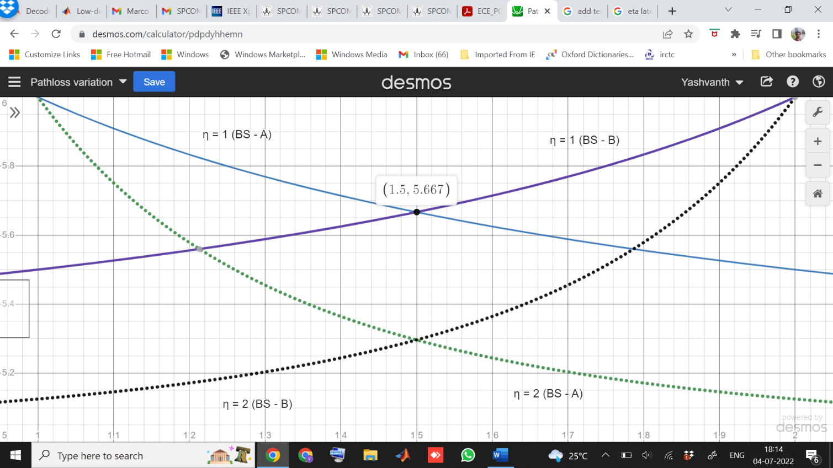

$$∆_{HO}$$

Received SNR

$$∆_{HO}$$



Base station A

Base station B

d0 (in NLOS)

X

d0 (in LOS)

Y

Distance (Km)

Fig 7‑1: Illustration of different handover points in LOS/NLOS cases

**Case A: Noise limited scenario**

Let a UE move from base station A towards base station B with inter site distance = 1 km as shown above. Consider for the moment that we are in a noise-limited regime, where the interferences are assumed to be absent from the base-stations. In such a scenario, as the UE moves from BS A towards BS B, the SNR seen by the UE from BS A decreases, while the SNR seen from BS B increases. For example, let the path loss exponent be set to 1 (ƞ=1), then solid blue curve represents the received SNR as a function of distance seen from BS A, while solid purple curve represents the received SNR as a function of distance seen from BS B. Further, assume that $∆_{HO}$ is the “handoff threshold” or “handover margin”, i.e., the required SNR difference between the base stations in order to perform a handoff from BS A to BS B. Let the distance at this point be d0. This point is indicated by the point Y in the above plot.

However, when the path loss exponent increases to 2, i.e., ƞ=2, the received SNR from both the BSs changes and the corresponding curves are shown in the above figure using dashed lines. Clearly, due to the differing slopes in the SNR curves at different values of ƞ, **the point at which the handoff occurs is different** (in fact it occurs earlier than the former case) and this point is indicated by X.

**Conclusion**: The point of handoff is different for environments with different pathloss exponents for a given handoff threshold.

**Remarks:** Observe from the figure that, as we increase the path loss from 1 to 2, the point of handoff occurs at d = 1.7 Km and d = 1.76 Km, respectively. This difference is more pronounced when the pathloss difference increases.

**Case B: Interference limited scenario.**

In this case, a similar plot (like above) can be used for handoff analysis, except that y-axis will now have the SINR instead of SNR. It is an exercise for the reader to understand and explain the impact of interference on the handover points in the LOS/NLOS cases.

## Exercises

Let the last two digits of your trainee ID be xx. Then set the inter-gNB distance to (500 + ceil(xx/2)) meters in the GUI.

1. Replicate the above experiment (reproduce table 7, and figure 10,11 and 12, only) for all the four cases. Set the mobility profile accordingly.
2. Repeat question – 1 using a different band (for example n5 or low band, 850 MHz). Justify the changes in your results compared to Q1 (if any.)
3. In the above two exercises, no fluctuations in the channel were enabled. Now, repeat question (1) by adding shadowing in the simulations and observe possible ping-pong handovers. Interpret your observations with suitable justifications.

## References

[1] M. Haenggi and R. K. Ganti, “Interference in Large Wireless Networks,” 2009.

Note:

Go to the gNB properties. Then under 5G RAN settings: select following:

1. Duplex Mode: FDD
2. CA Type: SINGLE_BAND

# On the Study of MAC Scheduling algorithms in 5G Communications

Objective

In this experiment, we understand how different scheduling algorithms affect the UDP download throughput of a multi-user (multi-UE) system. We will focus on three popular scheduler algorithms: Max-rate scheduler, Proportional fair (PF), and round-robin scheduler, and gain insights on the following aspects.

1. How does the throughput vary in networks with multiple UEs when channel is not time varying?
2. How does the throughput vary in networks with multiple UEs when channel is time varying?
3. Understanding the design of the proportional fair scheduler.

This experiment also introduces the notion of **multi-user diversity**.

## Introduction

One of the key requirements of 5G systems is the support of many users communicating through a wide range of devices and applications. These conditions give rise to heterogeneous traffic offered to the network. To carry such traffic in a wireless network, the design and development of schedulers capable of considering the conditions of each user is needed. Schedulers are usually the “secret sauce” to obtain superior performance of any network operator, and hence is an important design element. Among the class of several schedulers, we will focus on three popular algorithms in this experiment: **Max-rate, proportional fair (PF) and round-robin (RR).**

### Max-rate scheduler

In this type of scheduler, the gNB schedules the UE who observes the best instantaneous channel condition among all the UEs. Mathematically, in every time slot *t*, the user $k^{*}$ is selected as per the following criterion:

$k^{*}(t)=arg\max_{k∈\{1,2,…, K\}}{{|h_{k}(t)|}^{2}}$,

where $h_{k}$ is the channel seen by $k$ th user from the gNB in a *K* user system. This scheduler ensures that the total system throughput is the best possible among all other schedulers.

To understand the effect of max-rate scheduling on the impact of system throughput, we first understand the behavior of the metric $\max_{k∈\{1,2,…, K\}}{{|h_{k}(t)|}^{2}}$ as a function of *K*, the total number of UEs in the system. As an example, if we consider that every UE experiences a Rayleigh channel from the gNB and assuming that channels across UEs are independent, we can show that the probability distribution of the metric is shown below



Figure 8‑1: probability density function of $\max_{k∈\{1,2,…, K\}}{{|h_{k}(t)|}^{2}}.$

From above figure, as the total number of UEs increases, the best channel “hardens”, i.e., it concentrates around its mean value, and the support of the distribution keeps shifting towards the right, indicating that the average SNR seen by the system under max-rate scheduling monotonically increases with the number of UEs in the system. The following theorem accurately quantifies this behavior.

**Theorem 1:** Assume that a system is equipped with a single antenna gNB and UE with independent Rayleigh channels across the UEs. Then, under max-rate scheduling, the system spectral efficiency $R^{(K)}$ asymptotically (i.e., as K gets large) scales as

$\lim_{K →∞}\left(R^{(K)}-\log_{2}\left(1+\frac{P}{σ^{2}}×\log_{e}{(K)}\right)\right)=0$,

where P and $σ^{2}$ denote the transmit power and receiver noise power, respectively.

Thus, we see that the average SNR of this system scales as $\log_{e}{(K)}$ with K, the number of UEs, when max-rate scheduling is employed. This effect of obtaining additional gain in the SNR by having multiple (or many) users in the system and **opportunistically** scheduling the UEs in every time-resource element is called **multi-user diversity**.

A naïve way to implement this type of scheduling strategy is to first broadcast a common pilot symbol (possibly in a mini slot) by the gNB to all the UEs, and each UE computes the CQI using the above expression. Then, all UEs feedback only their CQI, and the gNB schedules that UE with the best UE. This process repeats in every time slot.

The max-rate scheduler achieves the highest possible system throughput and is therefore attractive to an operator that wants to maximize its revenue, when the revenue depends mainly on the amount of data consumed by the UEs. It’s drawback? A user who is far away from the gNB always sees a weak channel and would therefore rarely be scheduled. Such a user may remain unhappy and switch away from the operator, resulting in a loss of revenue in the long term. The round-robin scheduler, discussed next, is at the opposite end of the spectrum: it is absolutely fair across the users, but loses out on the achievable network throughput.

### Round-robin (RR)

In this type of scheduling mechanism, the emphasis of the scheduler is to ensure fairness among UEs in scheduling. As discussed above, although the max-rate scheduler achieves the highest system throughput, it does not ensure fairness among users in terms of the relative number of times any UE is scheduled. For example, if a UE is located on the cell edge, then it is highly unlikely that the UE will get scheduled at any time slot due to high path loss which deteriorates the CQI of the UE. To tackle this problem, the RR scheduler completely disregards the instantaneous CQI and schedules the users one after the other, in a round-robin fashion. This ensures that every user gets equal resource allocation regardless of the instantaneous CQI. A toy illustration the mechanism of RR scheduling is shown below, in a system with 4 users.

1 time slot

Scheduling chart:

|  |  |  |  |  |  |  |  |  |  |
| --- | --- | --- | --- | --- | --- | --- | --- | --- | --- |
| UE – 1 | UE – 2 | UE – 3 | UE – 4 | UE – 1 | UE – 2 | UE – 3 | UE – 4 | …… | ……. |

Round: n + 1

Round: n

Clearly, there is no feedback required from the UE to gNB, unlike the max – rate scheduler.

### Proportional-fair (PF)

It is clear that while the max-rate scheduler achieves the highest sum rate, it does not ensure fairness among users. On the other hand, the RR scheduler ensures highest fairness among users, while the throughput of the system is compromised. This necessitates the need for a scheduler that strikes a good trade-off between achievable throughput and fairness in the system. This is accomplished by the proportional-fair scheduler. In PF scheduler, in any time slot *t*, user $k^{*}$ is selected as follows:

$k^{*}\left(t\right)= arg\max_{k∈\{1,2,…, K\}}{\frac{R_{k}(t)}{T_{k}(t)}}$,

where $R_{k}\left(t\right)=\log_{2}\left(1+\frac{{\left|h_{k}\left(t\right)\right|}^{2}P}{σ^{2}}\right)$ and $T_{k}\left(t\right)$ are the instantaneous rate and average rate of user *k* in the system, respectively. In particular, $T_{k}\left(t\right)$ can be updated recursively as follows:

$$T_{k}\left(t+1\right)= \left\{\begin{aligned}\left(1-\frac{1}{α}\right) T_{k}\left(t\right)+\frac{1}{α} R_{k}\left(t\right), k=k^{*}(t) \\ \left(1-\frac{1}{α}\right) T_{k}\left(t\right), k≠k^{*}(t)\end{aligned}\right.$$

In the above, the parameter $α$ dictates the trade-off between the throughput and fairness in the system, and is a designer’s choice. It can be shown that,

* Higher values of $α$ makes the PF scheduler perform close to a max-rate scheduler,
* Lower values of $α (α≈1)$ makes the PF scheduler perform close to an RR scheduler.

## CASE 1: UEs at different distances and the channel is constant over time.

### Procedure

Open NetSim, Select **Examples ->5G NR ->Scheduling ->** **UEs at different distances and channel is not time varying**.Then click on one of the tiles (as required) in the middle panel to load the example as shown in below screenshot.

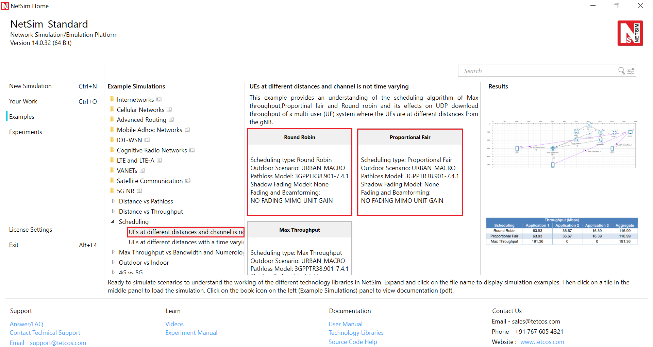

Figure 8‑2: List of scenarios for the example UEs equidistant and a time varying channel.

The following network diagram illustrates what the NetSim UI displays when you open this example configuration file.

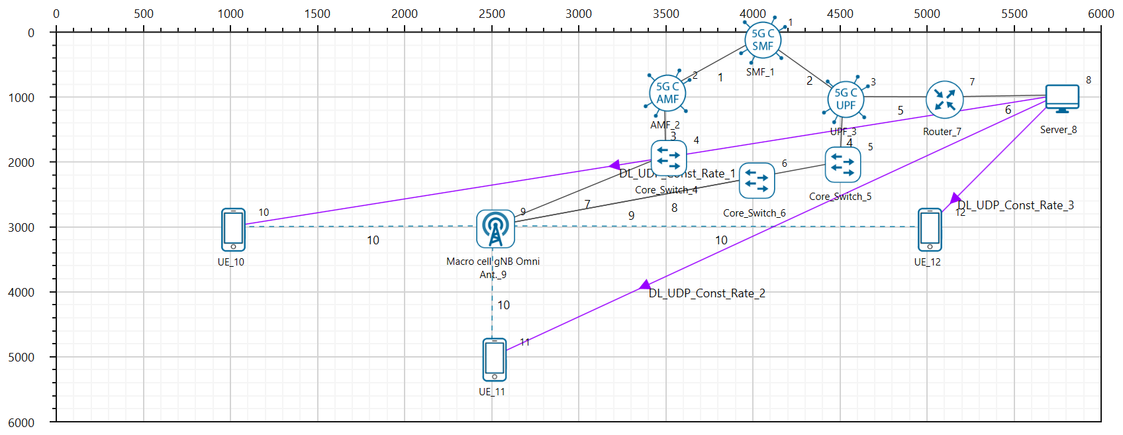

Figure 8‑3: Network set up for studying the Scheduling example.

**Configuring the scheduling algorithm, and parameter settings in example config files**

1. Set grid length as 6000 m from Environment setting.

Set distance as follows.

1. gNB_8 to UE_10 = 1500 m

gNB_8 to UE_11 = 2000 m, and

gNB_8 to UE_12 = 2500 m

Go to Wired link properties and set the properties shown below

|  |  |
| --- | --- |
| Wired Link Properties | |
| Uplink Speed | 10000 Mbps |
| Downlink Speed | 10000 Mbps |

Table 8‑1: Wired Link Properties

Go to gNB properties à Interface (5G_RAN), and set the properties shown in below table**.** In the first sample the scheduling type is set to Round Robin, in the second to Proportional fair, and in the third to Max throughput.

|  |  |
| --- | --- |
| Properties | |
| Data Link Layer Properties | |
| Scheduling Type | Varies: Proportional Fair, Max throughput, Round Robin |
| Physical Layer Properties | |
| CA Type | SINGLE_BAND |
| CA Configuration | n78 |
| CA1 | |
| Numerology | 1 |
| Channel Bandwidth | 100 MHz |
| Outdoor_Scenario | URBAN_MACRO |
| LOS NLOS Selection | USER_DEFINED |
| LOS Probabillity | 1 |
| Pathloss Model | 3GPPTR38.901-7.4.1 |
| Shadow Fading Model | None |
| Fading and Beamforming | NO_FADING_MIMO_UNIT_GAIN |

Table 8‑2: gNB >Interface (5G_RAN) >Data Link/Physical layer properties

Go to Application properties and set the properties shown in below table

|  |  |  |  |
| --- | --- | --- | --- |
| Application Properties | | | |
|  | **Application 1** | **Application 2** | **Application 3** |
| Application Type | CBR | CBR | CBR |
| Source ID | 8 | 8 | 8 |
| Destination ID | 10 | 11 | 12 |
| QoS | UGS | UGS | UGS |
| Transport Protocol | UDP | UDP | UDP |
| Packet Size | 1460Bytes | 1460Bytes | 1460Bytes |
| Inter-arrival time | 10μs | 10μs | 10μs |
| Start Time | 1s | 1s | 1s |

Table 8‑3: Application properties

Run the simulation for 1.5s and note down the throughput value from the results window in each sample. Recall that each sample has a different scheduling algorithm configured.

**Results and discussions**

The results with all the three UEs simultaneously downloading data is as given below.

|  |  |  |  |  |
| --- | --- | --- | --- | --- |
| Throughput (Mbps) | | | | |
| Scheduling | **Application 1** | **Application 2** | **Application 3** | **Aggregate** |
| Round Robin | 63.93 | 36.67 | 16.39 | 116.99 |
| Proportional Fair | 63.93 | 36.67 | 16.39 | 116.99 |
| Max Throughput | 191.36 | 0 | 0 | 191.36 |

Table 8‑4: UDP download throughputs for different scheduling algorithms when all three 3 UEs are simultaneously downloading data.

Next, consider a scenario with only one of the UEs seeing DL traffic (we don’t provide an inbuilt configuration file for this, and since it is a simple exercise for a user) First, run for the UE at 1500m, and then for UE at 2000m, 2500m. This gives the maximum achievable throughput per node since the gNB resources (bandwidth) is not shared between 3 UEs and is fully dedicated to just one UE. The results are below.

|  |  |  |  |
| --- | --- | --- | --- |
| Distance from gNB (m) | Application ID | Throughput (Mbps) | Remarks |
| 1500 | 1 | 191.36 | UE 1 alone has full buffer DL traffic |
| 2000 | 2 | 110.16 | UE 2 alone has full buffer DL traffic |
| 2500 | 3 | 49.266 | UE 3 alone has full buffer DL traffic |

Table 8‑5: UE throughputs if they were run standalone (without the other UEs downloading data)

The PHY rate is decided by the received SNR. Therefore, a UE closer to the gNB will get a higher date rate than a UE further away. In this example, the distances from the gNB are such that UE10_Distance > UE9_Distance > UE8_Distance.

In Round Robin scheduling, PRBs are allocated equally among the three UEs. However, throughputs are in the order UE8 > UE9 > UE10 because of their distances from the gNB. The individual throughputs seen by each of the UEs is exactly $\frac{1}{3}$ of the throughput shown in Table 8‑5.The PF scheduler results will match that of the RR scheduler since the channel is not time varying (why?). In Max-throughput scheduling, the PRBs are allocated such that the system gets the maximum download throughput. The nearest UE will get all the resources and its throughput will be $3$ times the throughput of the UE which got the max throughout in RR.

## CASE II: UEs at different distances and the channel is time-varying.

### Procedure

Open NetSim, Select **Examples ->5G NR ->Scheduling ->** **UEs at different distances with time varying channel**.Then click on one of the tiles (as required) in the middle panel to load the example as shown in below screenshot.

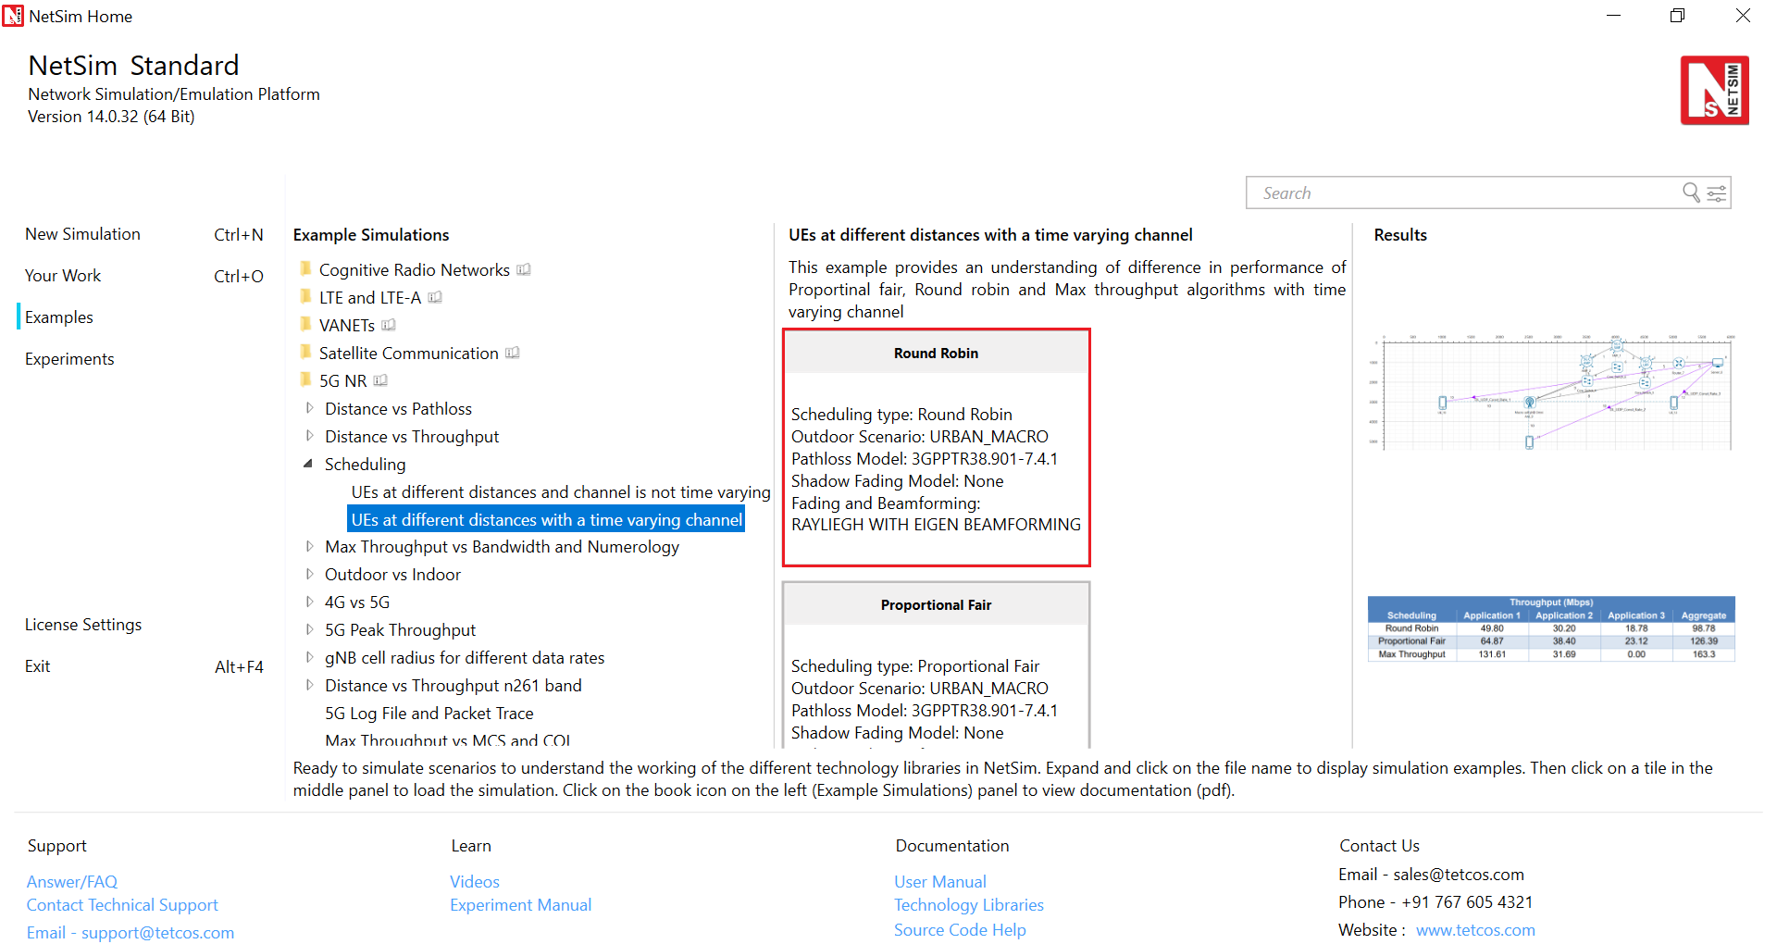Figure 8‑4: List of scenarios for the example UEs equidistant and a time varying channel

The rest of the procedure and configuration remains the same as the first case except that now we will enable the fading in the settings to obtain temporal variations in the channel.

|  |  |
| --- | --- |
| Properties | |
| Data Link Layer Properties | |
| Scheduling Type | Varies: Proportional Fair, Max throughput, Round Robin |
| Physical Layer Properties | |
| Fading and Beamforming | RAYLEIGH_WITH_EIGEN_BEAMFORMING |

Table 8‑6: Data Link Layer Properties

Run the simulation for 1.5 s and note down the throughput value from the results window in each sample.

**Results and discussion**

|  |  |  |  |  |
| --- | --- | --- | --- | --- |
| Throughput (Mbps) | | | | |
| Scheduling | **Application 1** | **Application 2** | **Application 3** | **Aggregate** |
| Round Robin | 50.38 | 29.69 | 18.73 | 98.81 |
| Proportional Fair | 64.91 | 37.98 | 23.12 | 126.01 |
| Max Throughput | 131.25 | 31.69 | 0 | 162.94 |

Table 8‑7: UDP download throughputs for different scheduling algorithms when all three 3 UEs simultaneously downloading data.

* When the channel is time-varying, the RR scheduler yields lower throughput than the PF scheduler. This is because the RR scheduler is not “opportunistic,” i.e., it does not take advantage of the knowledge that a UE has a good channel in the next slot and continues to serve the UEs cyclically irrespective of the channel state.
* We see that the performance of PFS has improved over the case of when the channel is not time-varying. This is because, when the channel fluctuates, the multi-user diversity gain improves because of more variability in the channel coefficients while performing opportunistic selection of user.
* It may appear that the performance of Max_throughput has deteriorated compared to Case I, but this is not the correct interpretation. This result is an artifact of the fact that, the simulation time was not sufficiently long enough to capture all possible channel realizations, and hence the sum-rate appears to be lower than in Case 1.

## CASE III: A study of the performance of the PF scheduler.

### Procedure

Open NetSim, Select **Examples ->5G NR ->Scheduling ->** **UEs at different distances with time varying channel**.Then click on “**Proportional Fair**” tile in the middle panel to load the example as shown in below screenshot.

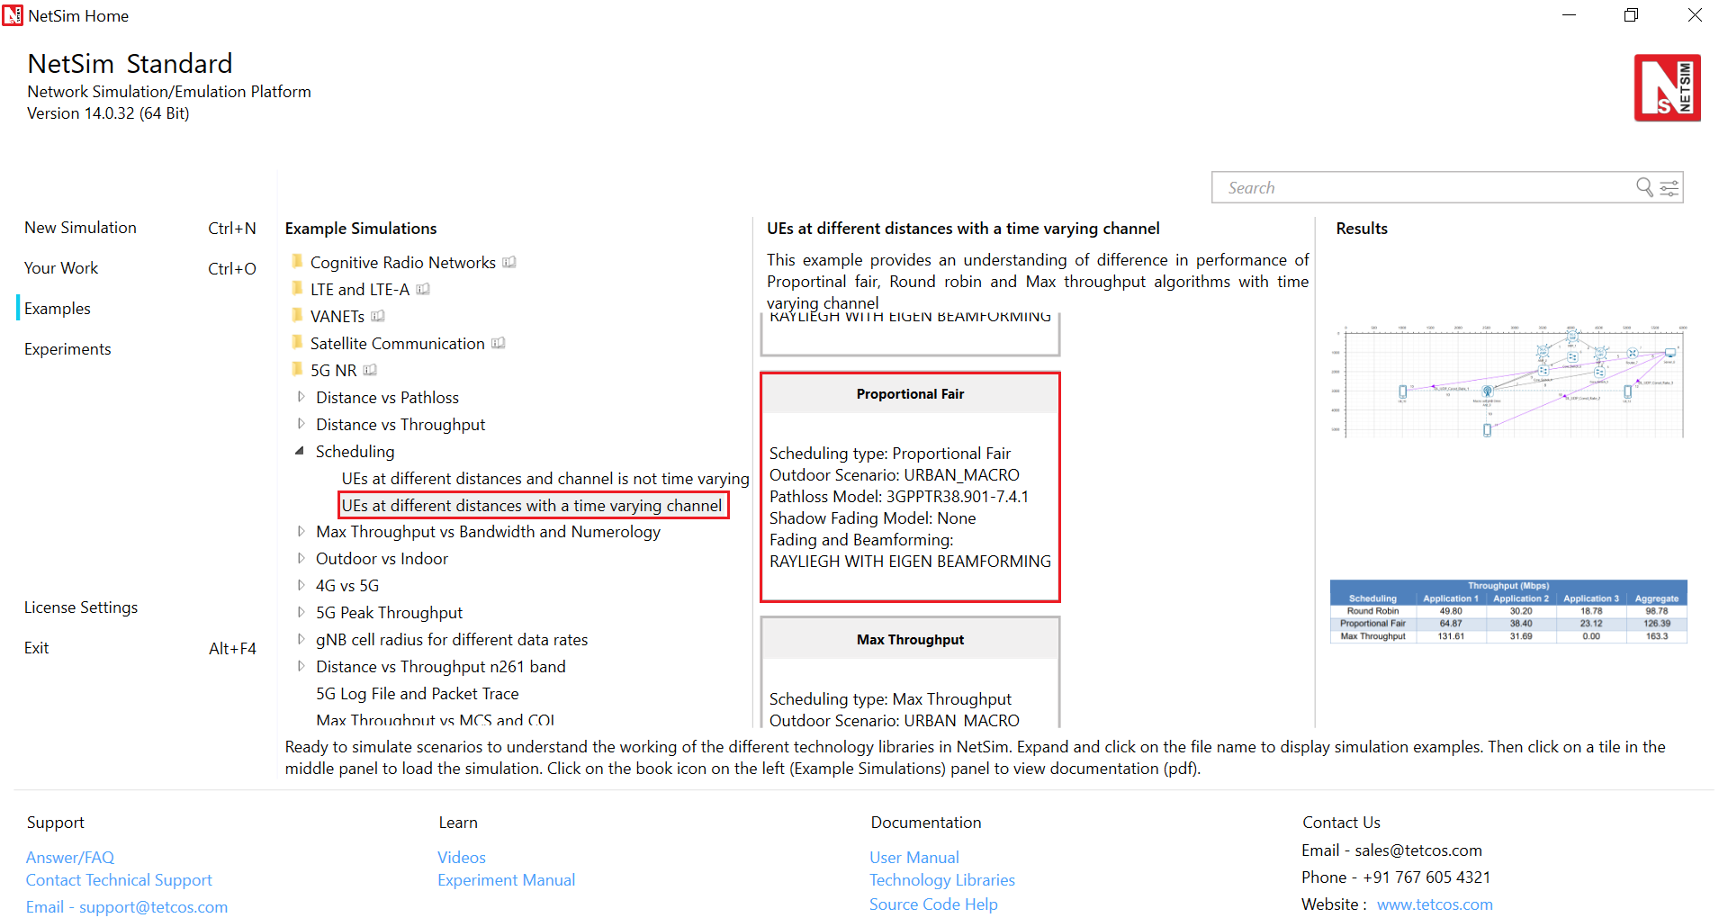Figure 8‑5: List of scenarios for the example UEs equidistant and a time varying channel.

In this study, we will understand the design of Proportional fair scheduler in detail. Specifically, we will study the performance of PFS when the factor $α$ as it appears in the average throughput calculation for the PFS is varied. Note that, in cases 1 and 2, we had $α=50$ in all cases with PFS. To change this, change the settings as follows. Note: $α$ is called as the “EWMA Averaging rate” in Netsim (EWMA stands for “exponentially weighted moving average”.)

|  |  |
| --- | --- |
| Properties | |
| Data Link Layer Properties | |
| Scheduling Type | Proportional Fair |
| EWMA Averaging rate $(α)$ | Vary: 1.001, 50, 9999 |
| Physical Layer Properties | |
| Fading and Beamforming | RAYLEIGH_WITH_EIGEN_BEAMFORMING |

Table 8‑8: gNB >Interface (5G_RAN) >Data Link/Physical layer properties

1. Now, set $α=1.001, 50,$ and $9999$ successively, and obtain the throughputs of the three UEs under PF scheduler.
2. The rest of the procedure and settings remain the same as in Case – II.
3. Run the simulation for 1.5 s and note down the throughput value from the results window.

**Results and discussion**

|  |  |  |  |  |
| --- | --- | --- | --- | --- |
| Throughput (Mbps) | | | | |
| Scheduling using PFS | **Application 1** | **Application 2** | **Application 3** | **Aggregate** |
| $$α=1.001$$ | 54.26 | 30.62 | 16.93 | 101.81 |
| $$α=50$$ | 64.91 | 37.98 | 23.12 | 126.01 |
| $$α=9999$$ | 70.05 | 42.42 | 23.38 | 135.85 |

Table 8‑9: UDP download throughputs for PFS scheduling when all three 3 UEs are simultaneously downloading data.

We make the following observations:

* In all cases, the throughputs of UEs vary as UE_10 > UE_11 > UE_12. This is because of the increasing path loss of these UEs.
* At any given UE, as $α$ is varied, the throughput varies as: $α=9999$ > $α=50$ > $α= 1.001$. The reason for this observation is: as $α$ increases, the performance gets closer to that of a max-rate scheduler, and as $α$ decreases, it tends to a round robin scheduler. It must be noted that these are slightly hand-waving explanations; in fact, the PFS retains fairness over a sufficiently long time window, whose duration depends on the value of $α$, so PFS does not quite “reduce” to the max rate scheduler for any value of $α$. These corroborate well with the theory.

**YOUR EXERCISES:**

**Let xx be last two digits of your trainee ID.**

1. **The first exercise is to understand the working of round-robin, max-rate and PF schedulers, as in Table 4. Take 3 UEs in an asymmetrical scenario, with the inter-gNB distances set as per the following:**

**gNB-UE_1 distance = 1400 + (2*xx);**

**gNB-UE_2 distance = 1900 + (2*xx);**

**gNB-UE_3 distance = 2400 + (2*xx);**

**Replicate table 4 for this case and make inferences. Compare your results with that in table 4.**

1. **In this exercise, we will study the effect of multi-user diversity by varying the number of transmit antennas at the gNB and observe the throughputs. For this experiment, consider only the performance of the max-rate and PF schedulers. Further, consider all UEs placed at the same distance from the gNB, with inter gNB- UE distance = 1400 + (2*xx);**

**Vary the transmit antenna count as 1, 4, and 128 at the gNB only and replicate table 7 (where fading is enabled) for each antenna count. Infer your results and justify.**

1. **In this exercise, we will demonstrate the utility of multi-user diversity as a function of the number of UEs in the system. Consider a symmetrical scenario such that inter gNB-UE distance = 1400 + (2*xx). Enable fading in the system (i.e., case – II of this experiment.)**

* **First place 2- UEs in the system, and obtain the throughputs of max-throughput scheduler, PFS with $α=1.1$, PFS with $α=100$, PFS with $α=9999$. Compute the aggregate throughputs in each of the cases.**
* **Now repeat the above exercise when there are 4, 5, 8, and 10 UEs in the system with four aggregate throughputs (for max-throughput scheduler, PFS with $α=1.1$, PFS with $α=100$, PFS with $α=9999$) for each of 4 –, 5 –, 8 –, and 10 – UE systems.**
* **Report all your values in the form of a tabular column as given below.**

|  |  |  |  |  |  |
| --- | --- | --- | --- | --- | --- |
| Aggregate Throughput (Mbps) in symmetrical scenario | | | | |  |
| Scheduler | **2 – UE system** | **4 – UE system** | **5 – UE system** | **8 – UE system** | **10 – UE system** |
| Max – rate | To be filled | To be filled | To be filled | To be filled | To be filled |
| PFS; $α=1.1$ | To be filled | To be filled | To be filled | To be filled | To be filled |
| PFS; $α=100$ | To be filled | To be filled | To be filled | To be filled | To be filled |
| PFS; $α=9999$ | To be filled | To be filled | To be filled | To be filled | To be filled |

* **Now plot a graph showing the aggregate throughput (y-axis) as a function of number of UEs (x-axis) for different scheduling schemes (different curves).**
* **Infer and justify all your results.**

**HINT:**

**Read Sec. II of the following paper, and you might want to produce plots like** Error! Reference source not found. **of this paper.**

***[1] Yashvanth, L., & Chandra R. Murthy. (2022). “Performance Analysis of Intelligent Reflecting Surface Assisted Opportunistic Communications”. ArXiv. Link:*** [***https://arxiv.org/abs/2203.06313***](https://arxiv.org/abs/2203.06313)

**Note: In the above paper, $α$ denotes a channel fluctuation factor and $τ$ denotes the PF scheduler constant (which was denoted by $α$ in this experiment).**

**Note: To insert a new UE in the network, do the following:**

1. **Click on the UE icon on the top toolbar and click it again on the grid somewhere near the gNB. You can change the co-ordinate of the UE to achieve a inter-gNB UE distance as you want! This question has to have to a symmetrical network!**
2. **Establish a connection between the gNB and UE by clicking on option "Wired/wireless" on the top toolbar and connect both the gNB and new UE by placing mouse at the gNB, then click it, and click the mouse again after placing the mouse at the UE.**
3. **Then add a new application: Click on the "Application" option on the top toolbar, and create a new application - to do this, in the application box, on the left, there will be option to create a new application (look at "+" symbol). After creating one, change the source node to the device ID of the "Wired Node" icon in the GUI; may be this is device ID 10 - please recheck this. Then select the destination ID as the device ID of the newly inserted UE.**
4. **Please ensure that all the "Application properties" and "UE properties" of the newly inserted UE are identical to the existing UEs for fair comparisons.**
5. **Repeat this procedure for all the other UEs.**

# Study of 5G Handover procedure

## Objective

In this experiment, we will study the procedure of handovers in 5G networks in more details. We will study the following aspects through Netsim **v14.0**:

1. The process of handover signaling via packet analysis through the RAN and core-network.
2. The impact of handover on the delay and throughput of the UE under handover.

## Introduction

The handover logic of NetSim 5G library is based on the Strongest Adjacent Cell Handover Algorithm[13]. The algorithm enables each UE to connect to that gNB which provides the highest Reference Signal Received Power (RSRP). Therefore, a handover occurs when a better gNB (adjacent cell has offset stronger RSRP, measured as SNR in NetSim) is detected.

Netsim implements a handover procedure similar to that described in 3GPP TS 38.331, Sec. 5.5.4.4, Event A3, wherein a handover occurs when a Neighbor cell’s RSRP becomes Offset better than serving cell’s RSRP. Note that in NetSim report-type is periodic, not event Triggered, since NetSim is a discrete event simulator, not a continuous time simulator.

This algorithm is susceptible to ping-pong handovers; continuous handovers between the serving and adjacent cells on account of changes in RSRP due mobility and shadow-fading. At one instant the adjacent cell's RSRP could be higher and the very next it could be the original serving cell's RSRP, and so on.

To solve this problem the algorithm uses:

1. Hysteresis (Hand-over-margin, HOM) which adds a RSRP threshold (Adjacent_cell_RSRP - Serving_cell_RSRP > Hand-over-margin, or hysteresis), and
2. Time-to-trigger (TTT) which adds a time threshold.

This HOM is part of NetSim implementation while TTT can be implemented as a custom project in NetSim. The reader is requested to refer to experiment – 7 for a discussion on the process of handovers and related theory from the PHY viewpoint.

## Network Setup

Open NetSim and click on **Experiments> 5G NR> Handover in 5GNR> Handover Algorithm** then click on the tile in the middle panel to load the example as shown below. In the next section, Select the Throughput and delay variation in the handover column: Effect of handover on Delay and Throughput.

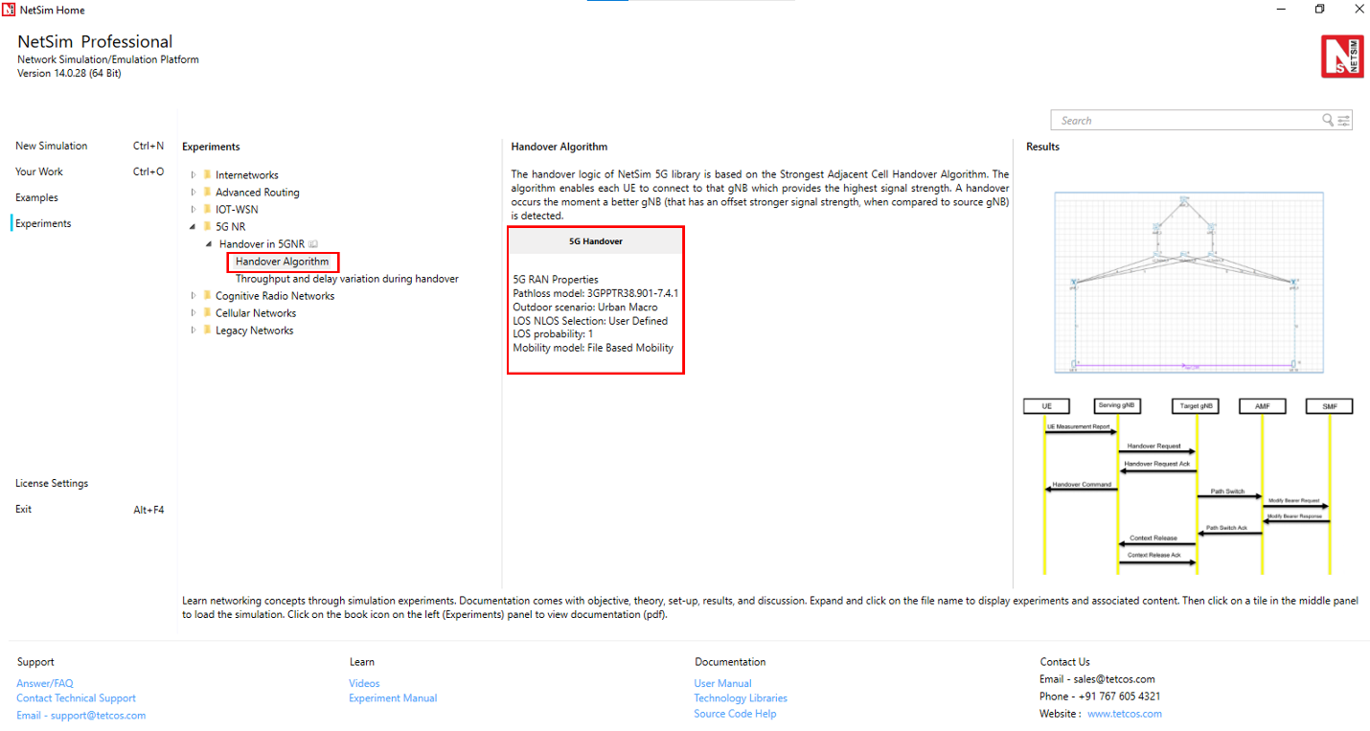

Figure 9‑1: List of scenarios for the example of Handover in 5GNR

## Part 1: Handover Algorithm

The Netsim UI displays the network configuration for this experiment as shown below

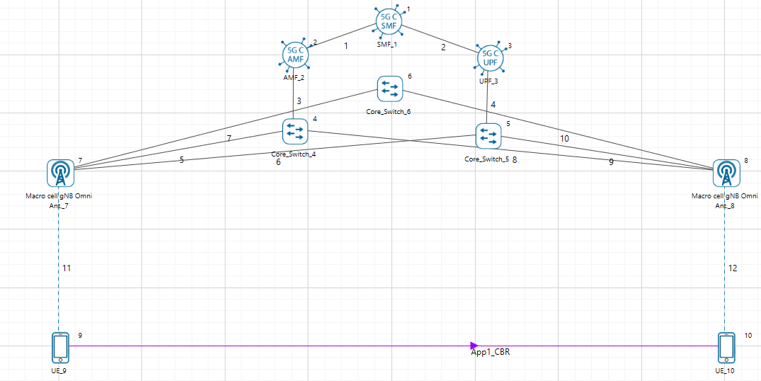

Figure 9‑2: Network set up for studying the 5G handover.

### Procedure for 5G Handover

The following set of procedures were done to generate this sample:

**Step 1:** A network scenario is designed in NetSim GUI comprising of 5G-Core, 2 gNBs, and 2 UEs in the **“5G NR”** Network Library.

**Step 2:** The device positions are set as per the table given below table

|  |  |  |  |  |
| --- | --- | --- | --- | --- |
|  | gNB 7 | gNB 8 | UE 9 | UE 10 |
| X Co-ordinate | 500 | 4500 | 500 | 4500 |
| Y Co-ordinate | 1500 | 1500 | 3000 | 3000 |

Table 9‑1: Device positions

**Step 3:** In the General Properties of UE 9 and UE 10, set Mobility Model as File Based Mobility.

**Step 4:** Right click on the gNB_7 and select Properties, the following is set Table 9‑2Table 9‑2.

|  |  |
| --- | --- |
| Interface_4(5G_RAN) Properties | |
| CA_Type | Single Band |
| CA_Configuration | n78 |
| CA_Count | 1 |
| Numerology | 0 |
| Channel Bandwidth (MHz) | 10 |
| PRB Count | 52 |
| MCS Table | QAMLOWSE |
| CQI Table | Table 3 |
| X_Overhead | XOH0 |
| DL UL Ratio | 4:1 |
| Pathloss Model | 3GPPTR38.901-7.4.1 |
| Outdoor Scenario | Urban Macro |
| LOS_NLOS_Selection | User_Defined |
| LOS Probability | 1 |
| Shadow Fading Model | None |
| Fading _and_Beamforming | NO_FADING_MIMO_UNIT_GAIN |
| Additional Loss Model | None |

Table 9‑2:gNB_7 > 5G_RAN Interface Properties Window

Similarly, it is set for gNB 8.

**Step 5:** The Tx_Antenna_Count was set to 2 and Rx_Antenna_Count was set to 1 in gNB > Interface (5G_RAN) > Physical Layer.

**Step 6:** The Tx_Antenna_Count was set to 1 and Rx_Antenna_Count was set to 2 in UE > Interface (5G_RAN) > Physical Layer.

**Step 7:** Configure applications between any two nodes by selecting an application from Set Traffic Tab.Right click on the Application Flow **App1 CBR** and select properties.

A CBR Application is generated from UE 9 i.e., Source to UE 10 i.e., Destination with Packet Size remaining 1460 Bytes and Inter Arrival Time remaining 20000µs. QOS is set to UGS.

Additionally, the **“Start Time(s)”** parameter is set to 40, while configuring the application.

**File Based Mobility:**

In File Based Mobility, users can write their own custom mobility models and define the movement of the mobile users. Create a mobility.txt file for UE’s involved in mobility with each step equal to 0.5 sec with distance 50 m.

The NetSim Mobility File (mobility.csv) format appears on a excel sheet which looks like the following figures:

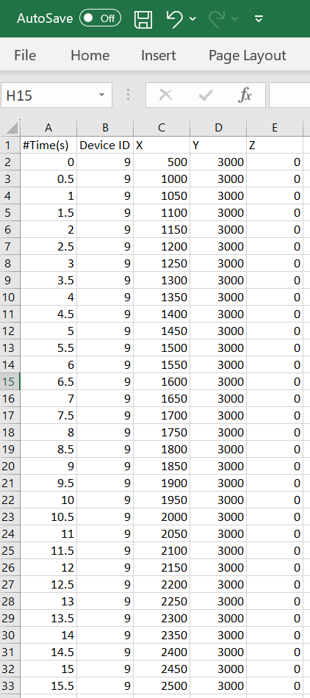 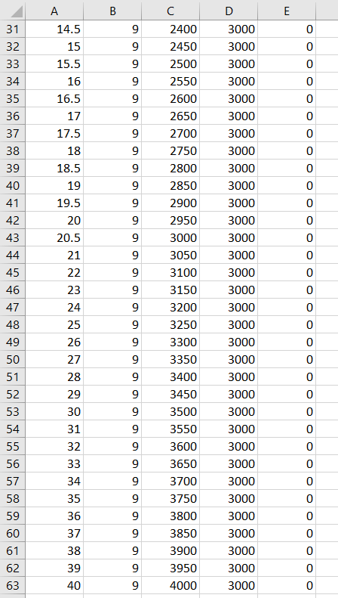

Figure 9‑3: Mobility file sample

**Step 8:** Packet Trace is enabled in NetSim GUI. At the end of the simulation, a very large .csv file containing all the packet information is available for the users to perform packet level analysis. Plots is enabled in NetSim GUI.

**Step 9:** The log file can enable per the information provided in **Section 3.20** 5G-NR technology library document.

**Step 10:** Run the simulation for 50 seconds.

### Results and Discussion

**Handover Signaling**



Figure 9‑4: Control packet flow in the 5G handover process

The packet flow depicted above can be observed from the packet trace.

1. UE will send the UE_MEASUREMENT_REPORT every 120 ms to the connected gNB
2. The initial UE-gNB connection and UE association with the core takes place by transferring the RRC and Registration, session request response packets.
3. As per the configured file-based mobility, UE 9 moves towards gNB 8.
4. After 18.6 s gNB 7sends the HANDOVER REQUEST to gNB 8.
5. gNB 8 sends back HANDOVER REQUEST ACK to gNB 7.
6. After receiving HANDOVER REQUEST ACK from gNB 8, gNB 7 sends the HANDOVER COMMAND to UE 9.
7. After the HANDOVER COMMAND packet is transferred to the UE, the target gNB will send the PATH SWITCH packet to the AMF via Switch 5.
8. When the AMF receives the PATH SWITCH packet, it sends MODIFY BEARER REQUEST to the SMF.
9. The SMF, on receiving the MODIFY BEARER REQUEST, provides an acknowledgement to the AMF.
10. On receiving the MODIFY BEARER RESPONSE from the SMF, AMF acknowledges the Path switch request sent by the target gNB by sending the PATH SWITCH ACK packet back to the target gNB via Switch 5.
11. The target gNB sends CONTEXT RELEASE to source gNB, and the source gNB sends back CONTEXT RELEASE ACK to target gNB. The context release request and ack packets are sent between the source and target gNB via Switch 6.
12. RRC Reconfiguration will take place between target gNB and UE 9.
13. The UE 9 will now start sending the UE MEASUREMENT REPORT to gNB 8.

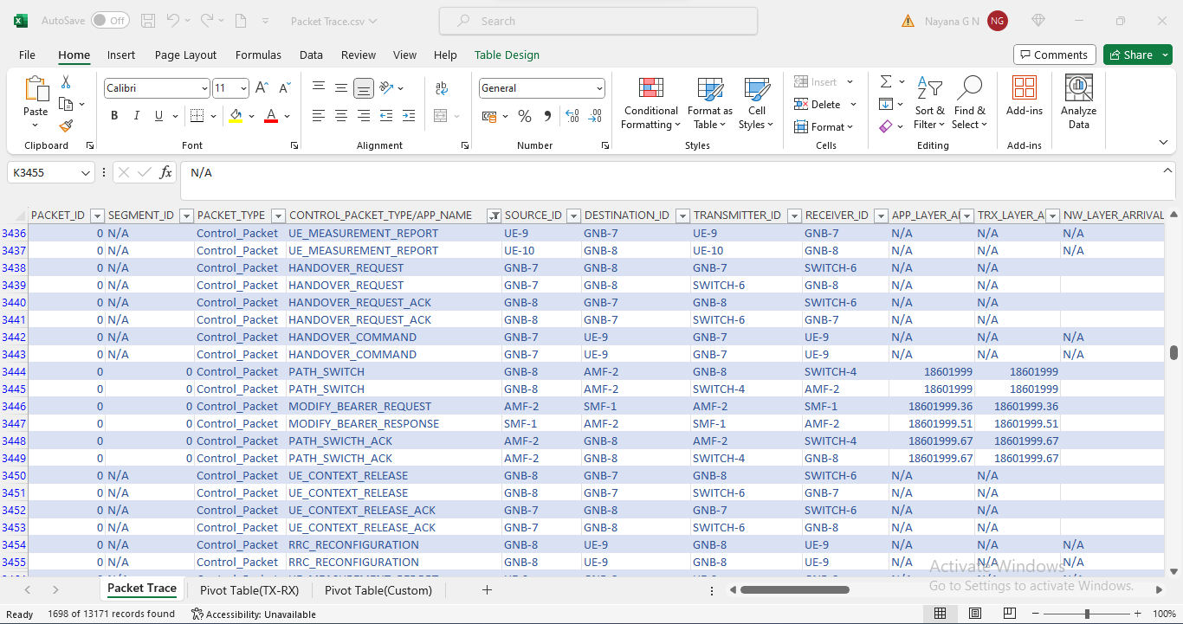

Figure 9‑5: Screenshot of NetSim packet trace file showing the control packets involved in handover. Some columns have been hidden before the last column.

### Plot of SNR vs. Time

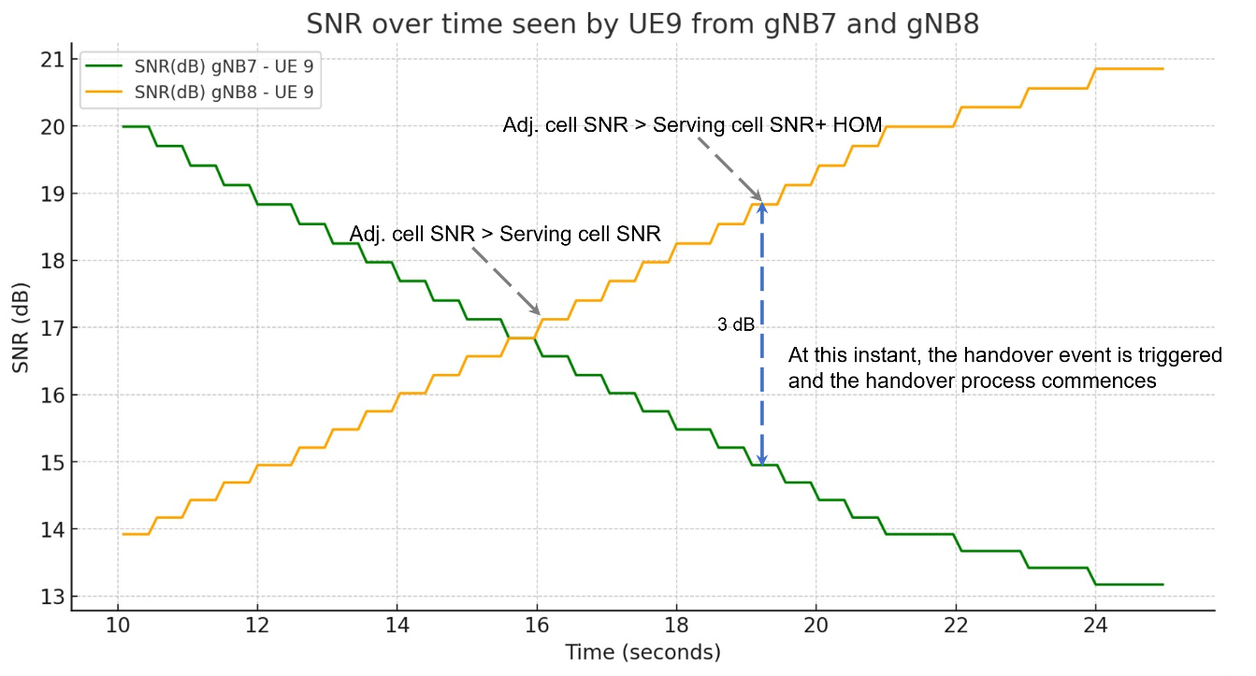

Fig ‑: Plot of DL SNR (at UE_3 from gNB1 and gNB2) vs time. The handover process shown in *Error! Reference source not found.*commences when Adj_cell_SNR > Serving_cell_SNR + Hand_over_Margin

This plot can be got from the LTENRLog file. However, it would involve a fair amount of time and effort. You can open the log file and see the values, instead of plotting. (You can obtain the values using Pivot tables, and the previous experiments contains the information required to work with pivot tables.)

* Time 15.60s, the SNR from gNB7 is 7.81dB and the SNR from gNB8 is also 7.81dB. This represents the point where the two curves intersect.
* Time 18.6s, the SNR from gNB7 is 6.18 dB and the SNR from gNB8 is 9.51dB. This represents the point where Adj cell RSRP is greater than serving cell RSRP by the Hand-over-margin (HOM) of 3 dB.

## Part 2: Throughput And Delay Variation During Handover

First, open the relevant configuration file by selecting: **Experiments> 5G NR> Handover in 5GNR> Throughput and delay variation during handover** > **Effect of handover on Delay and Throughput.** See figure below:

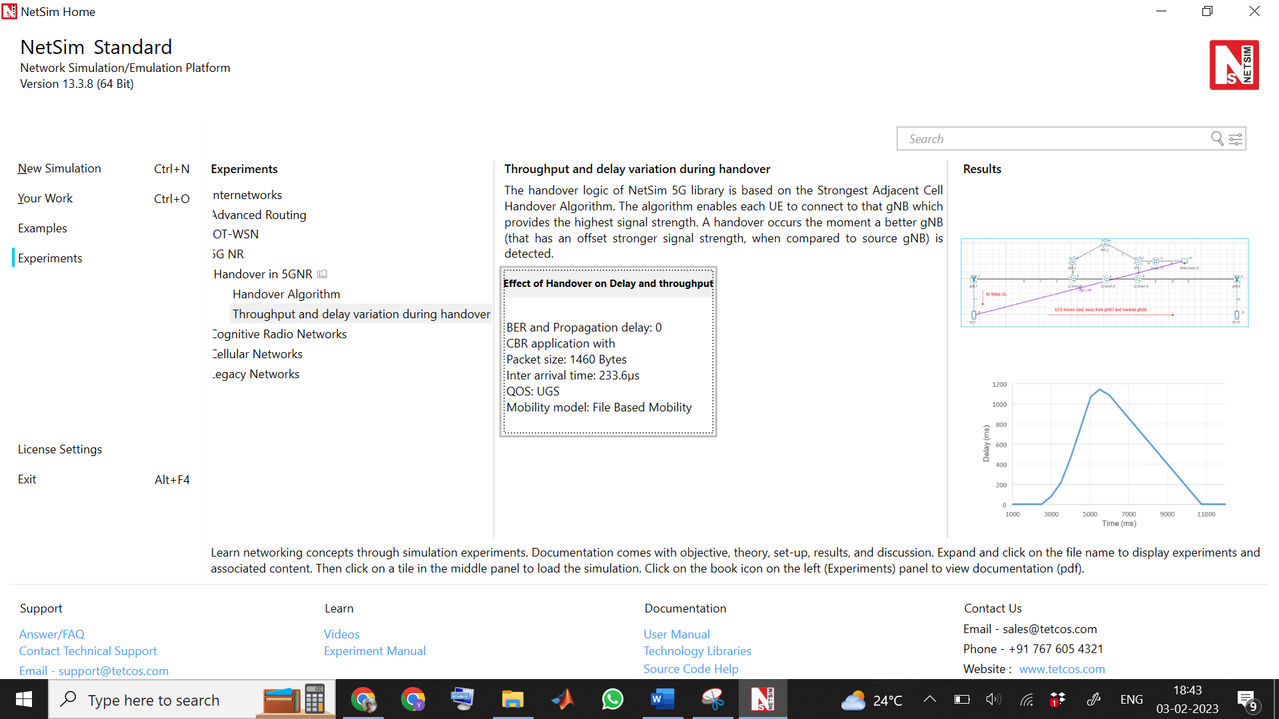

Fig 9‑2: NetSim UI displays the configuration file corresponding to this experiment as shown below

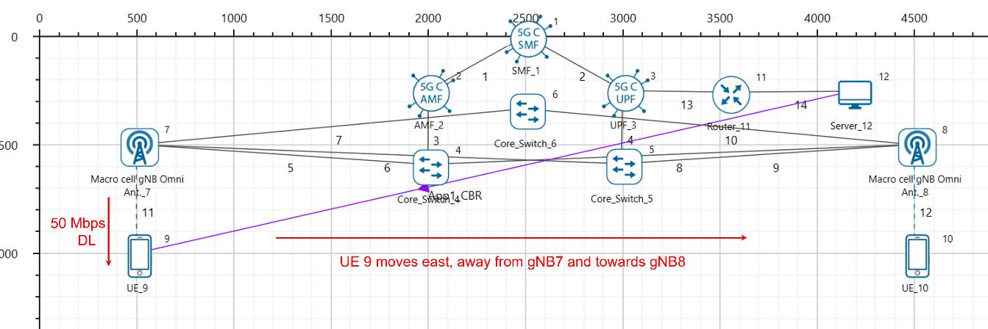Fig 9‑3: Network set up for studying the throughput and delay variation during handover

### Procedure for Effect of Handover on Delay and Throughput

The following set of procedures were done to generate this sample:

**Step 1:** A network scenario is designed in NetSim GUI comprising of 2 gNBs, 5G Core, 1 Router, 1 Wired Node and 2 UEs in the **“5G NR”** Network Library.

**Step 2:** The device positions are set as per the table given in Table 9‑3

|  |  |  |  |  |
| --- | --- | --- | --- | --- |
|  | gNB 7 | gNB 8 | UE 9 | UE 10 |
| X Co-ordinate | 500 | 4500 | 500 | 4500 |
| Y Co-ordinate | 500 | 500 | 1000 | 1000 |

Table 9‑3: Device positions.

**Step 3:** Right click on the gNB 7 and select Properties and set the following.

|  |  |
| --- | --- |
| Interface(5G_RAN) Properties |  |
| CA_Type | Single Band |
| CA_Configuration | n78 |
| CA_Count | 1 |
| Numerology | 0 |
| Channel Bandwidth (MHz) | 10 |
| PRB Count | 52 |
| MCS Table | QAM64 |
| CQI Table | Table 1 |
| X_Overhead | XOH0 |
| DL UL Ratio | 4:1 |
| Pathloss Model | 3GPPTR38.901-7.4.1 |
| Outdoor Scenario | Urban Macro |
| LOS_NLOS Selection | User_Defined |
| LOS Probability | 1 |
| Shadow Fading Model | None |
| Fading _and_Beamforming | NO_FADING_MIMO_UNIT_GAIN |
| Additional Loss Model | None |

Table 9‑4: gNB _7> Interface(5G_RAN) Properties Setting.

Similarly, it is set for gNB 8.

**Step 4:** The Tx_Antenna_Count was set to 2 and Rx_Antenna_Count was set to 1 in gNB > Interface (5G_RAN) > Physical Layer.

**Step 5:** The Tx_Antenna_Count was set to 1 and Rx_Antenna_Count was set to 2 in UE > Interface (5G_RAN) > Physical Layer.

**Step 6:** In the General Properties of UE 9 and UE 10, set Mobility Model as File Based Mobility.

**Step 7:** The BER and propagation delay was set to zero in all the wired links.

**Step 8:** Right click on the Application Flow **App1 CBR** and select Properties or click on the Application icon present in the top ribbon/toolbar.

A CBR Application is generated from Wired Node 12 i.e., Source to UE 9 i.e., Destination, with Packet Size 1460 Bytes and Inter Arrival Time 233.6µs. QOS is set to UGS.

Additionally, the **“Start Time(s)”** parameter is set to 1, while configuring the application.

**File Based Mobility:**

In File Based Mobility, users can write their own custom mobility models and define the movement of the mobile users. Create a mobility.txt file for UE’s involved in mobility with each step equal to 0.5 sec with distance 50 m.

The NetSim Mobility File (mobility.csv) looks like the following figure:

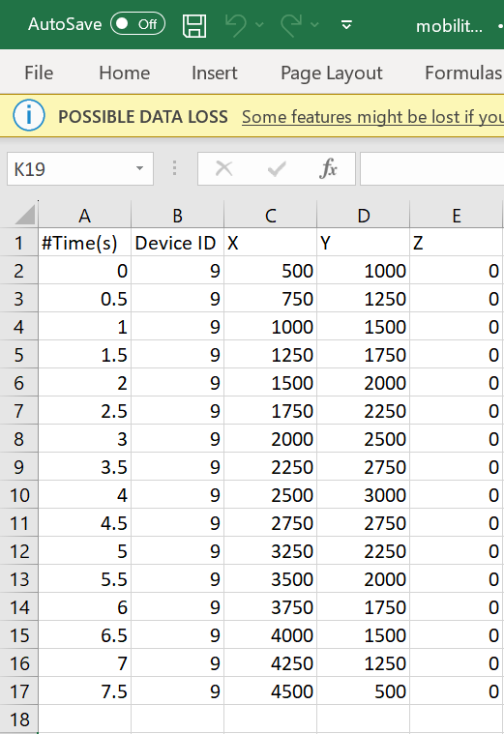

Fig 9‑4: Mobility file sample

**Step 9:** Packet Trace and Event Trace is enabled in NetSim GUI. At the end of the simulation, a very large .csv file containing all the packet information is available for the users to perform packet level analysis. Plots is enabled in NetSim GUI.

**Step 10:** The log file is populated as per the information provided in **Section 3.20** 5G NR technology library document.

**Step 11:** Run the simulation for 20 seconds.

### Computing the delay and throughput

#### Delay computation from Event Traces

The output excel trace files for this experiment exceeds 1-million and given below are the steps to to generate pivot table when operating on large excel files.

1. After simulation save the experiment
2. Open a blank workbook in MS Excel

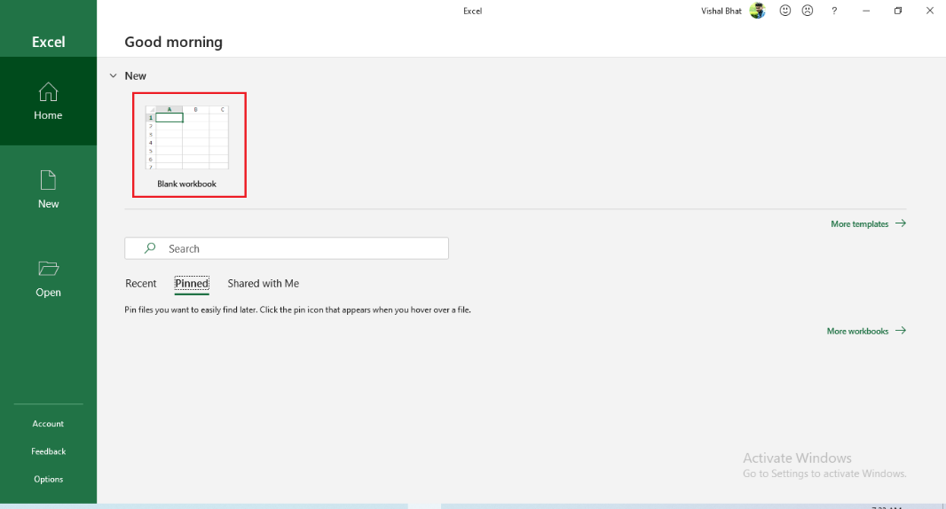

Fig 9‑5: Blank Sheet

1. Go to Data > Get & Transform Data

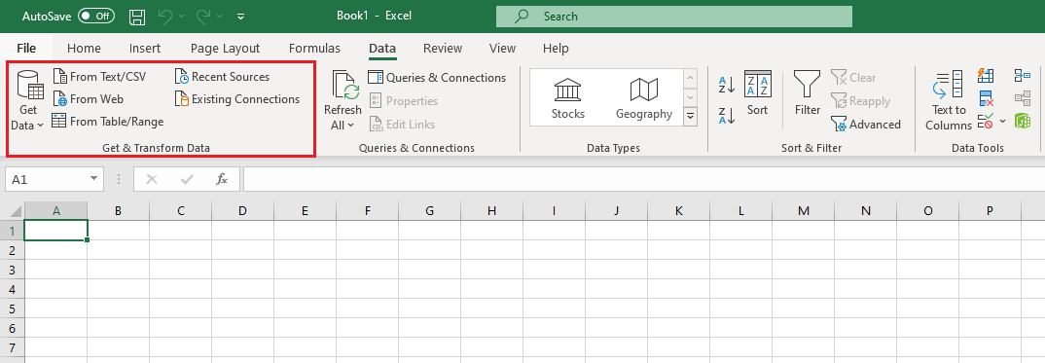

Fig 9‑6: Get & Transform Data

1. Click on From Text/CSV.
2. Browse to find the CSV file generated by NetSim. This will be in the experiment folder. For example, <Workspace Location>/Experiment name/<Event Trace> and click on Import

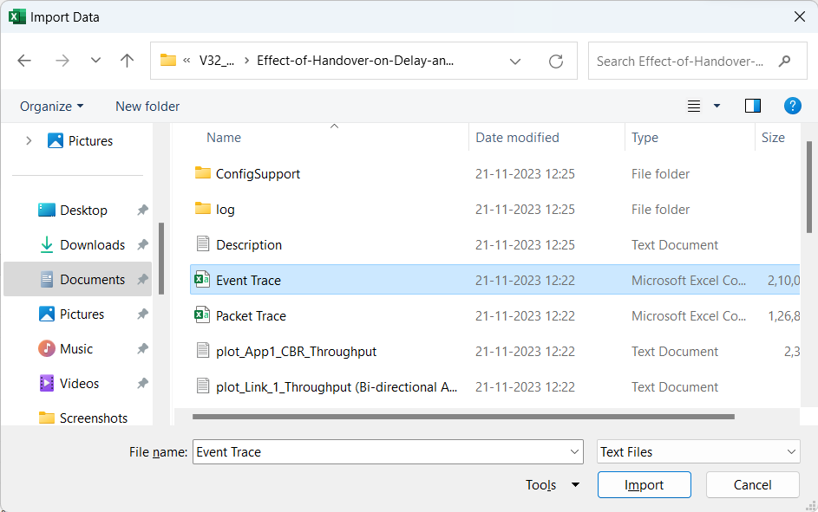

Fig 9‑7: Import Event Trace

1. Click on Load To (shown at the bottom in red).

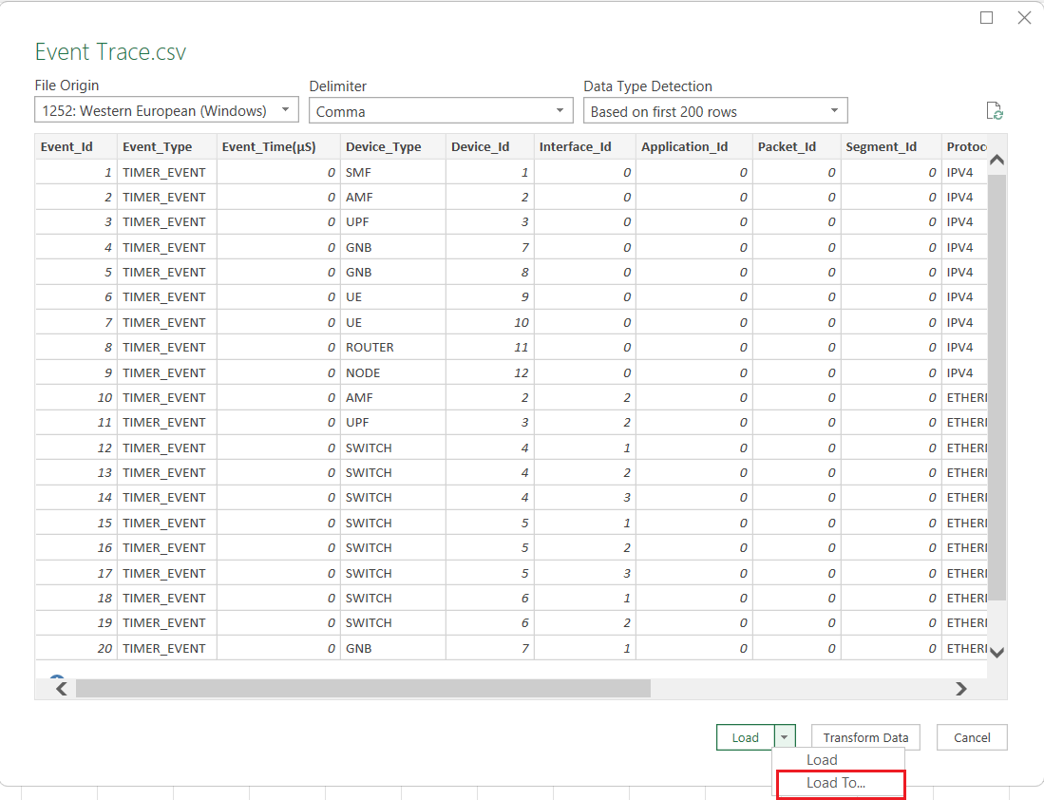

Fig 9‑8: Value Field Settings to Sum of Event Time

1. Now click on PivotTable Report to generate the Pivot Table.

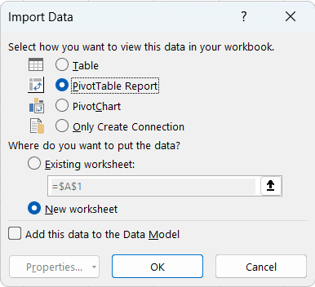

Fig 9‑9: Generating Pivot Table

1. This will create a new sheet with Pivot Table as shown below.

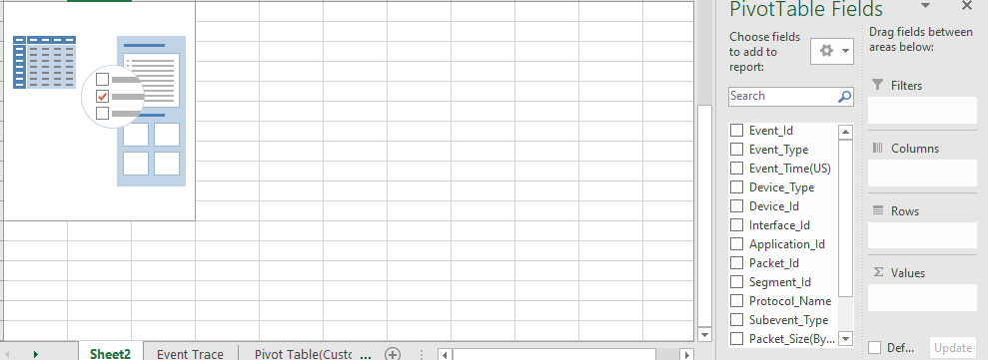

Fig 9‑10: Blank Pivot Table

1. Now drag and drop **Packet_Id** to **Rows** field. Similarly, drag and drop the following: **Event_Type** to **Columns** field, **Event_Time** to **Values** field as shown below.

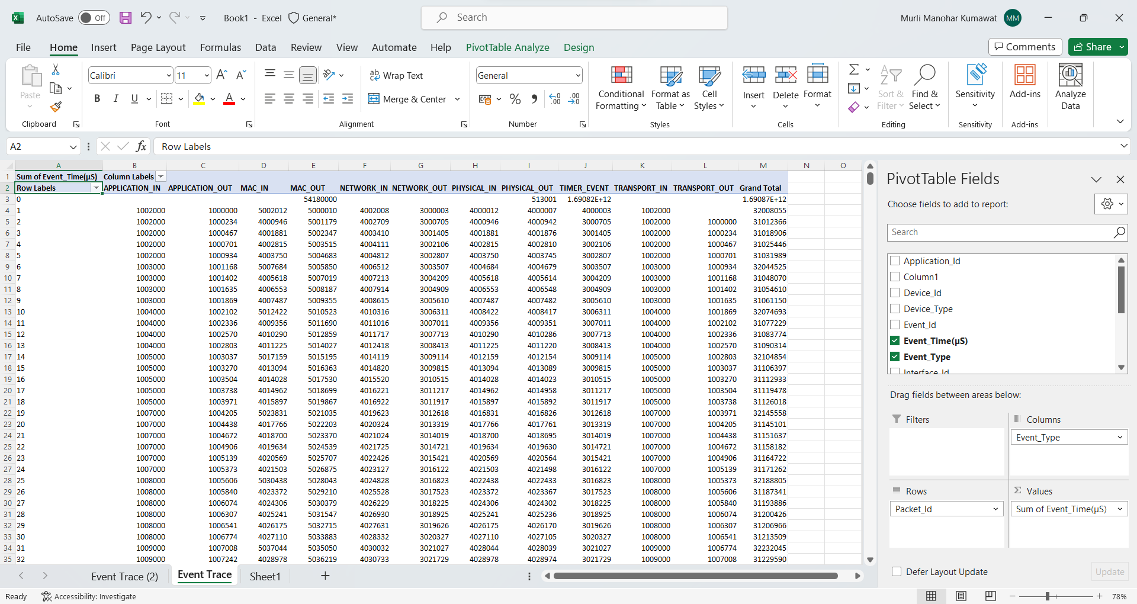

Fig 9‑11: Adding fields into Columns, Rows and Values

1. Now in the Pivot table formed, filter **Event_Type** to **APPLICATION_IN** and **APPLICATION_OUT** as shown below.

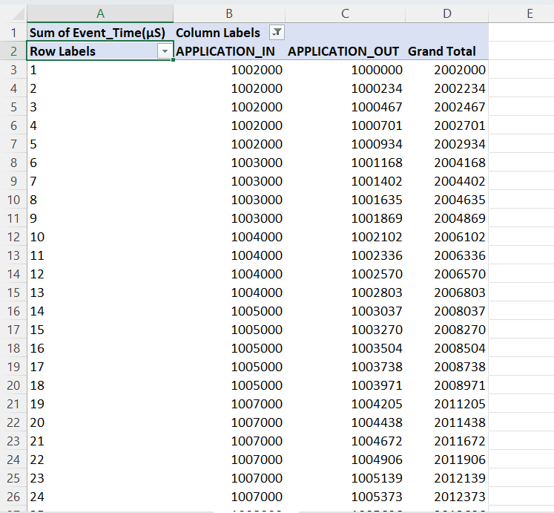

Fig 9‑12: Event Type filtered to APPLICATION_IN and APPLICATION_OUT to calculate delay

1. In the **Values** field in the Pivot Table Fields, Click on **Sum of Event Time ($μs$)** and select **Value Field Settings** as shown below.

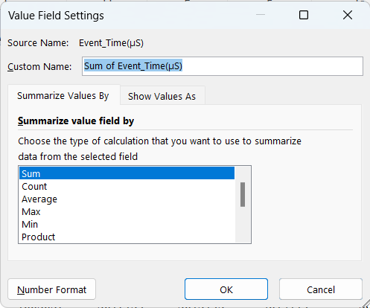

Fig 9‑13:Value Field Settings to Sum of Event Time

1. Select **Show Values As** option and filter it to **Difference From** as shown below.

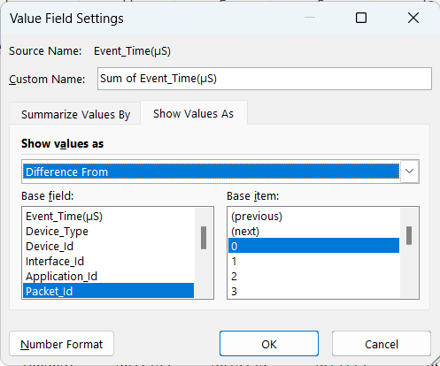

Fig 9‑14:Select Show Values as Difference From

1. In the **Base field**, select **Event_Type** and in the **Base_item** field select **APPLICATION_OUT** and click on OK. This will provide the end-to-end delay in the pivot table.

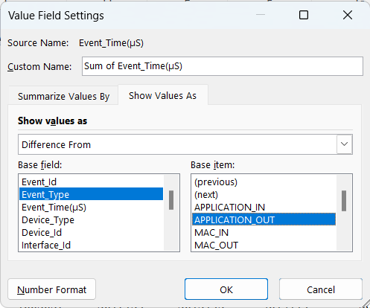

Fig 9‑15:Select Base field to Event Type and Base item to APPLICATION OUT

1. Now ignore the negative readings in the Delay values (Fig 9‑11) obtained and use these values to plot the Delay vs Time (APPLICATION_IN) graph.

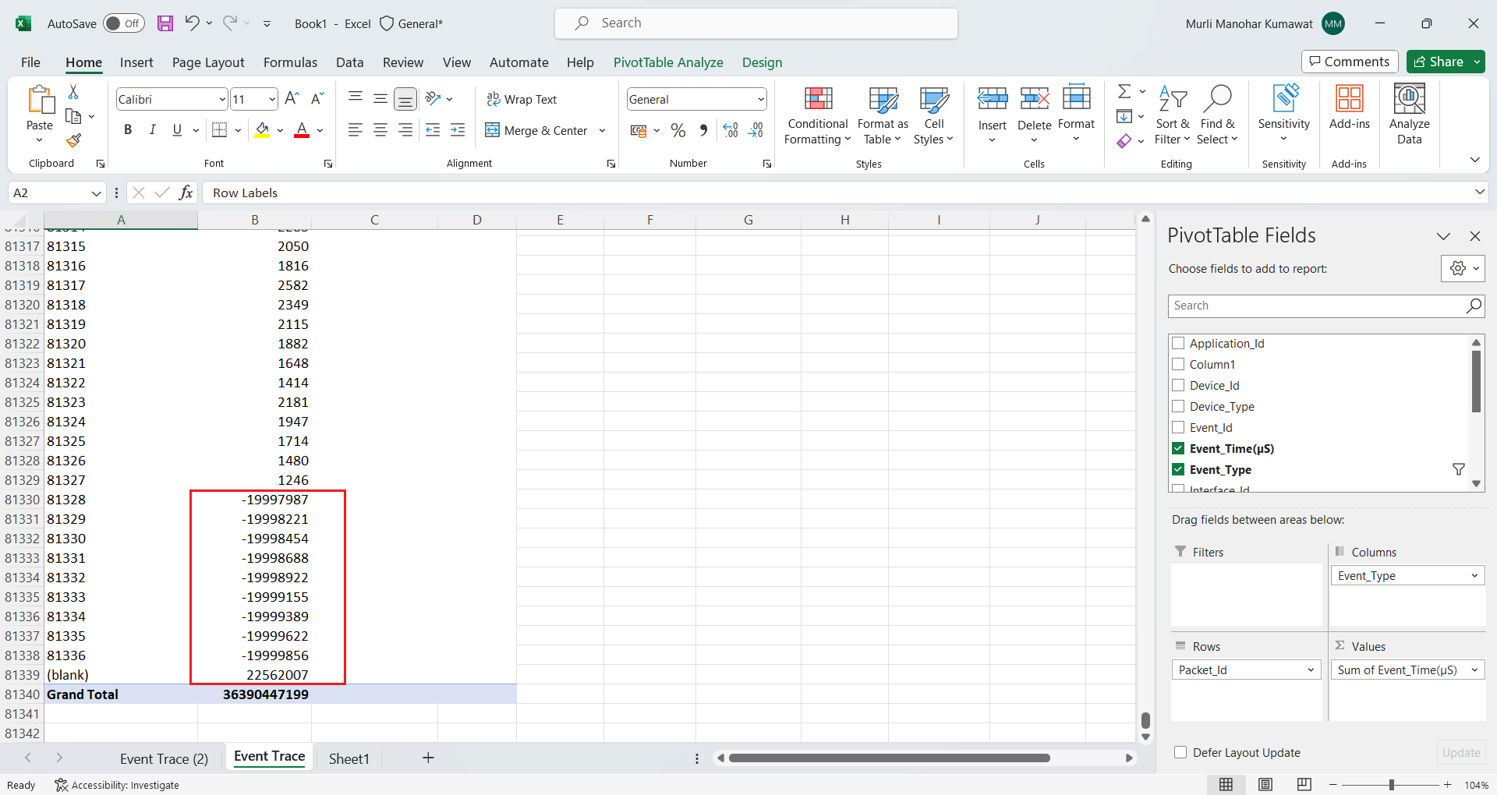

Fig 9‑16: Ignore the negative values in the Delay.

1. Repeat step 3, 4, 5 and click on Transform Data (as shown below in red)

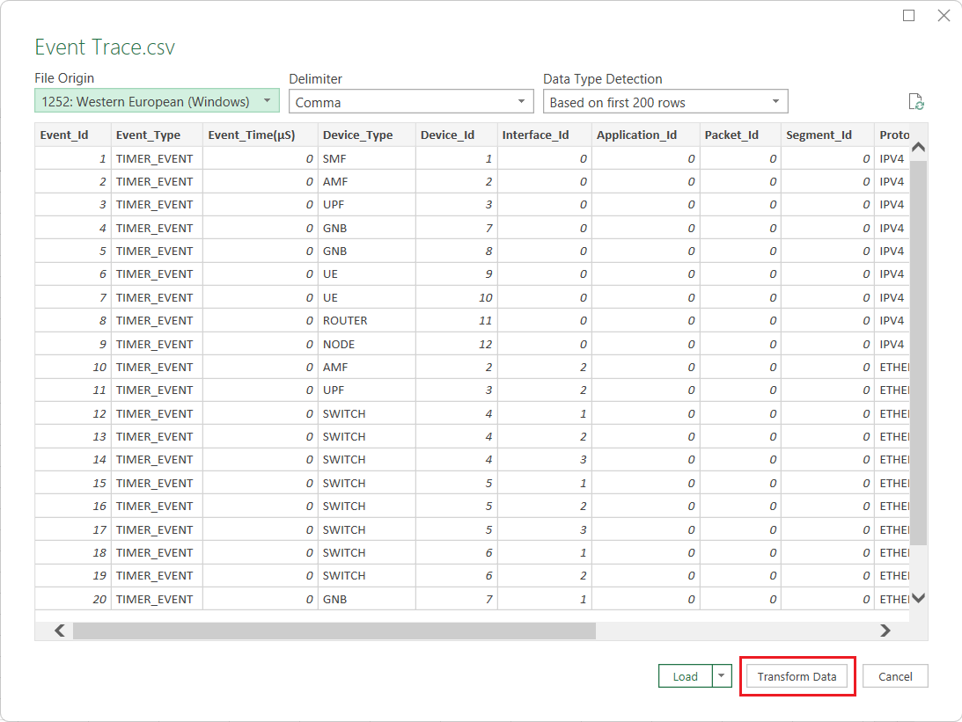

Fig 9‑17: Transforming data.

1. Filter the **Event Type** to **APPLICATION_IN**.

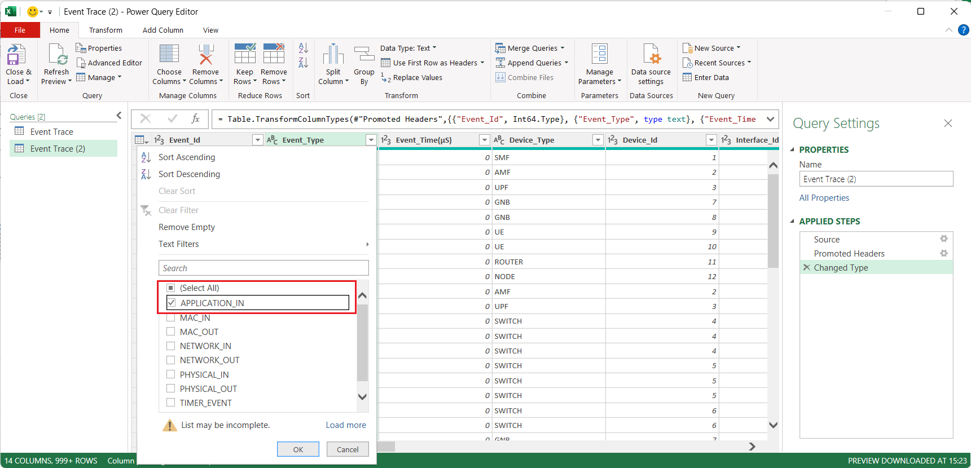

Fig 9‑18: Filter **APPLICATION_IN** event

1. In the Event trace window, filter the **Event Type** to **APPLICATION_IN** and use the Event Time thus obtained as the x-axis of the plot.

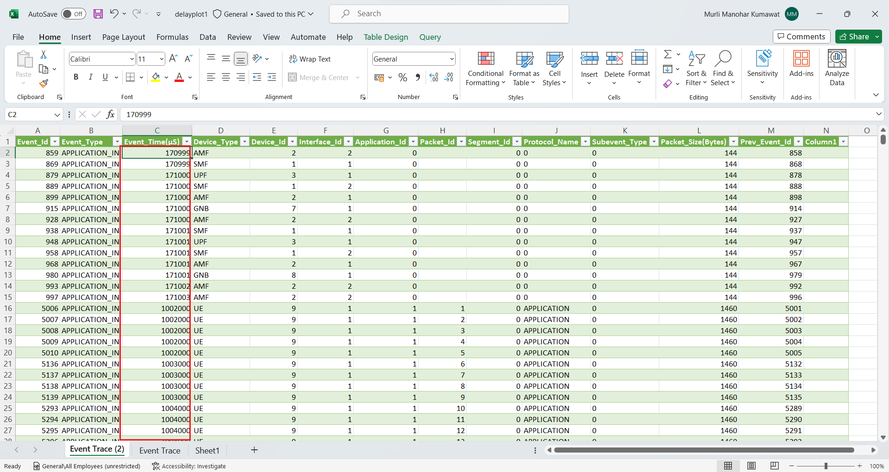

Fig 9‑19: Event Trace

1. Copy both APPLICATION_IN Event Time and Delay in new sheet.

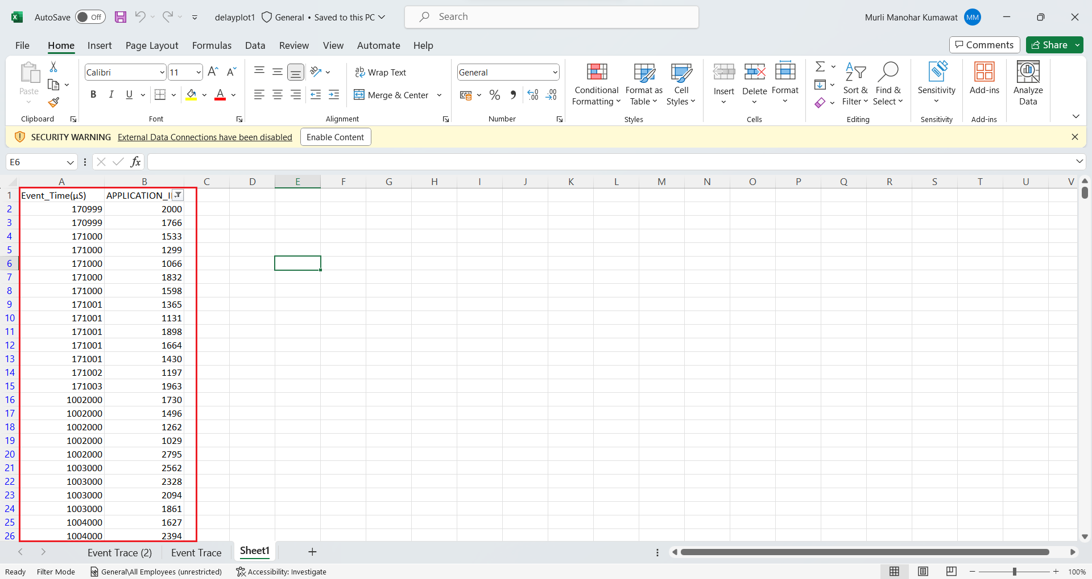

Fig 9‑20: Delay values

1. Select both the columns and click on Insert and plot Scatter plot (as shown in red).

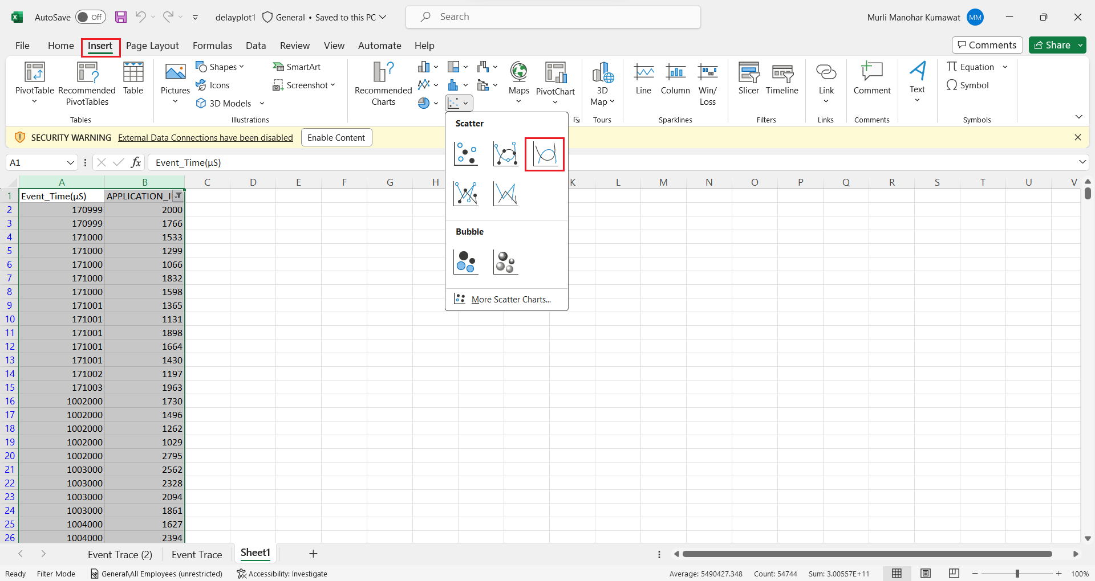

Fig 9‑21: Generating Delay Plot

### Results and Discussion

**UDP Throughput Plot**

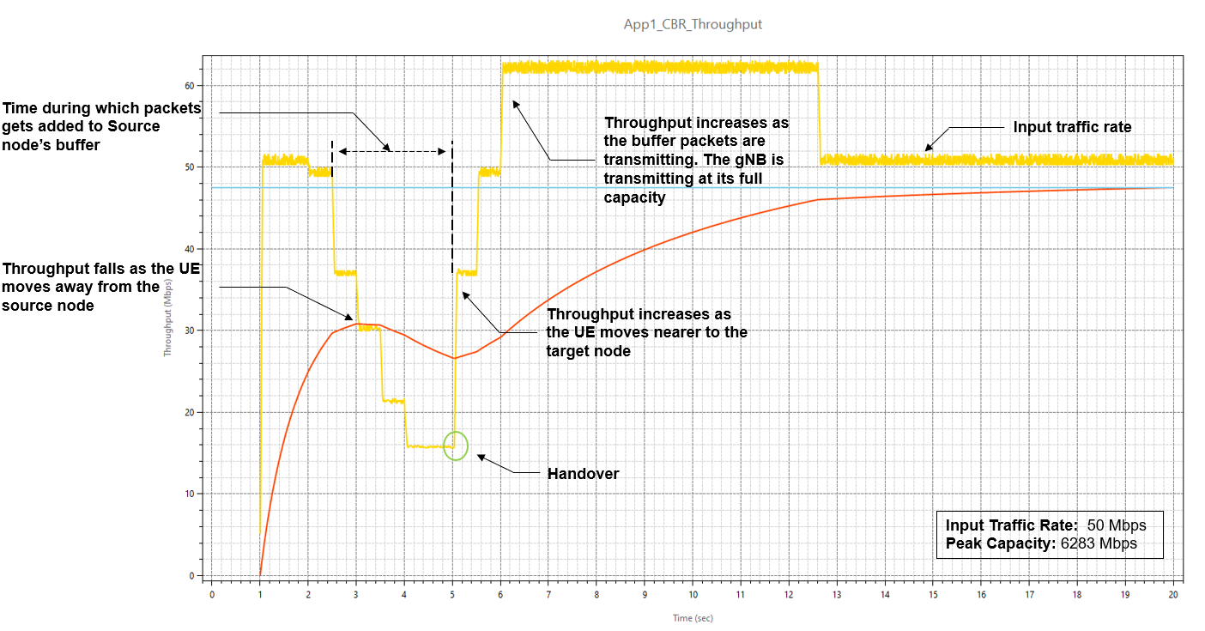

Fig 9‑22: We see how throughput varies with time, and the reasons for this variation, as the UE moves from the source gNB to the target gNB.

The application starts at 1s. The generation rate is 50 Mbps and we see the network is able to handle this load, and the throughput is equal to the generation rate. We then observe that the throughput starts dropping from 2.5s onwards because the UE is moving away from the gNB. As it moves as the SNR falls, and therefore a lower MCS is chosen leading to reduced throughput. At 3s there is a further drop in throughput and then a final dip at 3.9s. The time the handover occurs is 5.04 sec. At this point we see the throughput starts increasing once UE attaches to gNB8. The throughput for a short period of time is greater than 50 Mbps because of the transmission of queued packets in the s-gNB buffer which get transferred to the t-gNB buffer over the Xn interface.

**UDP Delay Plot**

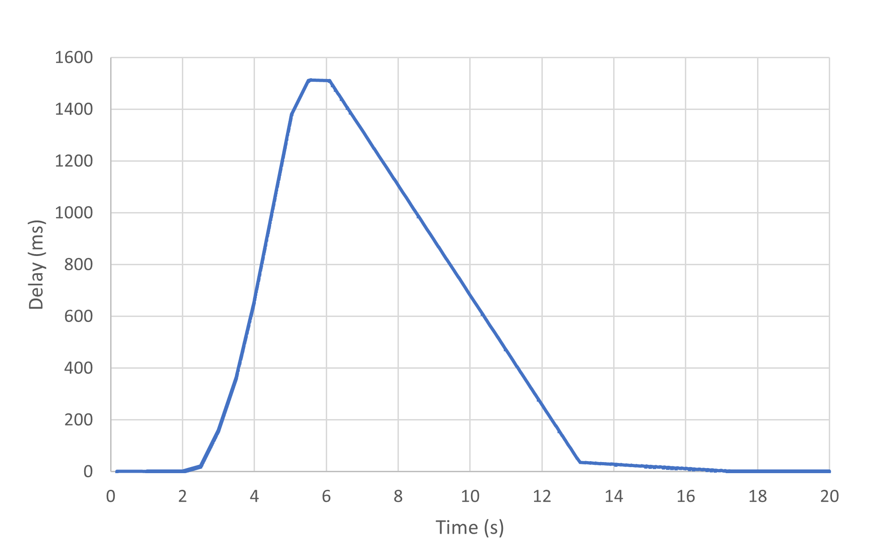

Fig 9‑23: Plot of Delay vs. Time

Since the application starts at 1s, the UDP plot begins at 1000 ms. The initial UDP delay is $≈1 ms$, and hence the curve is seen as close to 0 on the Y axis. We then see that the packet delay starts increasing as the UE moves away from the gNB. This is because the link capacity drops as the CQI falls. The peak delay experienced shoots up to $≈$ 1.1s at $≈$ 5.5s when the handover occurs. Once the handover is complete the delay starts reducing and returns to $≈1 ms$. The reason is that as the UE moves closer to the gNB its CQI increases and hence the 5G link can transmit at a higher rate (see Fig 9‑22).

## Exercises

**Let the last digit of your trainee ID be x. Then set the transmit power at the BS to (30 + 2*x) dBm at both the gNBs.**

1. **Repeat the above experiment for your value of transmit power by replicating Fig. 1-5, 1-15, 1-16. Infer and justify all your results.**
2. **In this exercise, we will understand the effect of handover margin on the process of handover. To change the handover margin, do the following steps.**
3. **gNB Properties > Interface_4 (5G_RAN) > DATALINK_LAYER > HANDOVER > Handover Margin (dB)**
4. **If x is odd, replicate figures 1-5, 1-15, 1-16 for two handover margins: 1 dB and 9 dB, with your customized gNB transmit powers.**
5. **If x is even, replicate figures 1-5, 1-15, 1-16 for two handover margins: 2 dB and 10 dB, with your customized gNB transmit powers.**
6. **Infer and justify your observations on how the handover margin affects the process of handover in terms of points of handover, delay and throughput of the application.**

1. We do not get into the details of the pathloss computations here. The specifics are explained in Experiment 4: Understand 3GPP 5GNR pathloss models.
2. This is the transmit power summed over entire BW and summed over all MIMO streams.
3. Refer Steps 5 through 8 in the section Analytical estimation of Data throughput, to understand how spectral efficiency is got from SNR, and then how MCS is set from spectral efficiency.
4. Users can refer to NetSim 5G NR user manual, section PHY implementation, for further details on the MIMO and Beamforming implementation in NetSim.
5. The application end time value of 10,000s is not changed. In NetSim the application runs for $\min\left(AppEndTime, SimulationTime\right)$. Since the simulation is run for 10s, the application runs for only 10s.
6. The antenna can be placed at different heights on the cell tower. Hence the term “Antenna height” would be technically precise.
7. A question for the reader: Why is it called break point?
8. Can the UE directly see the gNB? If yes, it is in a Line-of-sight (LOS) state and if not, it is in the NLOS state.
9. We mean the saturation or full buffer case. There is always a packet in the gNB queue to transmit; the queue is never empty.
10. Note that the eigenvectors are not required as they are only a part of the receive and transmit signal processing; NetSim only needs to work with the equivalent symbol-by-symbol flat fading SISO channels.
11. This is adapted from (Patriciello, Lagen, Giupponi, & Bojovic, 2018)
12. The application end time value of 10,000s is not changed. In NetSim the application runs for $\min\left(AppEndTime, SimulationTime\right)$. Since the simulation is run for 10s, the application runs for only 10s.
13. K. Dimou et al., "Handover within 3GPP LTE: Design Principles and Performance," 2009 IEEE 70th Vehicular Technology Conference Fall, Anchorage, AK, USA, 2009, pp. 1-5.